

quarterly report on
organizational performance excellence

THIRD state fiscal quarter 2015
January, February, March 2015

Robert J. Harper
Superintendent
 April 24, 2015
Please consider the environment before printing this document. It is formatted for double-sided printing.

THIS PAGE INTENTIALLY LEFT BLANK

Table of Contents

GLOSSARY OF TERMS, ACRONYMS, AND ABBREVIATIONS i
INTRODUCTION iii

CONSENT DECREE

STANDARDS FOR DEFINING SUBSTANTIAL COMPLIANCE

CONSENT DECREE PLAN 1

CLIENT RIGHTS 1

ADMISSIONS 2

PEER SUPPORTS 8

TREATMENT PLANNING 9

MEDICATIONS 12

DISCHARGES 13

STAFFING AND STAFF TRAINING 16

USE OF SECLUSION AND RESTRAINTS 20

CLIENT ELOPEMENTS 33

CLIENT INJURIES 35

PATIENT ABUSE, NEGLECT, EXPLOITATION, INJURY OR DEATH 39

PERFORMANCE IMPROVEMENT AND QUALITY ASSURANCE 40

COMPLIANCE RESPONSE TO ELIZABETH JONES REPORT 41

JOINT COMMISSION PERFORMANCE MEASURES

HOSPITAL-BASED INPATIENT PSYCHIATRIC SERVICES (HBIPS) 47

ADMISSION SCREENING (INITIAL ASSESSMENT) 48

HOURS OF RESTRAINT USE 49

HOURS OF SECLUSION USE 50

CLIENTS DISCHARGED ON MULTIPLE ANTIPSYCHOTIC MEDICATIONS 51

CLIENTS DISCHARGED ON MULTIPLE ANTIPSYCHOTIC MEDICATIONS

WITH JUSTIFICATION 53

POST DISCHARGE CONTINUING CARE PLAN CREATED 55

POST DISCHARGE CONTINUING CARE PLAN TRANSMITTED 56

JOINT COMMISSION PRIORITY FOCUS AREAS

CONTRACT PERFORMANCE INDICATORS 57

ADVERSE REACTIONS TO SEDATION OR ANESTHESIA 59

HEALTHCARE ACQUIRED INFECTIONS MONITORING & MANAGEMENT 60

MEDICATION ERRORS AND ADVERSE DRUG REACTIONS 62
Table of Contents

INPATIENT CONSUMER SURVEY 70
PAIN MANAGEMENT 77
FALL REDUCTION STRATEGIES 78
MEASURES OF SUCCESS 79

STRATEGIC PERFORMANCE EXCELLENCE

PROCESS IMPROVEMENT PLANS 80

ADMISSIONS 82

CAPITAL COMMUNITY CLINIC 88

DIETARY SERVICES 89

EMERGENCY MANAGEMENT 91
HARBOR TREATMENT MALL 93

HEALTH INFORMATION TECHNOLOGY (MEDICAL RECORDS) 94

HUMAN RESOURCES 104

MEDICAL STAFF 107

NURSING 119

PEER SUPPORT 124

PHARMACY SERVICES 127

PROGRAM SERVICES 135

PSYCHOLOGY 140

REHABILITATION THERAPY 141

SAFETY 142

THIS PAGE INTENTIALLY LEFT BLANK

Glossary of Terms, Acronyms & Abbreviations

ADC |  | Automated Dispensing Cabinets (for medications)
ADON |  | Assistant Director of Nursing
AOC |  | Administrator on Call
CCM |  | Continuation of Care Management (Social Work Services)
CCP |  | Continuation of Care Plan
CH/CON |  | Charges/Convicted
CMS |  | Centers for Medicare & Medicaid Services
CIVIL |  | Voluntary, No Criminal Justice Involvement
CIVIL-INVOL |  | Involuntary Civil Court Commitment (No Criminal Justice Involvement)
CoP |  | Community of Practice or  Conditions of Participation (CMS)
CPI |  | Continuous Process (or Performance) Improvement
CPR |  | Cardio-Pulmonary Resuscitation
CSP |  | Comprehensive Service Plan
DCC |  | Involuntary District Court Committed
DCC-PTP |  | Involuntary District Court Committed, Progressive Treatment Plan
GAP |  | Goal, Assessment, Plan Documentation
HOC |  | Hand off communications.
IMD |  | Institute for Mental Disease
ICDCC |  | Involuntary Civil District Court Commitment
ICDCC-M |  | Involuntary Civil District Court Commitment, Court Ordered Medications
ICDCC-PTP |  | Involuntary Civil District Court Commitment, Progressive Treatment Plan
IC-PTP+M |  | Involuntary Commitment, Progressive Treatment Plan, Court Ordered Medications
ICRDCC |  | Involuntary Criminal District Court Commitment
INVOL CRIM |  | Involuntary Criminal Commitment
INVOL-CIV |  | Involuntary Civil Commitment
ISP |  | Individualized Service Plan
IST |  | Incompetent to Stand Trial
LCSW |  | Licensed Clinical Social Worker
LEGHOLD |  | Legal Hold
LPN |  | License Practical Nurse
TJC |  | The Joint Commission (formerly JCAHO, Joint Commission on Accreditation of Healthcare Organizations)
MAR |  | Medication Administration Record
MHW |  | Mental Health Worker
MRDO |  | Medication Resistant Disease Organism (MRSA, VRE, C-Dif)
NAPPI |  | Non Abusive Psychological and Physical Intervention
NASMHPD |  | National Association of State Mental Health Program Directors
NCR |  | Not Criminally Responsible
NOD |  | Nurse on Duty
NP |  | Nurse Practitioner

i

Glossary of Terms, Acronyms & Abbreviations
NPSG |  | National Patient Safety Goals (established by the Joint Commission)
NRI |  | NASMHPD Research Institute, Inc.
OPS |  | Outpatient Services Program (Formally the ACT Team)
OT |  | Occupational Therapist
PA or PA-C |  | Physician’s Assistant (Certified)
PCHDCC |  | Pending Court Hearing
PCHDCC+M |  | Pending Court Hearing for Court Ordered Medications
PPR |  | Periodic Performance Review – a self-assessment based upon TJC standards that are conducted annually by each department head.
PSD |  | Program Services Director
PTP |  | Progressive Treatment Plan
PRET |  | Pretrial Evaluation
R.A.C.E. |  | Rescue/Alarm/Confine/Extinguish
RN |  | Registered Nurse
RPRC |  | Riverview Psychiatric Recovery Center
RT |  | Recreation Therapist
SA |  | Substance Abuse
SAMHSA |  | Substance Abuse and Mental Health Services Administration (Federal)
SAMHS |  | Substance Abuse and Mental Health Services, Office of (Maine DHHS)
SBAR |  | Acronym for a model of concise communications first developed by the US Navy Submarine Command. S = Situation, B = Background, A = Assessment, R = Recommendation
SD |  | Standard Deviation – a measure of data variability.
Seclusion, Locked |  | Client is placed in a secured room with the door locked.
Seclusion, Open |  | Client is placed in a room and instructed not to leave the room.
SRC |  | Single Room Care (seclusion)
STAGE III |  | 60 Day Forensic Evaluation
URI |  | Upper respiratory infection
UTI |  | Urinary tract infection
VOL |  | Voluntary – Self
VOL-OTHER |  | Voluntary – Others (Guardian)

ii

INTRODUCTION

The Riverview Psychiatric Recovery Center Quarterly Report on Organizational Performance Excellence has been created to highlight the efforts of the hospital and its staffs to provide evidence of a commitment to client recovery, safety in culture and practices and fiscal accountability. The report is structure to reflect a philosophy and contemporary practices in addressing overall organizational performance in a systems improvement approach instead of a purely compliance approach. The structure of the report also reflects a focus on meaningful measures of organizational process improvement while maintaining measures of compliance that are mandated though regulatory and legal standards.
The methods of reporting are driven by a national accepted focused approach that seeks out areas for improvement that were clearly identified as performance priorities. The American Society for Quality, National Quality Forum, Baldrige National Quality Program and the National Patient Safety Foundation all recommend a systems-based approach where organizational improvement activities are focused on strategic priorities rather than compliance standards.
There are three major sections that make up this report:
The first section reflects compliance factors related to the Consent Decree and includes those performance measure described in the Order Adopting Compliance Standards dated October 29, 2007. Comparison data is not always available for the last month in the quarter and is included in the next report.
The second section describes the hospital’s performance with regard to Joint Commission performance measures that are derived from the Hospital-Based Inpatient Psychiatric Services (HBIPS) that are reflected in the Joint Commissions quarterly ORYX Report and priority focus areas that are referenced in the Joint Commission standards;
I. Data Collection (PI.01.01.01)
II. Data Analysis (PI.02.01.01, PI.02.01.03)
III. Performance Improvement (PI.03.01.01)
The third section encompasses those departmental process improvement projects that are designed to improve the overall effectiveness and efficiency of the hospital’s operations and contribute to the system’s overall strategic performance excellence. Several departments and work areas have made significant progress in developing the concepts of this new methodology.
As with any change in how organizations operate, there are early adopters and those whose adoption of system changes is delayed. It is anticipated that over the next year, further contributors to this section of strategic performance excellence will be added as opportunities for improvement and methods of improving operational functions are defined.

iii

THIS PAGE INTENTIALLY LEFT BLANK

(Glossary of Terms, Acronyms & Abbreviations) (Back to Table of Contents)
CONSENT DECREE

Consent Decree Plan

V1) The Consent Decree Plan, established pursuant to paragraphs 36, 37, 38, and 39 of the Settlement Agreement in Bates v. DHHS defines the role of Riverview Psychiatric Recovery Center in providing consumer-centered inpatient psychiatric care to Maine citizens with serious mental illness that meets constitutional, statutory, and regulatory standards.
The following elements outline the hospital’s processes for ensuring substantial compliance with the provisions of the Settlement Agreement as stipulated in an Order Adopting Compliance Standards dated October 29, 2007.
Client Rights

V2) Riverview produces documentation that clients are routinely informed of their rights upon admission in accordance with ¶ 150 of the Settlement Agreement;

Indicators | 4Q2014 | 1Q2015 | 2Q2015 | 3Q2015
- Clients are routinely informed of their rights upon admission. | 100%  26/32  (97%,  27/29 for Lower Saco) | 97%  44/45  (100%,  14/15 for Lower Saco) | 97%  57/59  (All  four units) | 95%  57/60  (All four units)

Clients are informed of their rights and asked to sign that information has been provided to them. If they refuse, the staff documents the refusal and sign, date & time the refusal.

V3) Grievance tracking data shows that the hospital responds to 90% of Level II grievances within five working days of the date of receipt or within a five-day extension.

Indicators | 4Q2014 | 1Q2015 | 2Q2015 | 3Q2015
- Level II grievances responded to by RPRC on time. | 100%  2/2 | 100%  1/1 | 100%  3/3 | N/A
- Level I grievances responded to by RPRC on time. | 100%  51/51 | 100%  86/86 | 100%  65/65 | 98%  96/98

(Glossary of Terms, Acronyms & Abbreviations) (Back to Table of Contents)
CONSENT DECREE

Admissions

V4) Quarterly performance data shows that in 4 consecutive quarters, 95% of admissions to Riverview meet legal criteria;

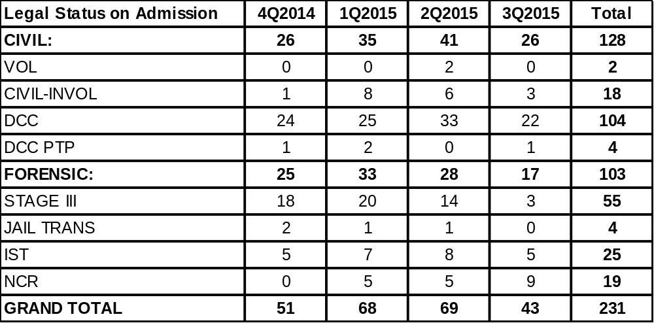
(Glossary of Terms, Acronyms & Abbreviations) (Back to Table of Contents)
CONSENT DECREE

V5) Quarterly performance data shows that in 3 out of 4 consecutive quarters, the % of readmissions within 30 days of discharge does not exceed one standard deviation from the national mean as reported by NASMHPD

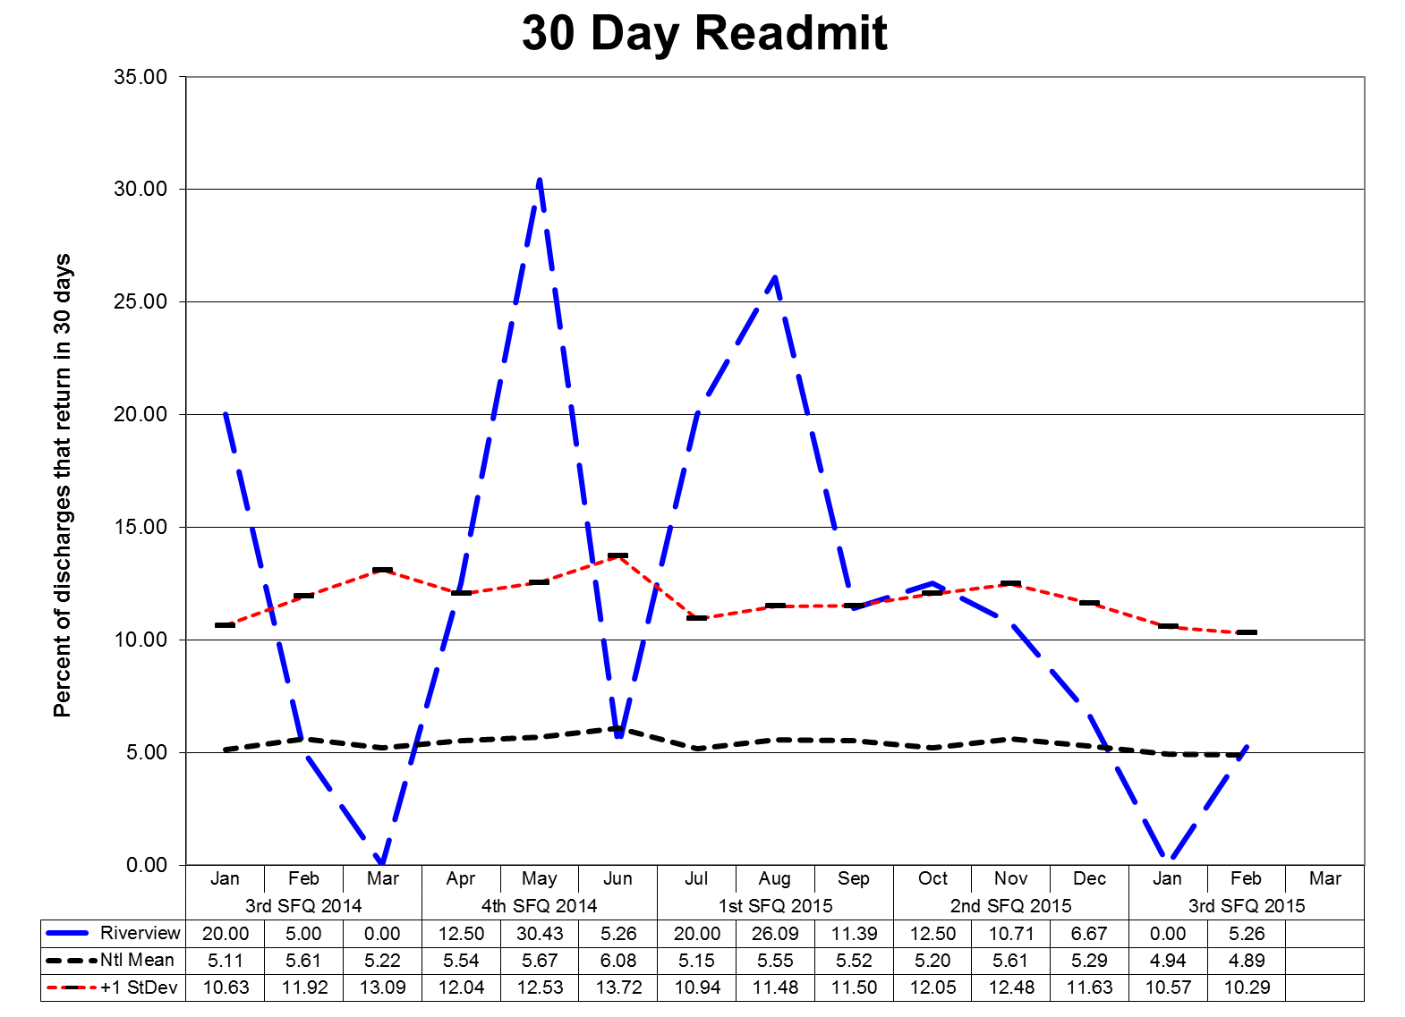
This graph depicts the percent of discharges from the facility that returned within 30 days of a discharge of the same client from the same facility. For example; a rate of 10.0 means that 10% of all discharges were readmitted within 30 days.
The graphs shown on the next page depict the percent of discharges from the facility that returned within 30 days of a discharge of the same client from the same facility stratified by forensic or civil classifications. For example; a rate of 10.0 means that 10% of all discharges were readmitted within 30 days. The hospital-wide results from the Dorothea Dix facility are compared to the civil population results at the Riverview facility due to the homogeneous nature of these two sample groups.
Reasons for client readmission are varied and may include decompensating or lack of compliance with a PTP to name a few. Specific causes for readmission are reviewed with each client upon their return. These graphs are intended to provide an overview of the readmission picture and do not provide sufficient granularity in data elements to determine trends for causes of readmission.

Note: Between August 2013 and November 2014 the Lower Saco unit was decertified. Patients had to be discharged and readmitted in our Meditech Electronic Medical Record system whenever they transferred units in the hospital (either from or to Lower Saco), which caused them to show up in this graph as a 30 Day Readmission, even though they technically never left the hospital.
(Glossary of Terms, Acronyms & Abbreviations) (Back to Table of Contents)
CONSENT DECREE
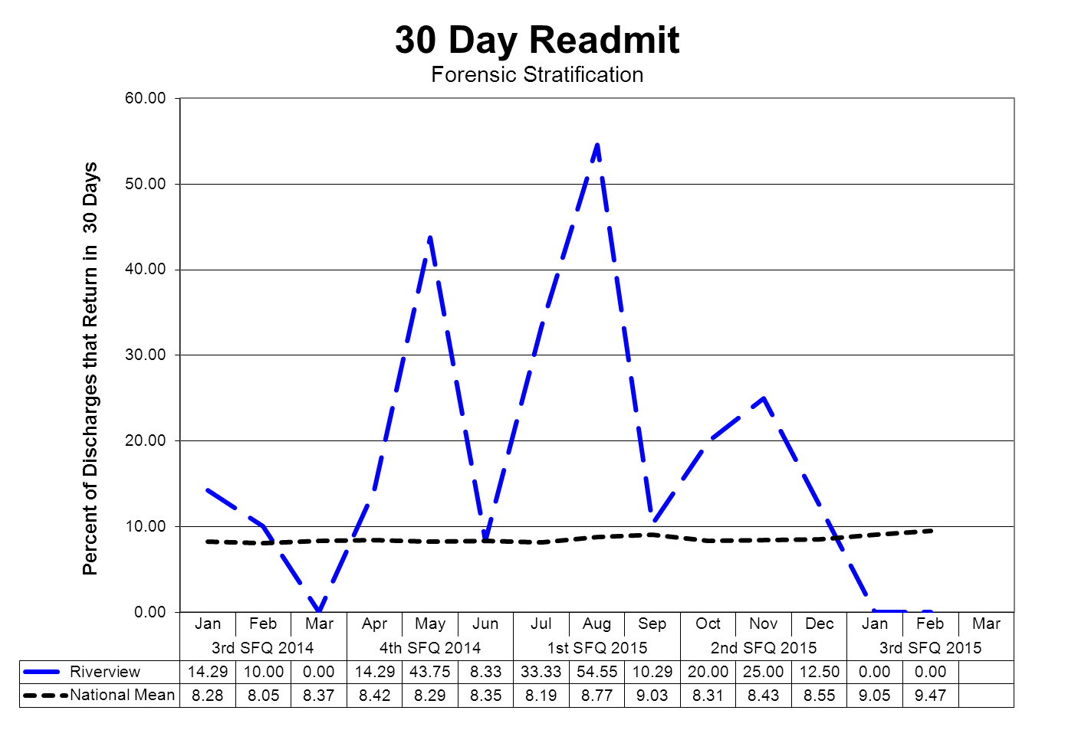
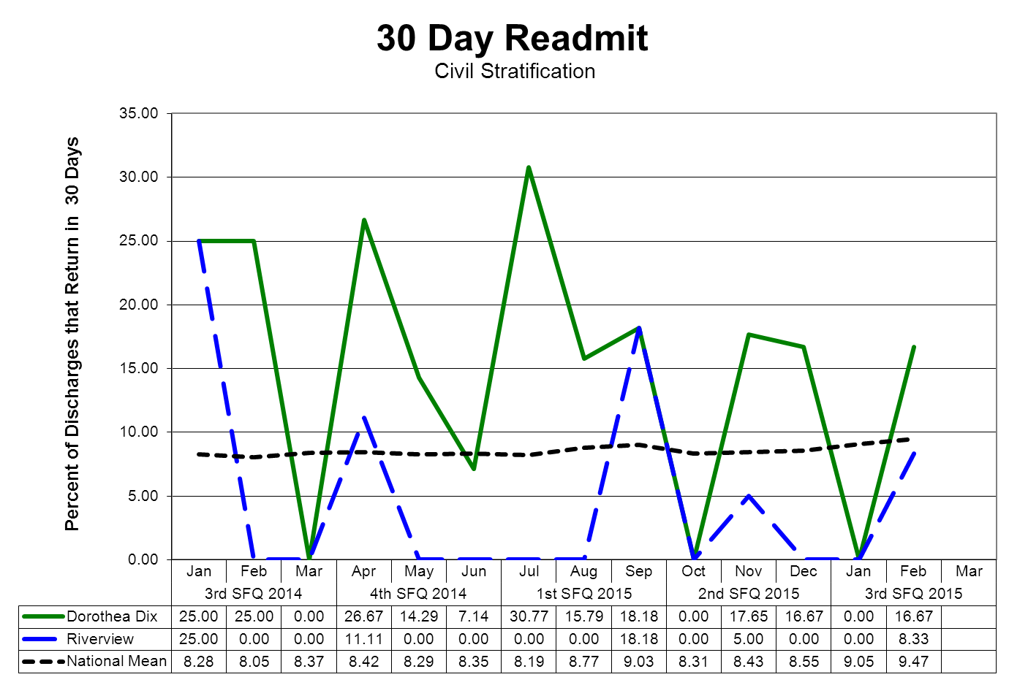
(Glossary of Terms, Acronyms & Abbreviations) (Back to Table of Contents)
CONSENT DECREE

V6) Riverview documents, as part of the Performance Improvement & Quality Assurance process, that the Director of Social Work reviews all readmissions occurring within 60 days of the last discharge; and for each client who spent fewer than 30 days in the community, evaluated the circumstances to determine whether the readmission indicated a need for resources or a change in treatment and discharge planning or a need for different resources and, where such a need or change was indicated, that corrective action was taken;

REVIEW OF READMISSION OCCURRING WITHIN 60 DAYS

Indicators | 4Q2014 | 1Q2015 | 2Q2015 | 3Q2015
Director of Social Services reviews all readmissions occurring within 60 days of the last discharge and for each client who spent fewer than 30 days in the community, evaluated the circumstances of the readmission to determine an indicated need for resources or a change in treatment and discharge planning or the need for alternative resources. In cases where such a need or change was indicated that corrective action was taken. | 100%  1/1 | 100%  3/3 | 100%  4/4 | 100%  5/5

Current Quarterly Summary

Five clients were re-admitted in quarter 3. Of the five re-admitted 4 spent less than 30days in the community. Client 1 spent 13 days in the community post discharge and was re-admitted to the hospital for violating his PTP treatment plan. Client 2 was in jail for 6 days post discharge and re-admitted to the Lower Saco unit. Client 3 was discharged to a forensic group home under care of the OPS team and was re-admitted 14 days later for verbally and physically threatening a housemate at his residence. Client 4 was discharged to the community to her own apartment with medication and case management services. From re-admission report it appears client immediately discontinued medication within days of discharge and became disorganized and fearful. Client was assessed by local crisis services and readmitted after 14 days in the community.
(Glossary of Terms, Acronyms & Abbreviations) (Back to Table of Contents)
CONSENT DECREE

Reduction of re-hospitalization for OUTPATIENT SERVICES PROGRAM (OPS) clients

Indicators | 4Q2014 | 1Q2015 | 2Q2015 | 3Q2015
- The Program Service Director of the Outpatient Services Program will review all client cases of re-hospitalization from the community for patterns and trends of the contributing factors leading to re-hospitalization each quarter. The following elements are considered during the review:  - Length of stay in community  - Type of residence (i.e.: group home, apartment, etc.)  - Geographic location of residence  - Community support network  - Client demographics (age, gender, financial)  - Behavior pattern/mental status  - Medication adherence  - Level of communication with Outpatient Treatment | 100%  1 client returned to RPRC for psychiatric instability from group home, remains in RPRC on Upper Saco | 100%  2 clients returned to RPRC for psychiatric instability manifested by assault of staff in their residence. Both remain in RPRC. | 100%  3 clients returned to RPRC; one for elopement and use of alcohol, one for assault (who was admitted twice in this period) and one for suspicion of illegal activity. All remain in RPRC. 1 client was arrested by US Marshalls and is in Somerset Co. Jail awaiting sentencing. | 100%  6 clients returned to RPRC. 5 of these clients remain at RPRC and one has returned to the community.
- Outpatient Treatment will work closely with inpatient treatment team to create and apply discharge plan incorporating additional supports determined by review noted in #1. | 100% | 100%  Attendance at all treatment team meetings. | 100%  Attendance at RPRC meetings and maintained contact while in jail. | 100%  Attendance at RPRC treatment team meetings that OPS was scheduled for.

Current Quarter Summary

- We had six clients return to RPRC; one for personal drug use and providing drugs to others, one for suicidal ideation as a result of disclosure of a relationship with RPRC staff, one for personal drug use, one for arson - set fire to own house, one pulled a knife and cut self three times and was then shot by APD three times, one accused a peer of calling the police, then pushed the peer and picked up a knife and was redirected by staff. Five clients readmitted to RPRC are male, 29, 33, 37, 43, and 54 years of age respectively. One client readmitted to RPRC is female age 50. Four clients were residing in group homes, one lived in a supervised apartment and one lived in his own home.

(Glossary of Terms, Acronyms & Abbreviations) (Back to Table of Contents)
CONSENT DECREE

V7) Riverview certifies that no more than 5% of patients admitted in any year have a primary diagnosis of mental retardation, traumatic brain injury, dementia, substance abuse or dependence.

Client Admission Diagnoses | 4Q14 | 1Q15 | 2Q15 | 3Q15 | TOT
ADJUSTMENT REACTION NOS |  |  |  | 1 | 1
ANXIETY STATE NOS | 3 | 1 | 4 |  | 8
BIPOL I DIS, MOST RECENT EPIS (OR CURRENT) MANIC, UNSPEC |  | 1 |  |  | 1
BIPOL I, MOST RECENT EPISODE (OR CURRENT) MIXED, UNSPEC |  | 1 |  |  | 1
BIPOL I, REC EPIS OR CURRENT MANIC, SEVERE, SPEC W PSYCH BEH |  | 1 | 4 | 1 | 6
BIPOLAR DISORDER, UNSPECIFIED | 3 | 6 | 7 | 1 | 17
DELUSIONAL DISORDER | 2 | 2 |  |  | 4
DEPRESS DISORDER-UNSPEC |  | 1 |  | 1 | 2
DEPRESSIVE DISORDER NEC |  | 5 | 1 |  | 6
HEBEPHRENIA-UNSPEC |  | 1 |  |  | 1
IMPULSE CONTROL DIS NOS |  |  |  | 2 | 2
INTERMITT EXPLOSIVE DIS | 1 |  |  |  | 1
OTH AND UNSPECIFIED BIPOLAR DISORDERS, OTHER | 1 | 2 |  |  | 3
OTH SPEC PERVASIVE DEVELOPMENT DIS, CURRENT OR ACT STATE |  |  | 1 |  | 1
PARANOID SCHIZO-CHRONIC | 6 | 8 | 5 | 1 | 20
PARANOID SCHIZO-UNSPEC | 1 |  | 1 | 3 | 5
POSTTRAUMATIC STRESS DISORDER | 1 | 4 | 3 | 1 | 9
PSYCHOSIS NOS | 8 | 6 | 11 | 8 | 33
RECURR DEPR DISORD-UNSP |  |  | 1 |  | 1
SCHIZOAFFECTIVE DISORDER, UNSPECIFIED | 12 | 16 | 19 | 17 | 64
SCHIZOPHRENIA NOS-CHR | 2 | 2 | 1 |  | 5
SCHIZOPHRENIA NOS-UNSPEC | 1 | 1 | 4 | 1 | 7
SCHIZOPHRENIFORM DISORDER, UNSPECIFIED | 2 | 1 |  |  | 3
UNSPECIFIED ALCOHOL-INDUCTED MENTAL DISORDERS |  | 1 | 1 |  | 2
UNSPECIFIED EPISODIC MOOD DISORDER | 8 | 8 | 6 | 6 | 28
Total Admissions | 51 | 68 | 69 | 43 | 231
Admitted with primary diagnosis of mental retardation, traumatic brain injury, dementia, substance abuse or dependence. | 0.00% | 0.00% | 0.00% | 0.00% | 0.00%
(Glossary of Terms, Acronyms & Abbreviations) (Back to Table of Contents)
CONSENT DECREE

Peer Supports

Quarterly performance data shows that in 3 out of 4 consecutive quarters:

V8) 100% of all clients have documented contact with a peer specialist during hospitalization;

V9) 80% of all treatment meetings involve a peer specialist.

Indicators | 4Q2014 | 1Q2015 | 2Q2015 | 3Q2015
- Attendance at Comprehensive Treatment Team meetings. (v9) | 89%  417/466 | 45%  183/404 | 91%  381/482 | 96%  383/414
- Attendance at Service Integration meetings. (v8) | 100%  46/46 | 100%  80/80 | Data not available | 93%  26/28
- Contact during admission. (v8) | 100%  62/62 | 100%  80/80 | 100%  72/72 | 100%  43/43
- Community Integration / Bridging Inpatient & OPS  Inpatient trips  OPS |  |  | 100%  63  130 | 100%  71  163
- Peer Support will make an attempt to assist all patients in recognizing their personal medicine and filling out form |  |  | 100%  72/72 | 100%  43/43
- Peer Support will make a documented attempt to have patients fill out a survey before discharge or annually to evaluate the effectiveness of the peer support relationship during hospitalization. |  |  | 30%  19/64 | 82%  46/56
- Grievances responded to on time by peer support, within 1 day of receipt. |  |  | 100%  65/65 | 100%  98/98

Current Quarter Summary

1. Out of the 414 treatment team meetings held, Peer Support was available to attend, at 15 meetings the client did not want Peer Support there. Peer Support declined does not count against peer support and the average for the quarter.
(Glossary of Terms, Acronyms & Abbreviations) (Back to Table of Contents)
CONSENT DECREE

Treatment Planning

V10) 95% of clients have a preliminary treatment and transition plan developed within 3 working days of admission;

Indicators | 4Q2014 | 1Q2015 | 2Q2015 | 3Q2015
1. Service Integration meeting and form completed by the end of the 3rd day. | 100%  30/30 | 100%  30/30 | 100%  45/45 | 100%  45/45
2. Client Participation in Service Integration meeting. | 100%  30/30 | 93%  28/30 | 95%  43/45 | 93%  42/45
3. Social Worker Participation in Service Integration meeting. | 100%  30/30 | 100%  30/30 | 100%  45/45 | 100%  45/45
4. Initial Comprehensive Psychosocial Assessments completed within 7 days of admission. | 86%  26/30 | 86%  26/30 | 95%  43/45 | 95%  43/45
5. Initial Comprehensive Assessment contains summary narrative with conclusion and recommendations for discharge and social worker role. | 100%  30/30 | 100%  30/30 | 100%  45/45 | 100%  45/45
6. Annual Psychosocial Assessment completed and current in chart. | 100%  15/15 | 100%  30/30 | 100%  15/15 | 100%  10/10

Current Quarter Summary

2. Three clients declined to meet for the Service Integration meeting and declined on follow up.

4. Two Comprehensive Psychosocial Assessments were not completed within the 7 day timeframe, they were completed at 8 and 9 days respectively.
(Glossary of Terms, Acronyms & Abbreviations) (Back to Table of Contents)
CONSENT DECREE

V11) 95% of clients also have individualized treatment plans in their records within 7 days thereafter;

Indicators | 4Q2014 | 1Q2015 | 2Q2015 | 3Q2015
- Progress notes in GAP/Incidental/Contact format will indicate at minimum weekly 1:1 meeting with all clients on assigned CCM caseload. | 83%  25/30 | 88%  40/45 | 91%  41/45 | 97%  44/45
- Treatment plans will have measurable goals and interventions listing client strengths and areas of need related to transition to the community or transition back to a correctional facility. | 86%  26/30 | 100%  45/45 | 100%  45/45 | 100%  45/45

Current Quarter Summary:

1. There was 1 record that did not indicate a note was done during a weekly period. The note was completed as a late entry in Meditech.

V12) Riverview certifies that all treatment modalities required by ¶155 are available.

The treatment modalities listed below as listed in ¶155 are offered to all clients according to the individual client’s ability to participate in a safe and productive manner as determined by the treatment team and established in collaboration with the client during the formulation of the individualized treatment plan.

Treatment Modality | Provision of Services Normally by….
Treatment Modality | Medical Staff  Psychology | Nursing | Social  Services | Rehabilitation Services/  Treatment Mall
Group and Individual Psychotherapy | X
Psychopharmacological Therapy | X
Social Services |  |  | X
Physical Therapy |  |  |  | X
Occupational Therapy |  |  |  | X
ADL Skills Training |  | X |  | X
Recreational Therapy |  |  |  | X
Vocational/Educational Programs |  |  |  | X
Family Support Services and Education |  | X | X | X
Substance Abuse Services | X
Sexual/Physical Abuse Counseling | X
Intro to Basic Principles of Health, Hygiene, and Nutrition |  | X |  | X

(Glossary of Terms, Acronyms & Abbreviations) (Back to Table of Contents)
CONSENT DECREE

An evaluation of treatment planning and implementation, performed in accordance with Attachment D, demonstrates that, for 90% of the cases reviewed:

V13) The treatment plans reflect

- Screening of the patient’s needs in all the domains listed in ¶61;
- Consideration of the patient’s need for the services listed in ¶155;
- Treatment goals for each area of need identified, unless the patient chooses not, or is not yet ready, to address that treatment goal;
- Appropriate interventions to address treatment goals;
- Provision of services listed in ¶155 for which the patient has an assessed need;
- Treatment goals necessary to meet discharge criteria; and
- Assessments of whether the patient is clinically safe for discharge;

V14) The treatment provided is consistent with the individual treatment plans;

V15) If the record reflects limitations on a patient’s rights listed in ¶159, those limitations were imposed consistent with the Rights of Recipients of Mental Health Services

An abstraction of pertinent elements of a random selection of charts is periodically conducted to determine compliance with the compliance standards of the consent decree outlined in parts V13, V14, and V15.

This review of randomly selected charts revealed substantial compliance with the consent decree elements. Individual charts can be reviewed by authorized individuals to validate this chart review.

(Glossary of Terms, Acronyms & Abbreviations) (Back to Table of Contents)
CONSENT DECREE

Medications

V16) Riverview certifies that the pharmacy computer database system for monitoring the use of psychoactive medications is in place and in use, and that the system as used meets the objectives of ¶168.
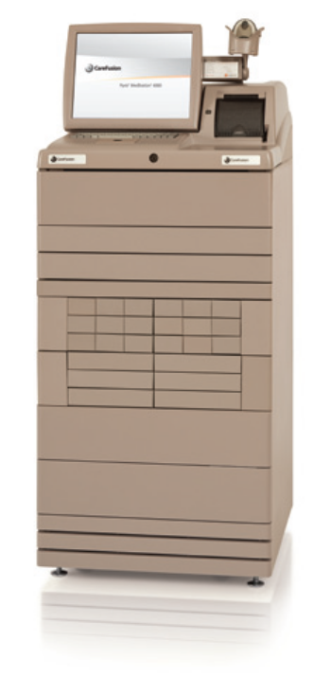
Riverview utilizes a Pyxis Medstation 4000 System for the dispensing of medications on each client care unit. A total of six devices, one on each of the four main units and in each of the two special care units, provide access to all medications used for client care, the pharmacy medication record, and allow review of dispensing and administration of pharmaceuticals.
A database program, HCS Medics, contains records of medication use for each client and allows access by an after-hours remote pharmacy service to these records, to the Pyxis Medstation 4000 System. The purpose of this after-hours service is to maintain 24 hour coverage and pharmacy validation and verification services for prescribers.
Records of transactions are evaluated by the Director of Pharmacy and the Medical Director to validate the appropriate utilization of all medication classes dispensed by the hospital. The Pharmacy and Therapeutics Committee, a multidisciplinary group of physicians, pharmacists, and other clinical staff evaluate issues related to the prescribing, dispensing, and administration of all pharmaceuticals.
The system as described is capable of providing information to process reviewers on the status of medications management in the hospital and to ensure the appropriate use of psychoactive and other medications.
The effectiveness and accuracy of the Pyxis Medstation 4000 System is analyzed regularly through the conduct of process improvement and functional efficiency studies. These studies can be found in the Medication Management and Pharmacy Services sections of this report.

(Glossary of Terms, Acronyms & Abbreviations) (Back to Table of Contents)
CONSENT DECREE

Discharges

Quarterly performance data shows that in 3 consecutive quarters:

V17) 70% of clients who remained ready for discharge were transitioned out of the hospital within 7 days of a determination that they had received maximum benefit from inpatient care;

V18) 80% of clients who remained ready for discharge were transitioned out of the hospital within 30 days of a determination that they had received maximum benefit from inpatient care;

V19) 90% of clients who remained ready for discharge were transitioned out of the hospital within 45 days of a determination that they had received maximum benefit from inpatient care (with certain clients excepted, by agreement of the parties and court master).

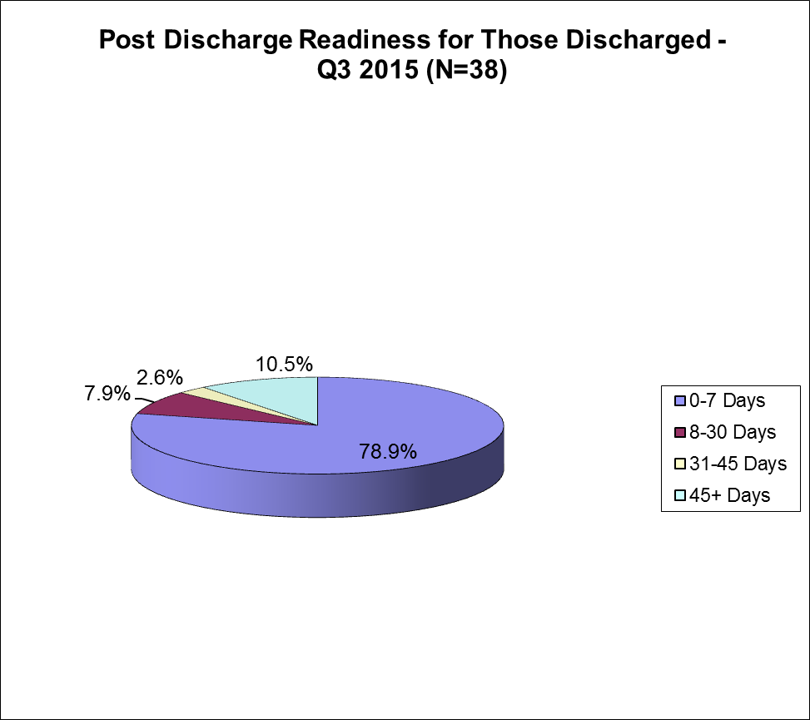 | Cumulative percentages & targets are as follows:  Within 7 days = (30) 78.9% (target 70%)  Within 30 days = (33) 86.8% (target 80%)  Within 45 days = (34) 89.4% (target 90%)  Post 45 days = (4) 10.5% (target 0%)
Barriers to Discharge Following Clinical Readiness
Residential Supports (0)  No barriers in this area |  | Housing (8) 21%  - 3 clients discharged 8-30 days post clinical readiness/housing barrier (8, 22, and 23 days)  - 1 client discharged 31-45 days post clinical readiness/housing barrier (35 days)  - 4 clients discharged 45+ days post clinical readiness/housing barrier (58, 69, 70, 111 days)  Other (0)  No barriers in this area
Treatment Services (0)
No barriers in this area

The previous four quarters are displayed in the table below

Target >> |  | Within 7 days | Within 30 days | Within 45 days | 45+ days
 |  | 70% | 80% | 90% | < 10%
2Q2015 | N=39 | 82.1% | 87.2% | 89.7% | 10.3%
1Q2015 | N=38 | 81.6% | 92.1% | 94.7% | 5.3%
4Q2014 | N=17 | 70.6% | 94.1% | 94.1% | 5.9%
3Q2014 | N=24 | 73.1% | 84.6% | 92.3% | 7.7%
(Glossary of Terms, Acronyms & Abbreviations) (Back to Table of Contents)
CONSENT DECREE

An evaluation of treatment and discharge planning, performed in accordance with Attachment D, demonstrates that, for 90% of the cases reviewed:

V20) Treatment and discharge plans reflect interventions appropriate to address discharge and transition goals;

V20a) For patients who have been found not criminally responsible or not guilty by reason of insanity, appropriate interventions include timely reviews of progress toward the maximum levels allowed by court order; and the record reflects timely reviews of progress toward the maximum levels allowed by court order;

V21) Interventions to address discharge and transition planning goals are in fact being implemented;

V21a) For patients who have been found not criminally responsible or not guilty by reason of insanity, this means that, if the treatment team determines that the patient is ready for an increase in levels beyond those allowed by the current court order, Riverview is taking reasonable steps to support a court petition for an increase in levels.

Indicators | 4Q2014 | 1Q2015 | 2Q2015 | 3Q2015
- The Client Discharge Plan Report will be updated/reviewed by each Social Worker minimally one time per week. | 91%  11/12 | 100%  13/13 | 100%  11/11 | 100%  10/10
- The Client Discharge Plan Report will be reviewed/updated minimally one time per week by the Director of Social Services. | 91%  11/12 | 76%  10/13 | 100%  11/11 | 100%  10/10
3. The Client Discharge Plan Report will be sent out weekly as indicated in the approved court plan. | 91%  11/12 | 76%  10/13 | 100%  11/11 | 90%  9/10
- Each week the Social Work team and Director will meet and discuss current housing options provided by the respective regions and prioritize referrals. | 91%  11/12 | 100%  13/13 | 100%  11/11 | 100%  10/10

Current Quarter Summary

3. On one occasion the report was not sent out electronically, it was distributed at the housing meeting due to a program computer issue.
(Glossary of Terms, Acronyms & Abbreviations) (Back to Table of Contents)
CONSENT DECREE

V22) The Department demonstrates that 95% of the annual reports for forensic patients are submitted to the Commissioner and forwarded to the court on time.

Indicators | 4Q2014 | 1Q2015 | 2Q2015 | 3Q2015
- Institutional Reports will be completed, reviewed internally, and delivered to the court within 10 business days of request. | 50%  3/6 | 25%  1/4 | 0%  0/5 | 0%  0/8
- The assigned CCM will review the new court order with the client and document the meeting in a progress note or treatment team note. | 100%  4/4 | 100%  6/6 | 100%  3/3 | 100%  2/2
- Annual Reports (due Dec) to the commissioner for all inpatient NCR clients are submitted annually | N/A | N/A | 100%  25/25 | N/A

Current Quarter Summary

1. Eight Institutional Reports were done in the quarter. None of the reports were completed in the 10 business day timeframe. We created a process to track the reports in the last quarter and despite efforts we were unable to meet the timeframes. The range of days for IR’s was between 11-59 days with the average for completion days as 27.

(Glossary of Terms, Acronyms & Abbreviations) (Back to Table of Contents)
CONSENT DECREE

Staffing and Staff Training
V23) Riverview performance data shows that 95% of direct care staff have received 90% of their annual training.

Indicators | 1Q2015 | 2Q2015 | 3Q2015 | 4Q2015 | YTD  Findings
1. Riverview and Contract staff will attend CPR training bi-annually. | 100%  62/62 | 100%  37/37 | 100%  26/26 |  | 100%  125/125
2. Riverview and Contract staff will attend Annual training. | 96%  109/113 | 83%  72/87 | 74%  34/46 |  | 87%  215/246
3. Riverview and contract staff will attend MOAB training bi-annually | 92%  389/424 | 87%  393/451 | 99%  389/391 |  | 92%  1171/ 1266

1Q2015
1. Employees who are out of compliance have been notified and corrective action is being taken.
2. MOAB was initiated in January 2014. Since the initiation date 398 staff have been trained leaving 35 employees still in need of training. MOAB is offered at least monthly.

2Q2015
1. Employees out of compliance were due in December 2014. Those employees who are out of compliance have been notified and corrective action is being taken.

2. MOAB was initiated in January 2014. Since the initiation date 393 current employees have received MOAB training. 58 current employees are in need training. Eight of the employees in need of training provide direct support to patients, the remainder are support staff with minimal or no patient contact. MOAB continues to be offered at least monthly.

3Q2015

1. MOAB was initiated in January 2014. This quarter, 30 employees including contract staff have obtained MOAB certification this quarter. We currently have 391 active employees who are MOAB certified. This number appears lower than previous quarters due to staff turnover & contract staff employment terminations.

Goal #1: SD will provide opportunities for employees to gain, develop and renew skills knowledge and aptitudes.

Objective: 100% of employees will be provided with an opportunity both formal and informal training and/or learning experiences that contribute to individual growth and improved performance in current position.

SD will survey staff annually and develop trainings to address training needs as identified by staff.

(Glossary of Terms, Acronyms & Abbreviations) (Back to Table of Contents)
CONSENT DECREE

Current Status:

1Q2015:
- Motivational Interviewing was provided in September 2014.

2Q2015:
- Motivational Interviewing was presented twice in December 2014 for Treatment Team Members
- Mental Health First Aid was provided in October, November and December 2014
- Beginning in November 2014, The Science of Mindfulness: A Research-Based Path to Well-Being. A Series from The Great Courses, Video Sessions are being shown Monday Wednesdays and Fridays of each week.
- HIPPA/HITECH/Confidentiality Trainings were provided twice each month in October, November and December 2014.
- Staff and Organizational Development in conjunction with the Education Committee are in the process of developing a survey to identify staff needs and assess staff attitudes around safety. We expect the survey to be developed and submitted to employees by the end of the third quarter for FY 2015.

3Q2015:
- Motivational Interviewing was provided in January and March 2014. Approximately 95 employees have received this eight hour training.
- Non-Violent Communication was offered in February 2014. Approximately 170 employees received the NVC part one, 2 hour training during this quarter.
- HIPAA/HITECH/Confidentiality Training was provided January, February and March.
- Advanced Intervention Training for Acuity Specialists was provided in March. All current acuity specialists received this training.
- The Science of Mindfulness: A Research-Based Path to Well-Being. A Series from The Great Courses, Video presentations were offered three days per week each month during the quarter.

Goal #2: SD will develop and implement a comprehensive mentoring program to assist new employees in gaining the skills necessary to do their job.

Objective: 100% of new Mental Health Workers will be paired with a mentor and will satisfactorily complete 12 competency areas on the unit orientation prior to being assigned regular duties requiring direct care of patients.

Current Status:

1Q2015: 100% of new Mental Health Workers were paired with a mentor and satisfactorily completed competency areas in the Unit Orientation.

2Q2015: 100% of new Mental Health Workers were paired with a mentor and satisfactorily completed competency areas in the Unit Orientation.

3Q2015: 100% of new Mental Health Workers satisfactorily completed unit orientation competencies prior to being assigned regular duties requiring direct care of patients.

(Glossary of Terms, Acronyms & Abbreviations) (Back to Table of Contents)
CONSENT DECREE

V24) Riverview certifies that 95% of professional staff have maintained professionally-required continuing education credits and have received the ten hours of annual cross-training required by ¶216;

DATE | HRS | TITLE | PRESENTER
1Q2013 | 3 | July – September 2012
2Q2013 | 9 | October – December 2012
3Q2013 | 11 | January – March 2013
4Q2013 | 12 | April – June 2013
1Q2014 | 5.5 | July - September 2013
2Q2014 | 7 | October – December 2013
3Q2014 | 15 | January – March 2014
4Q2014 | 16 | April – June 2014
1Q2015 | 18 | July - September 2014
2Q2015 | 13 | October – December 2014
1/8/2015 | 1 | A Multidisciplinary Look at Managing a Complex Patient | Miriam Davidson, PMHNP
1/15/2015 | 1 | Introduction to Collaborative Proactive Solutions | John Kootz, MD
1/20/2015 | 1 | Medical Staff Quality Assurance and Performance Improvement Committee | Brendan Kirby, MD
1/22/2015 | 1 | Psychological aspects of remote area survival | Reid Kincaid, PA-C
1/29/2015 | 1 | Putting a Recovery-Oriented Vision into Action -- Thoughts Over Time | Will Torrey, MD
2/5/2015 | 1 | Suicidality and the Insanity Defense | Ann LeBlanc, PhD
2/12/2015 | 2 | Dartmouth Review: Managing Violent Behaviors in the Psychiatric Setting | Miriam Davidson, PMHNP  Art DiRocco, PhD
2/26/2015 | 1 | Introduction to Collaborative Proactive Solutions: Part II, Plan B | John Kootz, MD
3/12/2015 | 1 | A Tale of Two Cases: Adverse Drug Reaction Risk Management | Miranda Cole, PharmD
3/17/2015 | 1 | Medical Staff Quality Assurance and Performance Improvement Committee | Brendan Kirby, MD
3/19/2015 | 1 | Talk the Talk and Walk the Walk: A review of functional cognition | Amy Walsh, OTR/L  Jeremy Richardson, OTR/L
3/26/2015 | 1 | The essentials of Risk Management | Debra Baeder, PhD  Ann LeBlanc, PhD  Nadir Behrem, PsyD
(Glossary of Terms, Acronyms & Abbreviations) (Back to Table of Contents)
CONSENT DECREE

V25) Riverview certifies that staffing ratios required by ¶202 are met, and makes available documentation that shows actual staffing for up to one recent month;

Staff Type | Consent Decree Ratio
General Medicine Physicians | 1:75
Psychiatrists | 1:25
Psychologists | 1:25
Nursing | 1:20
Social Workers | 1:15
Mental Health Workers | 1:6
Recreational/Occupational Therapists/Aides | 1:8

With 92 beds, Riverview regularly meets or exceeds the staffing ratio requirements of the consent decree.

Staffing levels are most often determined by an analysis of unit acuity, individual monitoring needs of the clients who reside on specific units, and unit census.

V26) The evaluation of treatment and discharge planning, performed in accordance with Attachment D, demonstrates that staffing was sufficient to provide patients access to activities necessary to achieve the patients’ treatment goals, and to enable patients to exercise daily and to recreate outdoors consistent with their treatment plans.

Treatment teams regularly monitor the needs of individual clients and make recommendations for ongoing treatment modalities. Staffing levels are carefully monitored to ensure that all treatment goals, exercise needs, and outdoor activities are achievable. Staffing does not present a barrier to the fulfillment of client needs. Staffing deficiencies that may periodically be present are rectified through utilization of overtime or mandated staff members.

(Glossary of Terms, Acronyms & Abbreviations) (Back to Table of Contents)
CONSENT DECREE

Use of Seclusion and Restraints

V27) Quarterly performance data shows that, in 5 out of 6 quarters, total seclusion and restraint hours do not exceed one standard deviation from the national mean as reported by NASMHPD;

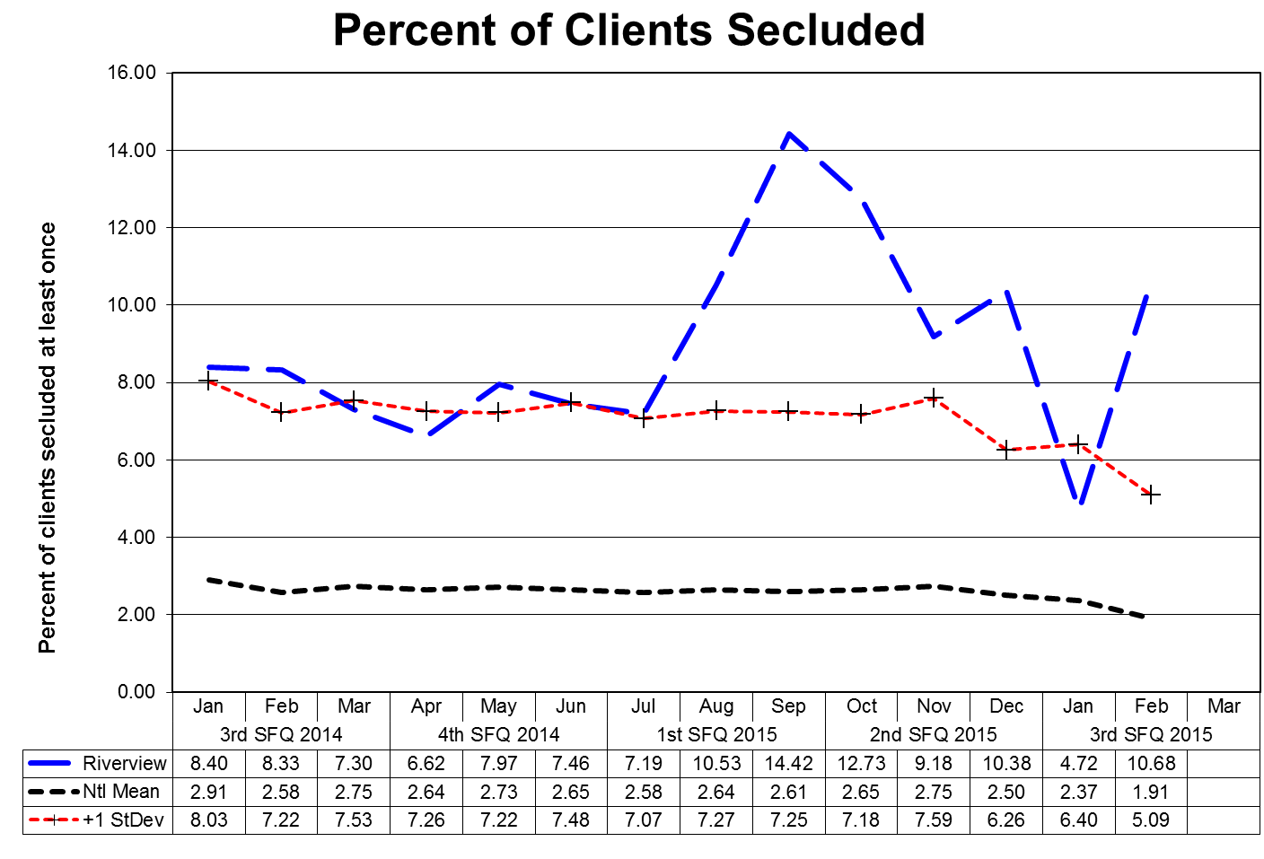
This graph depicts the percent of unique clients who were secluded at least once. For example, rates of 3.0 means that 3% of the unique clients served were secluded at least once.
The following graphs depict the percent of unique clients who were secluded at least once stratified by forensic or civil classifications. For example; rates of 3.0 means that 3% of the unique clients served were secluded at least once.
The hospital-wide results from the Dorothea Dix facility are compared to the civil population results at the Riverview facility due to the homogeneous nature of these two sample groups.
(Glossary of Terms, Acronyms & Abbreviations) (Back to Table of Contents)
CONSENT DECREE

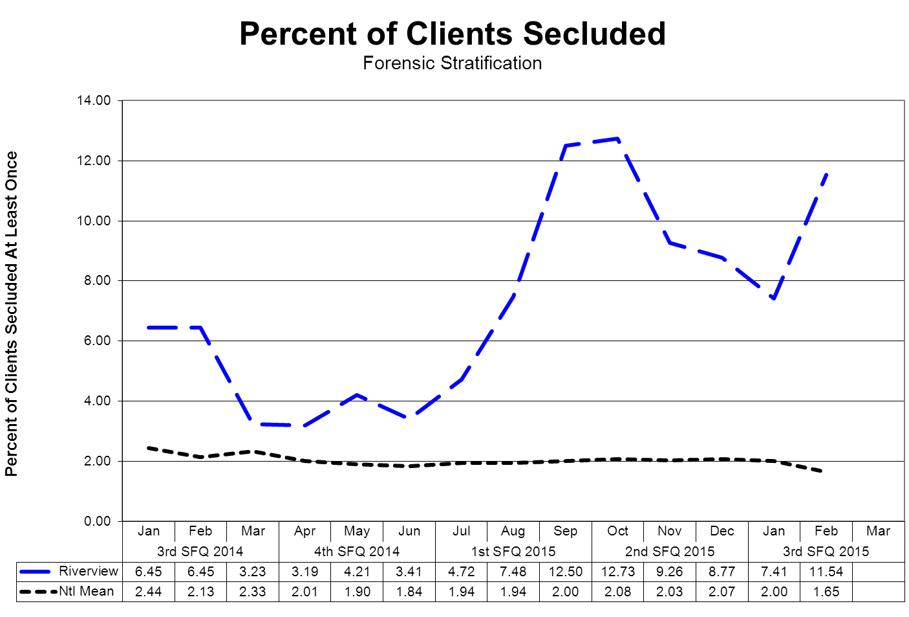
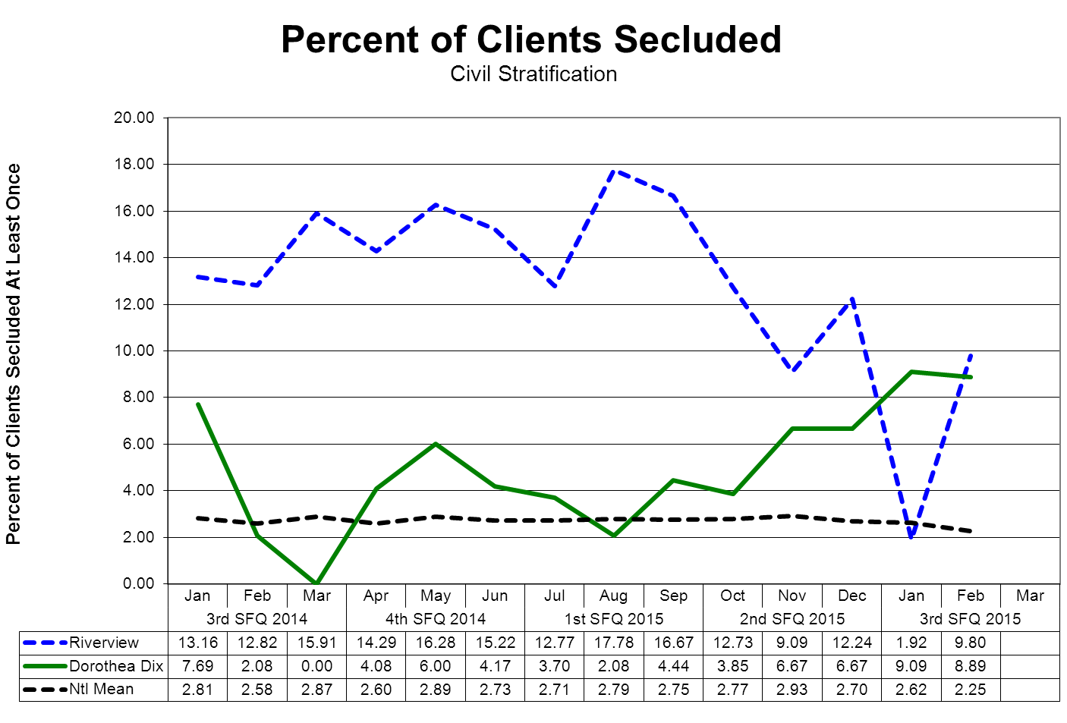

(Glossary of Terms, Acronyms & Abbreviations) (Back to Table of Contents)
CONSENT DECREE

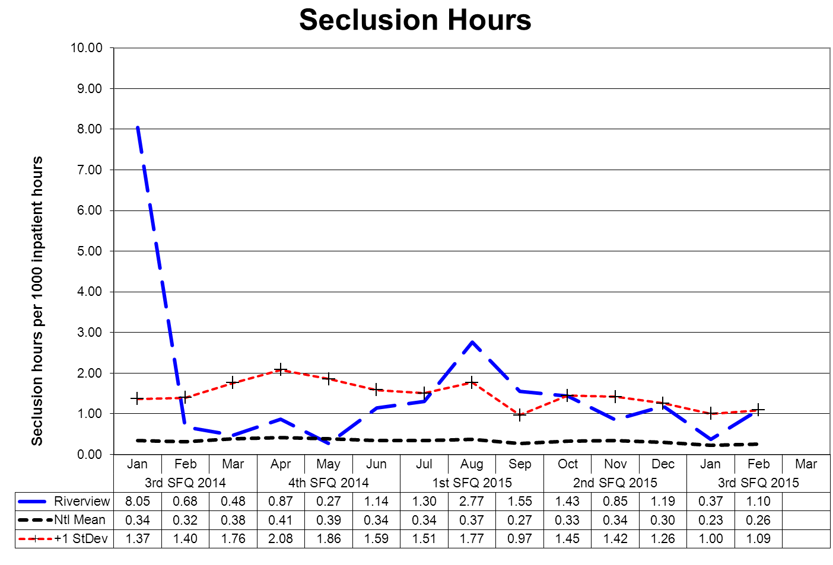

This graph depicts the number of hours clients spent in seclusion for every 1000 inpatient hours. For example, a rate of 0.8 means that 1 hour was spent in seclusion for each 1250 inpatient hours.

The outlier values shown in May and June reflect the events related to a single individual during this period. This individual was in seclusion for extended periods of time due to extremely aggressive behaviors that are focused on staff. It was determined that the only way to effectively manage this client and create a safe environment for both the staff and other clients was to segregate him in an area away from other clients and to provide frequent support and interaction with staff in a manner that ensured the safety of the staff so engaged.
The following graphs depict the number of hours clients spent in seclusion for every 1000 inpatient hours stratified by forensic or civil classifications. For example, a rate of 0.8 means that 1 hour was spent in seclusion for each 1250 inpatient hours.
The hospital-wide results from the Dorothea Dix facility are compared to the civil population results at the Riverview facility due to the homogeneous nature of these two sample groups.
(Glossary of Terms, Acronyms & Abbreviations) (Back to Table of Contents)
CONSENT DECREE
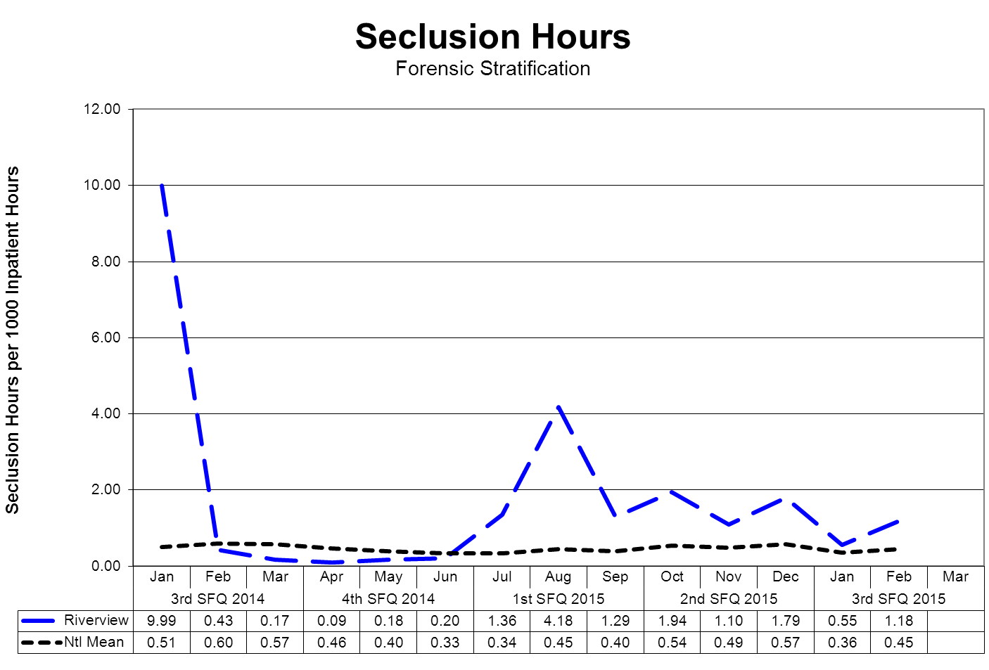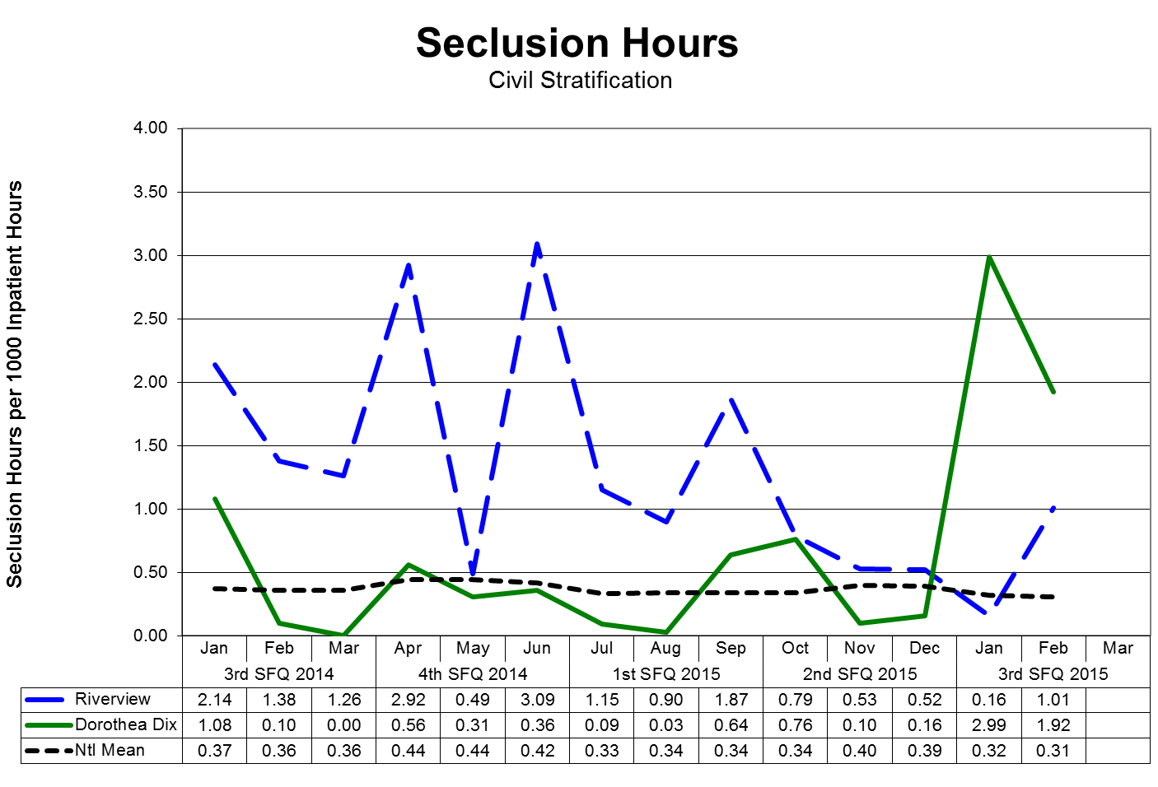
(Glossary of Terms, Acronyms & Abbreviations) (Back to Table of Contents)
CONSENT DECREE

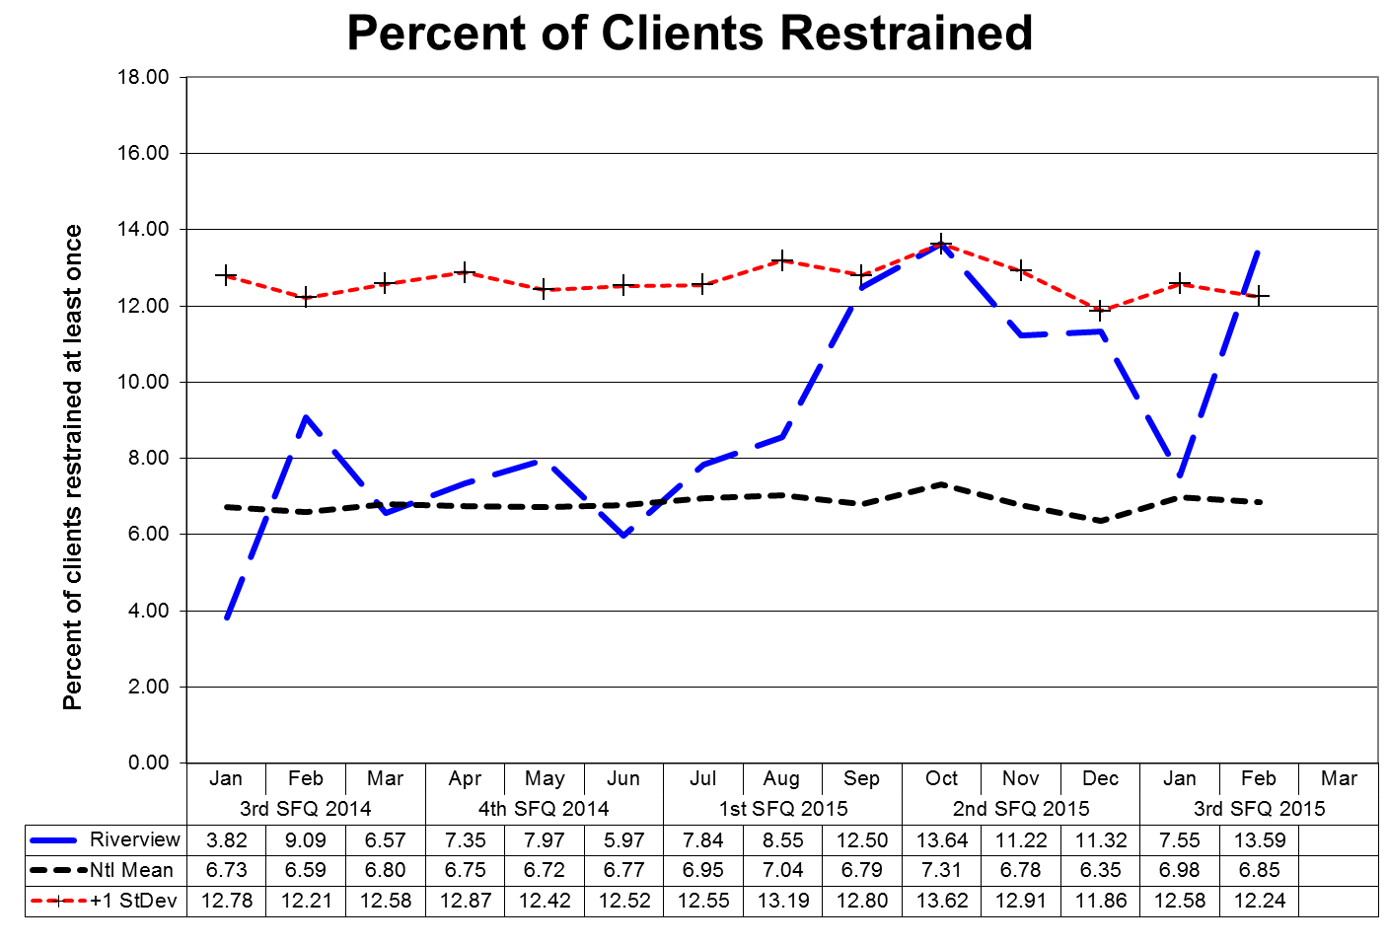
This graph depicts the percent of unique clients who were restrained at least once – includes all forms of restraint of any duration. For example; a rate of 4.0 means that 4% of the unique clients served were restrained at least once.
The following graphs depict the percent of unique clients who were restrained at least once stratified by forensic or civil classifications – includes all forms of restraint of any duration. For example; a rate of 4.0 means that 4% of the unique clients served were restrained at least once.
The hospital-wide results from the Dorothea Dix facility are compared to the civil population results at the Riverview facility due to the homogeneous nature of these two sample groups.

(Glossary of Terms, Acronyms & Abbreviations) (Back to Table of Contents)
CONSENT DECREE
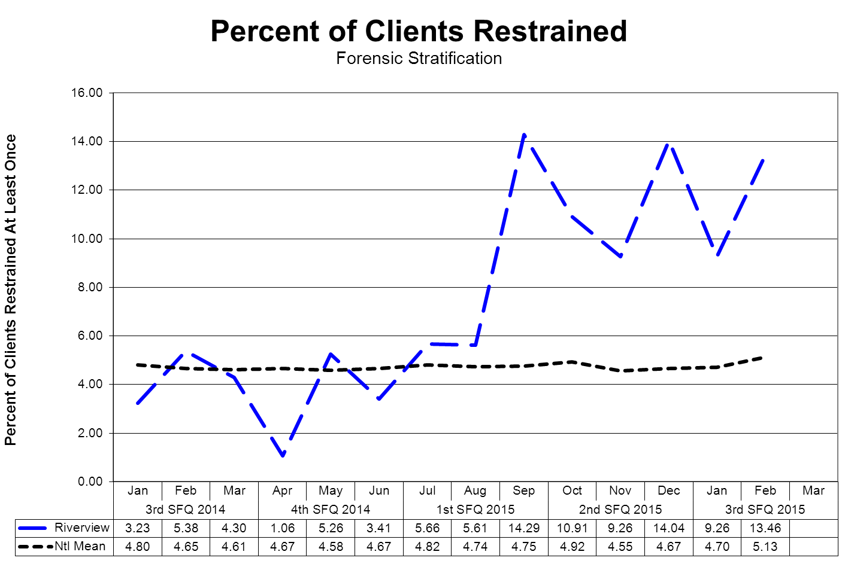
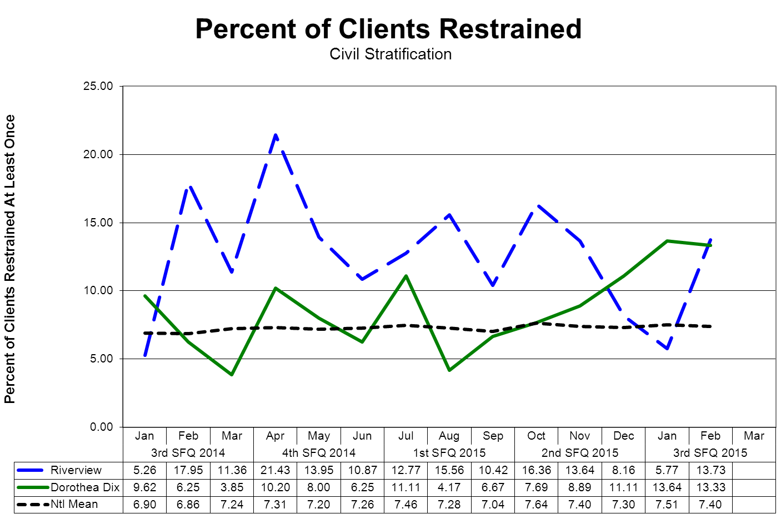
(Glossary of Terms, Acronyms & Abbreviations) (Back to Table of Contents)
CONSENT DECREE

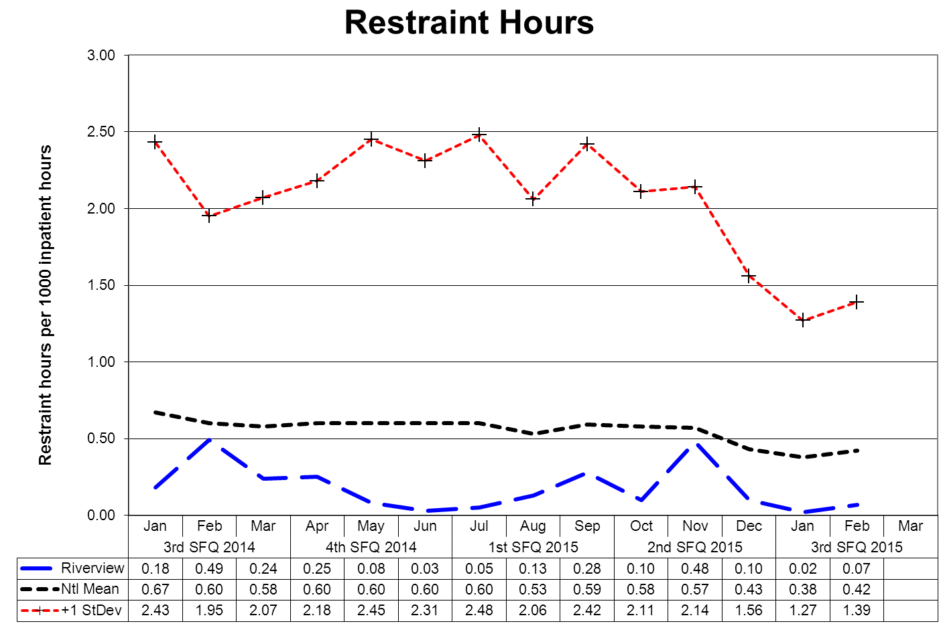

This graph depicts the number of hours clients spent in restraint for every 1000 inpatient hours - includes all forms of restraint of any duration. For example; a rate of 1.6 means those 2 hours were spent in restraint for each 1250 inpatient hours.
The following graphs depict the number of hours clients spent in restraint for every 1000 inpatient hours stratified by forensic or civil classifications - includes all forms of restraint of any duration. For example; a rate of 1.6 means those 2 hours were spent in restraint for each 1250 inpatient hours.
The hospital-wide results from the Dorothea Dix facility are compared to the civil population results at the Riverview facility due to the homogeneous nature of these two sample groups.
(Glossary of Terms, Acronyms & Abbreviations) (Back to Table of Contents)
CONSENT DECREE
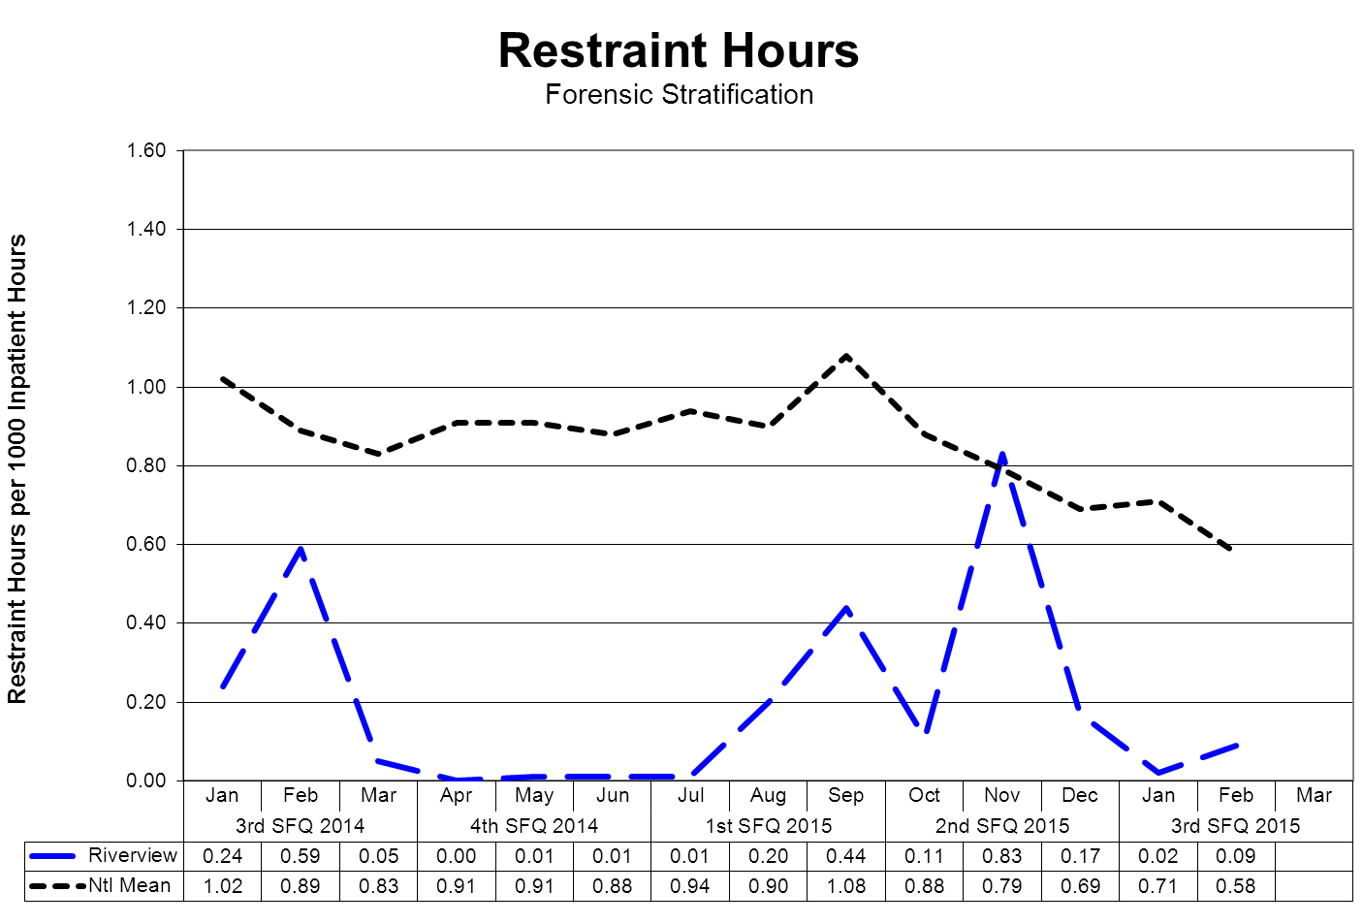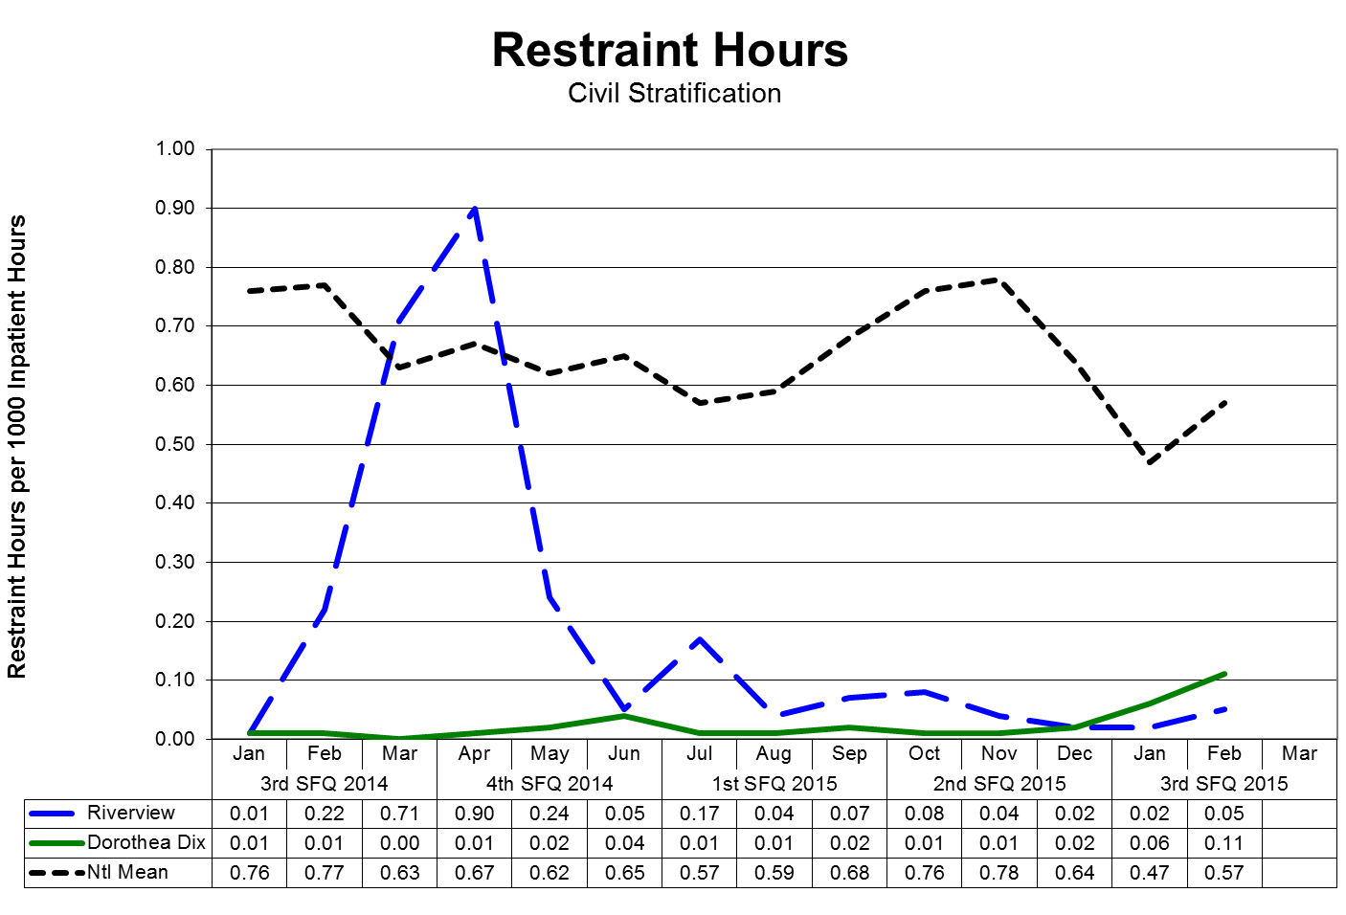
(Glossary of Terms, Acronyms & Abbreviations) (Back to Table of Contents)
CONSENT DECREE

Confinement Event Detail
3rd Quarter 2015

 | Manual Hold | Mechanical  Restraint | Locked  Seclusion | Grand Total | % of Total | Cumulative %
MR5634 | 12 |  | 12 | 24 | 19.35% | 19.35%
MR6714 | 12 |  | 9 | 21 | 16.94% | 36.29%
MR7118 | 4 |  | 6 | 10 | 8.06% | 44.35%
MR3374 | 2 |  | 7 | 9 | 7.26% | 51.61%
MR7704 | 5 |  | 3 | 8 | 6.45% | 58.06%
MR6799 | 2 |  | 4 | 6 | 4.84% | 62.90%
MR997 | 3 |  | 2 | 5 | 4.03% | 66.93%
MR91 | 2 |  | 2 | 4 | 3.23% | 70.16%
MR6707 | 2 |  | 2 | 4 | 3.23% | 73.38%
MR5199 | 2 |  | 2 | 4 | 3.23% | 76.61%
MR5297 | 2 |  | 1 | 3 | 2.42% | 79.03%
MR7431 | 1 |  | 2 | 3 | 2.42% | 81.45%
MR5267 | 1 |  | 2 | 3 | 2.42% | 83.87%
MR4506 | 1 |  | 2 | 3 | 2.42% | 86.29%
MR4647 | 1 |  | 2 | 3 | 2.42% | 88.70%
MR7665 | 1 |  | 2 | 3 | 2.42% | 91.12%
MR3377 | 1 |  | 1 | 2 | 1.61% | 92.74%
MR7032 | 1 |  | 1 | 2 | 1.61% | 94.35%
MR7705 | 1 |  |  | 1 | 0.81% | 95.16%
MR1831 | 1 |  |  | 1 | 0.81% | 95.96%
MR7409 | 1 |  |  | 1 | 0.81% | 96.77%
MR7681 | 1 |  |  | 1 | 0.81% | 97.58%
MR7654 | 1 |  |  | 1 | 0.81% | 98.38%
MR175 | 1 |  |  | 1 | 0.81% | 99.19%
MR29 |  | 1 |  | 1 | 0.81% | 100.00%
 | 61 | 1 | 62 | 124

30% (25/84) of average hospital population experienced some form of confinement event during the 3rd fiscal quarter 2015. Five of these clients (6% of the average hospital population) accounted for 58% of the containment events.
(Glossary of Terms, Acronyms & Abbreviations) (Back to Table of Contents)
CONSENT DECREE

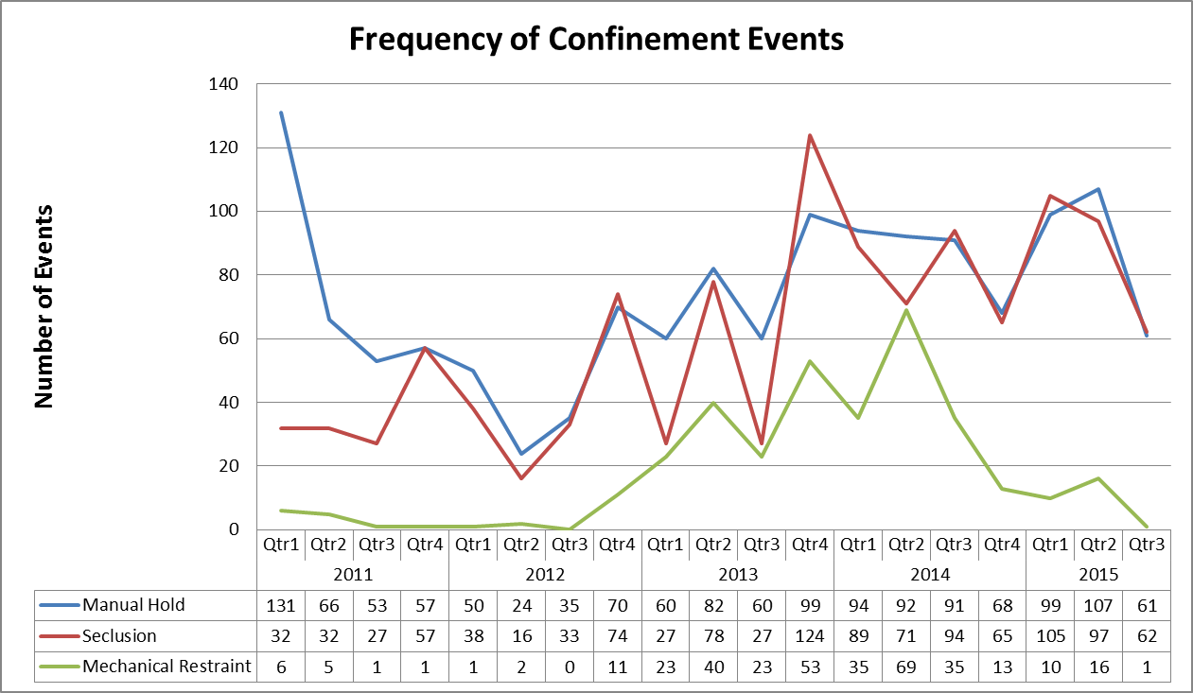
(Glossary of Terms, Acronyms & Abbreviations) (Back to Table of Contents)
CONSENT DECREE

V28) Riverview demonstrates that, based on a review of two quarters of data, for 95% of seclusion events, seclusion was employed only when absolutely necessary to protect the patient from causing physical harm to self or others or for the management of violent behavior;

Factors of Causation Related to Seclusion Events
 | 4Q14 | 1Q15 | 2Q15 | 3Q15 | Total
Danger to Others/Self | 63 | 17 | 8 | 7 | 95
Danger to Others | 3 | 88 | 89 | 55 | 235
Danger to Self |  |  |  |  | 0
% Dangerous Precipitation | 100% | 100% | 100% | 100% | 100%
Total Events | 66 | 105 | 97 | 62 | 330

V29) Riverview demonstrates that, based on a review of two quarters of data, for 95% of restraint events involving mechanical restraints, the restraint was used only when absolutely necessary to protect the patient from serious physical injury to self or others;

Factors of Causation Related to Mechanical Restraint Events
 | 4Q14 | 1Q15 | 2Q15 | 3Q15 | Total
Danger to Others/Self | 12 | 4 | 6 |  | 22
Danger to Others |  | 4 | 9 | 1 | 14
Danger to Self | 1 | 2 | 1 |  | 4
% Dangerous Precipitation | 100% | 100% | 100% | 100% | 100%
Total Events | 13 | 10 | 16 | 1 | 40

V30) Riverview demonstrates that, based on a review of two quarters of data, for 95% of seclusion and restraint events, the hospital achieved an acceptable rating for meeting the requirements of paragraphs 182 and 184 of the Settlement Agreement, in accordance with a methodology defined in Attachments E-1 and E-2.

See Pages 30 & 31

(Glossary of Terms, Acronyms & Abbreviations) (Back to Table of Contents)
CONSENT DECREE

Confinement Events Management
Seclusion Events (62) Events
  Standard | Threshold | Compliance
  The record reflects that seclusion was absolutely necessary to protect the patient from causing physical harm to self or others, or if the patient was examined by a physician or physician extender prior to implementation of seclusion, to prevent further serious disruption that significantly interferes with other patients’ treatment. | 95% | 100%
  The record reflects that lesser restrictive alternatives were inappropriate or ineffective. This can be reflected anywhere in record. | 90% | 100%
  The record reflects that the decision to place the patient in seclusion was made by a physician or physician extender. | 90% | 100%
  The decision to place the patient in seclusion was entered in the patient’s records as a medical order. | 90% | 100%
  The record reflects that, if the physician or physician extender was not immediately available to examine the patient, the patient was placed in seclusion following an examination by a nurse. | 90% | 100%
  The record reflects that the physician or physician extender personally evaluated the patient within 30 minutes after the patient has been placed in seclusion, and if there is a delay, the reasons for the delay. | 90% | 100%
  The record reflects that the patient was monitored every 15 minutes. (Compliance will be deemed if the patient was monitored at least 3 times per hour.) | 90% | 100%
  Individuals implementing seclusion have been trained in techniques and alternatives. | 90% | 100%
  The record reflects that reasonable efforts were taken to notify guardian or designated representative as soon as possible that patient was placed in seclusion. | 75% | 100%
  Standard | Threshold | Compliance
  The medical order states time of entry of order and that number of hours in seclusion shall not exceed 4. | 85% | 100%
  The medical order states the conditions under which the patient may be sooner released. | 85% | 100%
  The record reflects that the need for seclusion is re-evaluated at least every 2 hours by a nurse. | 90% | 100%
  The record reflects that the 2 hour re-evaluation was conducted while the patient was out of seclusion room unless clinically contraindicated. | 70% | 100%
  The record includes a special check sheet that has been filled out to document reason for seclusion, description of behavior and the lesser restrictive alternatives considered. | 85% | 100%
  The record reflects that the patient was released, unless clinically contraindicated, at least every 2 hours or as necessary for eating, drinking, bathing, toileting or special medical orders. | 85% | 100%
  Reports of seclusion events were forwarded to medical director and advocate. | 90% | 100%
  The record reflects that, for persons with mental retardation, the regulations governing seclusion of clients with mental retardation were met. | 85% | 100%
  The medical order for seclusion was not entered as a PRN order. | 90% | 100%
  Where there was a PRN order, there is evidence that physician was counseled. | 95% | N/A
(Glossary of Terms, Acronyms & Abbreviations) (Back to Table of Contents)
CONSENT DECREE

Confinement Events Management
Mechanical Restraint Events (1) Events
  Standard | Threshold | Compliance
  The record reflects that restraint was absolutely necessary to protect the patient from causing serious physical injury to self or others. | 95% | 100%
  The record reflects that lesser restrictive alternatives were inappropriate or ineffective. | 90% | 100%
  The record reflects that the decision to place the patient in restraint was made by a physician or physician extender | 90% | 100%
  The decision to place the patient in restraint was entered in the patient’s records as a medical order. | 90% | 100%
  The record reflects that, if a physician or physician extended was not immediately available to examine the patient, the patient was placed in restraint following an examination by a nurse. | 90% | 100%
  The record reflects that the physician or physician extender personally evaluated the patient within 30 minutes after the patient has been placed in restraint, or, if there was a delay, the reasons for the delay. | 90% | 100%
  The record reflects that the patient was kept under constant observation during restraint. | 95% | 100%
  Individuals implementing restraint have been trained in techniques and alternatives. | 90% | 100%
  The record reflects that reasonable efforts taken to notify guardian or designated representative as soon as possible that patient was placed in restraint. | 75% | 100%
  The medical order states time of entry of order and that number of hours shall not exceed four. | 90% | 100%
  The medical order shall state the conditions under which the patient may be sooner released. | 85% | 100%
  Standard | Threshold | Compliance
  The record reflects that the need for restraint was re-evaluated every 2 hours by a nurse. | 90% | 100%
  The record reflects that re-evaluation was conducted while the patient was free of restraints unless clinically contraindicated. | 70% | 100%
  The record includes a special check sheet that has been filled out to document the reason for the restraint, description of behavior and the lesser restrictive alternatives considered. | 85% | 100%
  The record reflects that the patient was released as necessary for eating, drinking, bathing, toileting or special medical orders. | 90% | 100%
  The record reflects that the patient’s extremities were released sequentially, with one released at least every fifteen minutes. | 90% | 100%
  Copies of events were forwarded to medical director and advocate. | 90% | 100%
  For persons with mental retardation, the applicable regulations were met. | 85% | 100%
  The record reflects that the order was not entered as a PRN order. | 90% | 100%
  Where there was a PRN order, there is evidence that physician was counseled. | 95% | N/A
  A restraint event that exceeds 24 hours will be reviewed against the following requirement: If total consecutive hours in restraint, with renewals, exceeded 24 hours, the record reflects that the patient was medically assessed and treated for any injuries; that the order extending restraint beyond 24 hours was entered by Medical Director (or if the Medical Director is out of the hospital, by the individual acting in the Medical Director’s stead) following examination of the patient; and that the patient’s guardian or representative has been notified. | 90% | 100%

(Glossary of Terms, Acronyms & Abbreviations) (Back to Table of Contents)
CONSENT DECREE

Client Elopements

V31) Quarterly performance data shows that, in 5 out of 6 quarters, the number of client elopements does not exceed one standard deviation from the national mean as reported by NASMHPD.

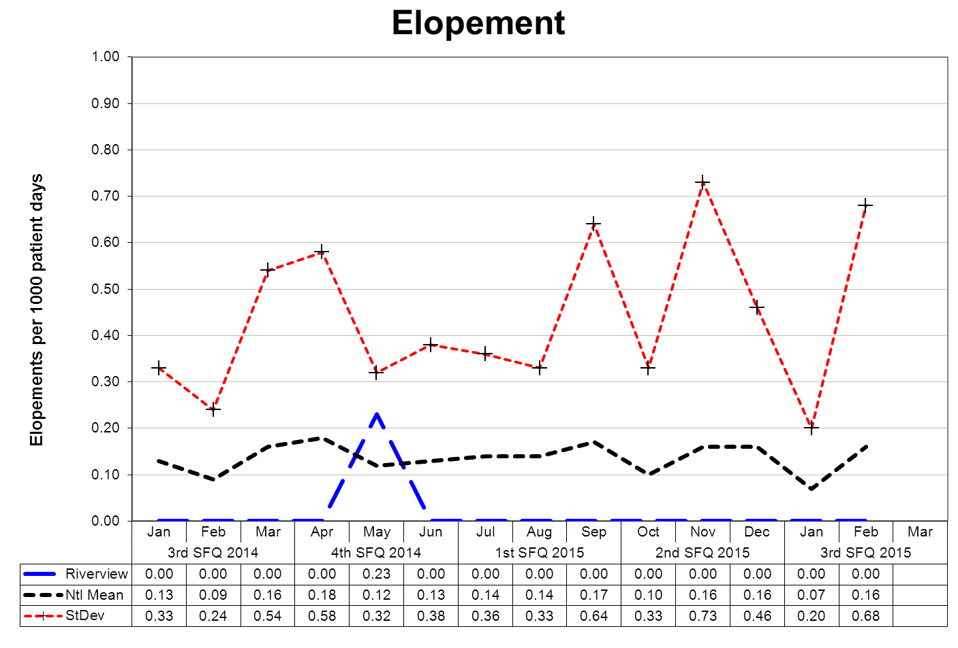
This graph depicts the number of elopements that occurred for every 1000 inpatient days. For example, a rate of 0.25 means that 1 elopement occurred for each 4000 inpatient days.
An elopement is defined as any time a client is “absent from a location defined by the client’s privilege status regardless of the client’s leave or legal status.”
The following graphs depict the number of elopements stratified by forensic or civil classifications that occurred for every 1000 inpatient days. For example, a rate of 0.25 means that 1 elopement occurred for each 4000 inpatient days. The hospital-wide results from the Dorothea Dix facility are compared to the civil population results at the Riverview facility due to the homogeneous nature of these two sample groups.
(Glossary of Terms, Acronyms & Abbreviations) (Back to Table of Contents)
CONSENT DECREE
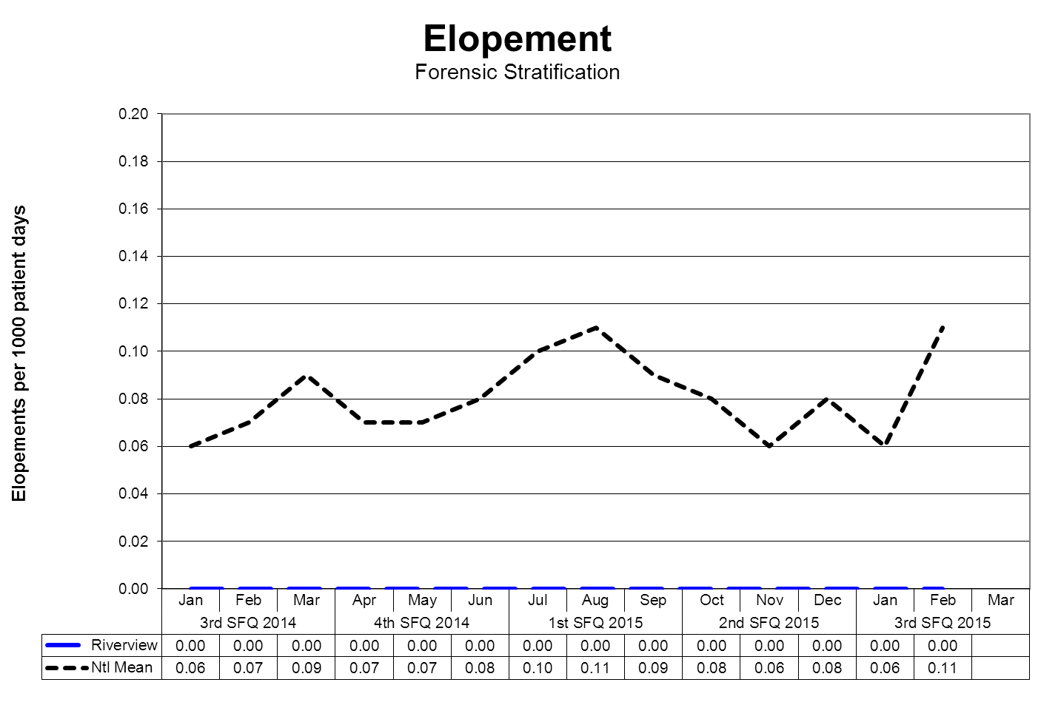

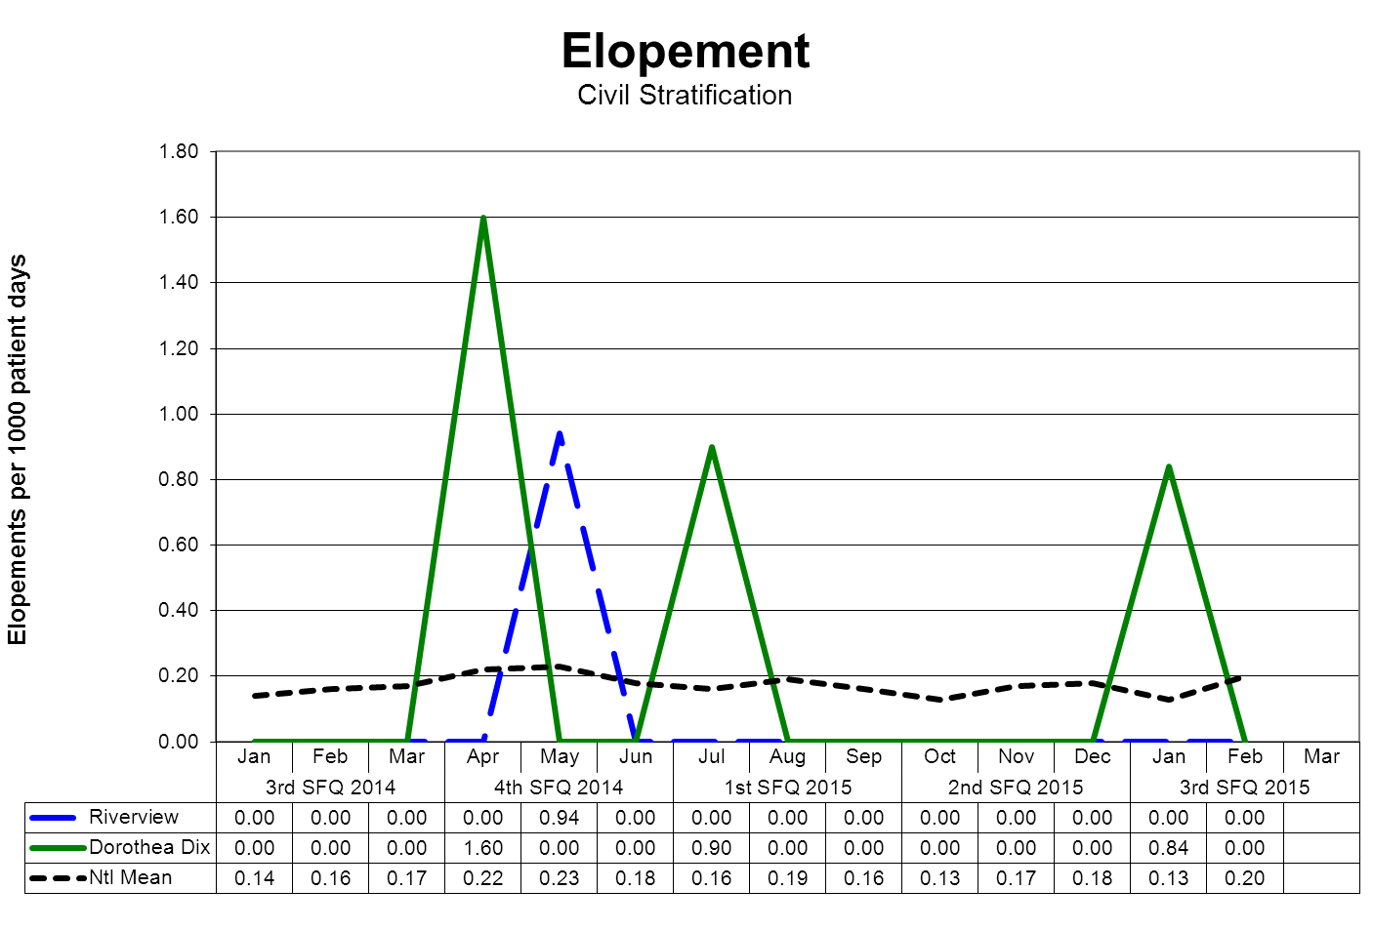
(Glossary of Terms, Acronyms & Abbreviations) (Back to Table of Contents)
CONSENT DECREE

Client Injuries

V32) Quarterly performance data shows that, in 5 out of 6 quarters, the number of client injuries does not exceed one standard deviation from the national mean as reported by NASMHPD.
The NASMHPD standards for measuring client injuries differentiate between injuries that are considered reportable to the Joint Commission as a performance measure and those injuries that are of a less severe nature. While all injuries are currently reported internally, only certain types of injuries are documented and reported to NRI for inclusion in the performance measure analysis process.
“Non-reportable” injuries include those that require: 1) No Treatment, or 2) Minor First Aid
Reportable injuries include those that require: 3) Medical Intervention, 4) Hospitalization or where, 5) Death Occurred.
- No Treatment – The injury received by a client may be examined by a clinician but no treatment is applied to the injury.
- Minor First Aid – The injury received is of minor severity and requires the administration of minor first aid.
- Medical Intervention Needed – The injury received is severe enough to require the treatment of the client by a licensed practitioner, but does not require hospitalization.
- Hospitalization Required – The injury is so severe that it requires medical intervention and treatment as well as care of the injured client at a general acute care medical ward within the facility or at a general acute care hospital outside the facility.
- Death Occurred – The injury received was so severe that if resulted in, or complications of the injury lead to, the termination of the life of the injured client.
The comparative statistics graph only includes those events that are considered “Reportable” by NASMHPD.

(Glossary of Terms, Acronyms & Abbreviations) (Back to Table of Contents)
CONSENT DECREE

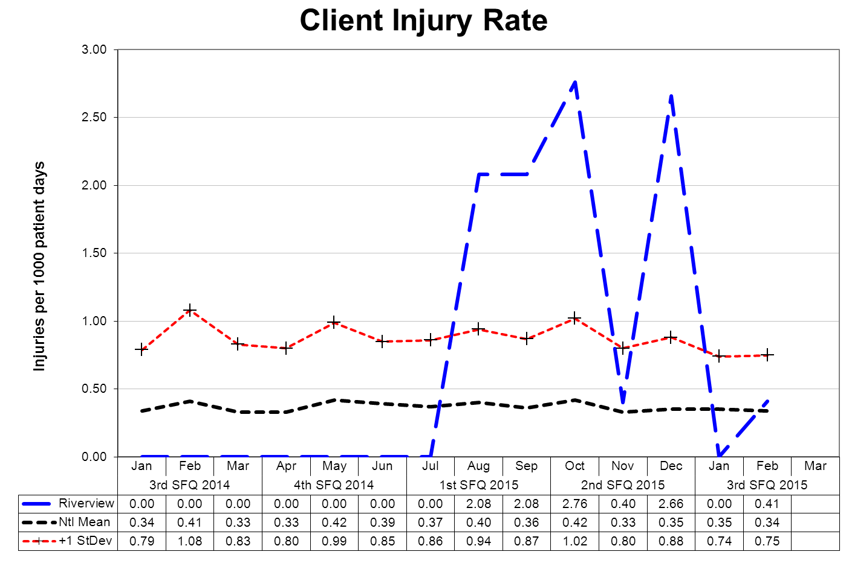
This graph depicts the number of client injury events that occurred for every 1000 inpatient days. For example, a rate of 0.5 means that 1 injury occurred for each 2000 inpatient days.
The following graphs depict the number of client injury events stratified by forensic or civil classifications that occurred for every 1000 inpatient days. For example, a rate of 0.5 means that 1 injury occurred for each 2000 inpatient days.
The hospital-wide results from the Dorothea Dix facility are compared to the civil population results at the Riverview facility due to the homogeneous nature of these two sample groups.
(Glossary of Terms, Acronyms & Abbreviations) (Back to Table of Contents)
CONSENT DECREE

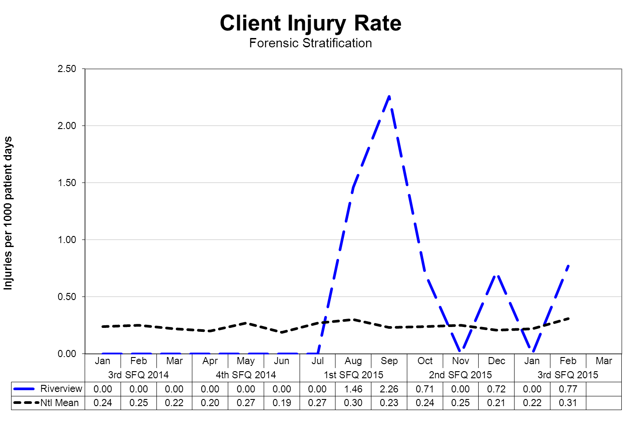
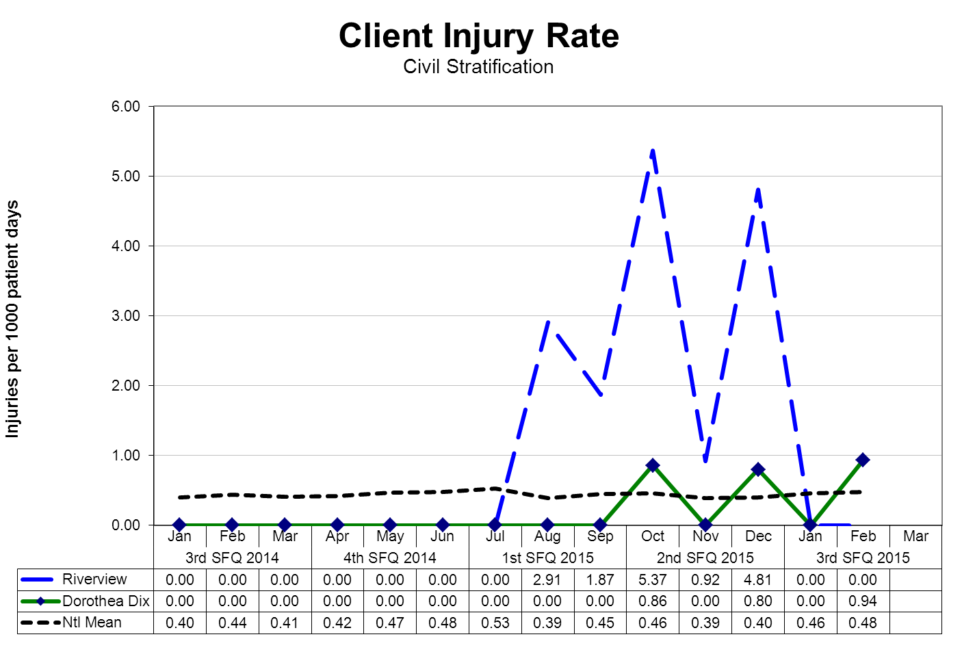
(Glossary of Terms, Acronyms & Abbreviations) (Back to Table of Contents)
CONSENT DECREE

Severity of Injury by Month

Severity | JAN | FEB | MAR | 3Q2015
No Treatment | 1 | 6 | 1 | 8
Minor First Aid | 4 | 5 | 5 | 14
Medical Intervention Required |  | 3 | 1 | 4
Hospitalization Required |  |  |  | 0
Death Occurred |  |  |  | 0
Total | 5 | 14 | 7 | 26

Type and Cause of Injury by Month

Type - Cause | JAN | FEB | MAR | 3Q2015
Accident – Equipment Use | 1 |  | 1 | 2
Accident – Environmental |  | 1 |  | 1
Accident – Fall | 1 | 3 | 2 | 6
Accident – Other | 2 | 1 | 3 | 6
Assault – Patient to Patient | 1 | 1 | 1 | 3
Self-Injurious Behavior |  | 8 |  | 8
Total | 5 | 14 | 7 | 26

Note: Previous quarterly report numbers may have been higher as they included data on incidents as well as injuries. This report has been modified to only include injuries. Per NASMHPD, injuries occur when harm or damage is done.
Changes in reporting standards related to “criminal” events as defined by the “State of Maine Rules for Reporting Sentinel Events”, effective February 1, 2013 as defined the by “National Quality Forum 2011 List of Serious Reportable Events” the number of reportable “assaults” that occur as the result of client interactions increased significantly. This change is due primarily as a result of the methods and rules related to data collection and abstraction.
Further information on Fall Reduction Strategies can be found under the Joint Commission Priority Focus Areas section of this report.
(Glossary of Terms, Acronyms & Abbreviations) (Back to Table of Contents)
CONSENT DECREE

Patient Abuse, Neglect, Exploitation, Injury or Death

V33) Riverview certifies that it is reporting and responding to instances of patient abuse, neglect, exploitation, injury or death consistent with the requirements of ¶¶ 192-201 of the Settlement Agreement.

Type of Allegation | 4Q2014 | 1Q2015 | 2Q2015 | 3Q2015
Abuse Physical | 7 | 8 | 10 | 14
Abuse Sexual | 14 | 5 | 17 | 11
Abuse Verbal | 2 | 4 | 4 | 3
Coercion/Exploitation |  | 3 | 7
Neglect |  | 1 | 1 | 1
Total | 23 | 21 | 39 | 29

Note: Previous data has been adjusted as we removed allegations of patient abuse, neglect, and exploitation that did not occur within the hospital and/or were not against hospital staff or patients
Riverview utilizes several vehicles to communicate concerns or allegations related to abuse, neglect or exploitation.
- Staff members complete an incident report upon becoming aware of an incident or an allegation of any form of abuse, neglect, or exploitation.
- Clients have the option to complete a grievance or communicate allegations of abuse, neglect, or exploitation during any interaction with staff at all levels, peer support personnel, or the client advocates.
- Any allegation of abuse, neglect, or exploitation is reported both internally and externally to appropriate stakeholders, include:
- Superintendent and/or AOC
- Adult Protective Services
- Guardian
- Client Advocate
- Allegations are reported to the Risk Manager through the incident reporting system and fact-finding or investigations occur at multiple levels. The purpose of this investigation is to evaluate the event to determine if the allegations can be substantiated or not and to refer the incident to the client’s treatment team, hospital administration, or outside entities.
- When appropriate to the allegation and circumstances, investigations involving law enforcement, family members, or human resources may be conducted.
- The Human Rights Committee, a group consisting of consumers, family members, providers, and interested community members, and the Medical Executive Committee receive a report on the incidence of alleged abuse, neglect, and exploitation monthly.

(Glossary of Terms, Acronyms & Abbreviations) (Back to Table of Contents)
CONSENT DECREE

Performance Improvement and Quality Assurance

V34) Riverview maintains Joint Commission accreditation;

Riverview successfully completed an accreditation survey with The Joint Commission on November 11-13, 2013. The Joint Commission conducted an unannounced visit on July 28-29, 2014. The hospital maintains its accreditation with the Joint Commission. The hospital will conduct a required annual self-assessment in October 2014. A triennial accreditation survey is expected to occur in November 2016 or earlier.

The hospital currently has 1 Measure of Success that is being monitored for the Joint Commission.

V35) Riverview maintains its hospital license;

Riverview maintains licensing status as required through the Maine Department of Health and Human Services Division of Licensing and Regulatory Services. In March, the hospital’s full license was restored after having a conditional license for 18 months.

V36) The hospital seeks CMS certification;

The hospital was terminated from the Medicare Provider Agreement on September 2, 2013 for failing to show evidence of substantial compliance in eight areas by August 27, 2013. The hospital reapplied for certification in December 2013 and a 3 day site visit was conducted in May 2014. CMS found the hospital out of substantial compliance in one area and the hospital was denied certification. In meeting with the Division of Licensing and Regulatory Services in 2015, the hospital was informed that CMS would not approve certification with the current level of forensic patients who did not require hospital level of care. Plans are being developed to resolve this issue before an application for certification

V37) Riverview conducts quarterly monitoring of performance indicators in key areas of hospital administration, in accordance with the Consent Decree Plan, the accreditation standards of the Joint Commission, and according to a QAPI plan reviewed and approved by the Advisory Board each biennium, and demonstrates through quarterly reports that management uses that data to improve institutional performance, prioritize resources and evaluate strategic operations.

Riverview complies with this element of substantial compliance as evidenced by the current Integrated Plan for Performance Excellence, the data and reports presented in this document, the work of the Integrated Performance Excellence Committee and sub-groups of this committee that are engaged in a transition to an improvement orientated methodology that is support by the Joint Commission and is consistent with modern principles of process management and strategic methods of promoting organizational performance excellence. The Advisory Board approved the Integrated Plan for Performance Excellence in August 2014 including Maine Division of Licensing and Regulatory Services required language that the hospital will comply with all federal and state hospital Conditions of Participation.

(Glossary of Terms, Acronyms & Abbreviations) (Back to Table of Contents)
CONSENT DECREE

Quality Improvement Measures from “Response to the Recommendations from the Report by Elizabeth Jones, Consultant”

Approved by the Maine Superior Court on February 27, 2015

Leadership met on Friday, March 6th to review the corrective action steps outlined in the hospital’s response.

Recommendation | Quality Improvement Measure | Actions Taken During the Quarter
Prior to his/her treatment team meeting, the class members should be provided the opportunity to meet with a peer specialist in order to prepare for the discussion and to clearly outline any preferences for treatment or discharge planning. Recovery-oriented approaches to treatment, including employment, should be consistently explored with and offered to class member, despite disinterest or refusal at the time of admission. | Treatment Team Coordinators will document all patient engagement in preparation for Treatment Team meetings. The daily chart audit form used by Treatment Team Coordinators/Auditors will be updated by Medical Records to reflect which patients received pre-treatment team meeting engagement. | Treatment Team Coordinators developed & use an audit tool on each record as it is reviewed / revised the day of the team meeting.  TTCs handout to the patient, the ‘Your Input is Essential” form 2-3 days prior to the meeting and offer to assist the patient to complete the form (if needed) prior to the meeting. The form is attached to the treatment plan. If patient refuses to complete the from, this is noted on the form and signed by the staff
Riverview's leadership should take immediate steps to ensure that the principles of the Recovery model are clearly defined, articulated and supported throughout each of the four units. | 100% of patient records will include documentation of the patient's input into their individualized treatment plan and that the input was used during the Treatment Team meeting. | All patients are encouraged to complete the “Your Input is Essential” form which is completed prior to the Treatment Plan Meeting.  Input from the plan is included in the treatment planning process.
Riverview's clinical leadership should work with nursing and Mental Health Worker staff to design and implement case conferences or Grand Rounds so that there is greater knowledge, skills and support in working with class members with challenging behaviors. | The list of case conferences and Grand Rounds will be maintained. The roster of staff participation will be maintained by the Staff and Organizational Development Office. These data will be reported in the Quarterly Report. | Nursing leadership will identify nurses and mental health workers to attend Grand Rounds. A panel of nursing leadership who will cover the floor so front line staff can attend. Attendance sheets will be used for all Clinical Grand Rounds including name, signature and discipline.
Efforts should be initiated to intensify the opportunities offered to class members on the Forensic Units in order to increase their social skills and their knowledge and performance | Patient Individualized Treatment Plans will contain documentation of participation in all treatment activities. Treatment Team Coordinators will conduct daily chart audits to ensure | All disciplines involved in the patient’s care are included in the treatment team meetings. Plans for treatment are individualized to each patient. The Treatment Team
(Glossary of Terms, Acronyms & Abbreviations) (Back to Table of Contents)
CONSENT DECREE

Recommendation | Quality Improvement Measure | Actions Taken During the Quarter
competencies about subjects of interest to them. | documentation. | Coordinators conduct chart audits to ensure that all documentation is current and accurate.
Riverview should be managed as a single Hospital and the exclusion of Lower Saco from the federal Medicaid program should be reconsidered as an urgent priority. | Completed in November 2014. | Completed in November 2014.
In order to ensure that any limitations are not in violation of the Consent Decree, restrictive practices, including access to outdoor areas, should be reviewed with involvement by class members and mental health workers. | Unit activity logs will be reviewed on a monthly basis to determine whether any limitations in a patient’s access to treatment or services occurred. Unit community meetings will include a standing agenda item to review whether any restrictive practices were in place. | Administration reviews all grievances from patient, staff and advocate relative to any violations of the Consent Decree. Currently the RPRC management is negotiating with the employee unions around the creation of unit based staffing and core staff assignments. Following these negotiations we will be focusing on the systematic review of unit practices that may restrict or inhibit access to outdoor areas and the roles of employees to relieve these restrictions.
The use of seclusion and restraint requires continued independent review to ensure that there are adequate alternatives designed and implemented for any class member potentially subject to such restrictive measures. Specifically, class members with a history of unacceptable behavior, such as aggression towards peers and/or staff, need to be reviewed again by the treatment team, and, if necessary, by an independent clinical consultant, to determine whether sufficiently individualized interventions are being designed and consistently implemented to replace unacceptable behavior with appropriate alternative behaviors. | The Risk Manager reviews 100% of cases of seclusion and restraint events including the content and timeliness of events. The hospital sends weekly reports of seclusion and restraint events to the Court Master. The Staff and Organizational Development Office will conduct its first annual review of the MOAB program and present results to Executive Leadership in January 2015. | The Risk Manager continues to review 100% of cases of seclusion and restraint events including the content and timeliness of events.  A weekly report of seclusion and restraint events is sent to the Court Master weekly.  The Staff and Organizational Development Office has identified a consultant to conduct a review of the MOAB program and upon completion will present results to Executive Leadership.

(Glossary of Terms, Acronyms & Abbreviations) (Back to Table of Contents)
CONSENT DECREE

Recommendation | Quality Improvement Measure | Actions Taken During the Quarter
The reporting requirements by Paragraphs 188 and 189 of the Consent Decree should be completed as mandated. | On an annual basis (starting in January 2015), the Staff and Organizational Development Office will present a report to Executive Leadership at the hospital on the Behavioral Management system being used. The report will include (but is not limited to) information on:  - Documentation on certification and external reviews of behavioral management system  - Number of staff trained  - Number of staff retrained  - Results of inter-rater reliability tests for trainers  - Number of staff injuries  - Number of patient injuries  - Number of incident reports showing that staff varied from techniques  - Review of fact-findings or investigations where behavioral management system failed to achieve goals  - Findings from external reviews of the MOAB program  The Risk Manager reviews 100% of all incident reports for seclusion and restraint daily to determine whether further actions are required. A summary report of 100% of all seclusion and restraint events are sent to the Court Master weekly. | Riverview has identified a consultant with expertise in MOAB. The scope of work, deliverables and delivery date are being negotiated.  The Staff and Organizational Development Office is working with on the metrics to be reported.  Training data are reported in the hospital’s quarterly report.  Injury data are reported in the hospital’s quarterly report.  The Risk Manager continues to provide the Court Master a summary report of all seclusion and restraint events.
In light of the current demographics of admissions to Riverview, the adequacy of staffing requires further independent review. It is highly recommended that staffing ratios be determined by acuity rather than by census on the units. | The hospital will continue to monitor the staffing ratio as defined in the Consent Decree. In addition, the Integrated Quality team will work with Clinical Leadership to establish measurements to test the reliability and validity of data | Nursing works with staffing office daily to ensure that each unit, each shift has adequate numbers of staff based upon Consent Decree and taking into account a minimum of 8 additional acuity factors including: increased level of
(Glossary of Terms, Acronyms & Abbreviations) (Back to Table of Contents)
CONSENT DECREE

Recommendation | Quality Improvement Measure | Actions Taken During the Quarter
 | used with acuity based models to ensure that, in addition to meeting the Consent Decree’s minimum staffing ratios, staffing is sufficient to carry out Consent Decree requirements. . | observation- medical issues – outside appointments – coercive events – admissions – discharges – increased dangerousness level -  Nursing has offered flex shifts and is looking at unit based staffing.  Riverview is cooperating with State Psychiatric Hospitals in Maine, Vermont and New Hampshire to test two acuity assessment tools: The “Modified Overt Aggression Scale” and the “Staff Observation Aggression Scale.” Meetings among staff at the hospitals are occurring to define measurement. A decision is being made to submit either single or multiple IRB applications for use of the instruments for research purposes.
The use of "float" staff, especially those recently hired at Riverview, requires review in order to reduce the likelihood of risk due to unfamiliarity with and knowledge of the individuals with challenging behaviors or the need for specialized interventions. This review is especially critical for any assignment to the Forensic Units. | 100% of new staff on acute units will have received and passed competency based skills training before being assigned. | All new staff must complete skills training as outlined by the hospital prior to being released from orientation. Some of these skills include MOAB training, CPR & power point presentations with competency quizzes on the subjects of Incident Reports, documentation, Patient Rights and seclusion/ restraint.
There should be consideration of supplemental pay for staff assigned to the Lower Saco unit. | The Human Resource office reviews its payroll records to ensure that staff who are eligible for the supplemental pay are receiving it according to Human Resource guidance. | All employees who were eligible for supplemental pay received it during the quarter.
Discussions should be held with Mental Health Workers and nursing staff to determine what additional measures are required to reduce the pressures experienced by staff and the resulting effects on the class | Action steps will be developed based on the results of the DHHS Human Resources survey. The results of the survey and subsequent action steps will be reported to the Quality Improvement Committee and | We have regular labor management meetings to discussion several of these concerns. This combined with some internal staff questionnaires has allowed us to more fully review
(Glossary of Terms, Acronyms & Abbreviations) (Back to Table of Contents)
CONSENT DECREE

Recommendation | Quality Improvement Measure | Actions Taken During the Quarter
members hospitalized for treatment. | distributed to staff and included in the Quarterly Report. | opportunities for additional measures that can be taken in training, building renovations and policies to reduce presses experienced by staff.
Qualification for Mental Health Workers should not be reduced. | 100% of Mental Health workers meet and maintain the competencies required for their positions. | Qualifications for Mental Health Workers have remained the same. RPRC is investigating two options for promoting general skill sets utilized by Mental Health Workers on occasion around taking vital signs and assisting patients with care.
Continuing effort is required to ensure that all staff understand the mandate for reporting any suspected abuse, neglect, or exploitation of class members. | 100% of incidents of abuse, neglect or exploitation are reported to Adult Protective Services. This will be monitored by a monthly review of incident reports. On a bi-monthly basis, the hospital’s survey team (comprised of quality improvement staff from both Riverview and Dorothea Dix) will conduct an audit of the patient records for seclusion/restraint events to ensure that all events have been reported. | The Risk Manager continues to verify that all allegations of abuse, neglect or exploitation are reported to Adult Protective Services. All incidents are reviewed. A monthly report is sent to hospital’s Human Rights Committee for review. On a monthly review of Incident Reports, the hospital’s survey team (comprised of quality improvement staff from both RPRC and DDPC) conduct an audit of the patient records for seclusion/restraint events to ensure that all events have been reported.
With consultation from class members and staff on the units, there should an examination of the weaknesses and vulnerabilities that could lead to abuse, neglect and exploitation at Riverview. | A content analysis will be conducted on all debriefing forms to determine themes and patterns. The results from this analysis will be shared with leadership and included in the Quarterly Report. Results of staff surveys will be included in the Quarterly Report. The results of the patient discharge survey will continue to be included in the Quarterly Report. | Initial discussions with the hospital’s Human Rights Committee have been discussed about surveying patients using a modified hospital discharge survey. From this survey, staff will meet with patients and staff on the units about weaknesses and vulnerabilities about abuse, neglect and exploitation.  The latest staff survey is included in the Quarterly Report. Patient discharge data are included in the quarterly report.

(Glossary of Terms, Acronyms & Abbreviations) (Back to Table of Contents)
CONSENT DECREE

Recommendation | Quality Improvement Measure | Actions Taken During the Quarter
The Consent Decree language should be modified to specify that timely reporting of abuse and neglect cases should be made to Adult Protective Services (APS), Licensing, the Court Master and Plaintiffs' Counsel. | 100% of alleged cases of abuse, neglect or exploitation are reviewed and reported as required by statute, rule, and Consent Decree. The Court Master and Patient Advocate will receive copies of the validation form received after submitting reports to Adult Protective Services. A monthly summary report of all allegations of abuse, neglect and exploration is prepared for the hospital’s Human Rights Committee. Substantiated claims of abuse, neglect or exploitation are noted in the hospital's quarterly report. | The Risk Manager continues to verify that all cases of abuse, neglect, or exploitation are reviewed and reported as required by statute, rule, and Consent Decree. The Court Master and Patient Advocates receive copies of the validation form received after submitting reports to APS. A monthly summary is prepared for the hospital’s HRC. Substantiated claims of abuse, neglect, or exploitation are noted in the hospital’s quarterly report.
(Glossary of Terms, Acronyms & Abbreviations) (Back to Table of Contents)
JOINT COMMISSION

Hospital-Based Inpatient Psychiatric Services (ORYX Data Elements)

The Joint Commission Quality Initiatives
In 1987, The Joint Commission announced its Agenda for Change, which outlined a series of major steps designed to modernize the accreditation process. A key component of the Agenda for Change was the eventual introduction of standardized core performance measures into the accreditation process. As the vision to integrate performance measurement into accreditation became more focused, the name ORYX® was chosen for the entire initiative. The ORYX initiative became operational in March of 1999, when performance measurement systems began transmitting data to The Joint Commission on behalf of accredited hospitals and long term care organizations. Since that time, home care and behavioral healthcare organizations have been included in the ORYX initiative.
The initial phase of the ORYX initiative provided healthcare organizations a great degree of flexibility, offering greater than 100 measurement systems capable of meeting an accredited organization’s internal measurement goals and the Joint Commission’s ORYX requirements. This flexibility, however, also presented certain challenges. The most significant challenge was the lack of standardization of measure specifications across systems. Although many ORYX measures appeared to be similar, valid comparisons could only be made between healthcare organizations using the same measures that were designed and collected based on standard specifications. The availability of over 8,000 disparate ORYX measures also limited the size of some comparison groups and hindered statistically valid data analyses. To address these challenges, standardized sets of valid, reliable, and evidence-based quality measures have been implemented by The Joint Commission for use within the ORYX initiative.
Hospital-Based Inpatient Psychiatric Services (HBIPS) Core Measure Set
Driven by an overwhelming request from the field, The Joint Commission was approached in late 2003 by the National Association of Psychiatric Health Systems (NAPHS), the National Association of State Mental Health Program Directors (NASMHPD) and the NASMHPD Research Institute, Inc. (NRI) to work together to identify and implement a set of core performance measures for hospital-based inpatient psychiatric services. Project activities were launched in March 2004. At this time, a diverse panel of stakeholders convened to discuss and recommend an overarching initial framework for the identification of HBIPS core performance measures. The Technical Advisory Panel (TAP) was established in March 2005 consisting of many prominent experts in the field.
The first meeting of the TAP was held May 2005 and a framework and priorities for performance measures was established for an initial set of core measures. The framework consisted of seven domains:
Assessment
Treatment Planning and Implementation
Hope and Empowerment
Patient Driven Care
Patient Safety
Continuity and Transition of Care
Outcomes
The current HBIPS standards reflected in this report are designed to reflect these core domains in the delivery of psychiatric care.
(Glossary of Terms, Acronyms & Abbreviations) (Back to Table of Contents)
JOINT COMMISSION

Admissions Screening (HBIPS 1)
For Violence Risk, Substance Use, Psychological Trauma History, and Patient Strengths
Description
Patients admitted to a hospital-based inpatient psychiatric setting who are screened within the first three days of admission for all of the following: risk of violence to self or others, substance use, psychological trauma history and patient strengths
Rationale
Substantial evidence exists that there is a high prevalence of co-occurring substance use disorders as well as history of trauma among persons admitted to acute psychiatric settings. Professional literature suggests that these factors are under-identified yet integral to current psychiatric status and should be assessed in order to develop appropriate treatment (Ziedonis, 2004; NASMHPD, 2005). Similarly, persons admitted to inpatient settings require a careful assessment of risk for violence and the use of seclusion and restraint. Careful assessment of risk is critical to safety and treatment. Effective, individualized treatment relies on assessments that explicitly recognize patients’ strengths. These strengths may be characteristics of the individuals themselves, supports provided by families and others, or contributions made by the individuals’ community or cultural environment (Rapp, 1998). In the same way, inpatient environments require assessment for factors that lead to conflict or less than optimal outcomes.
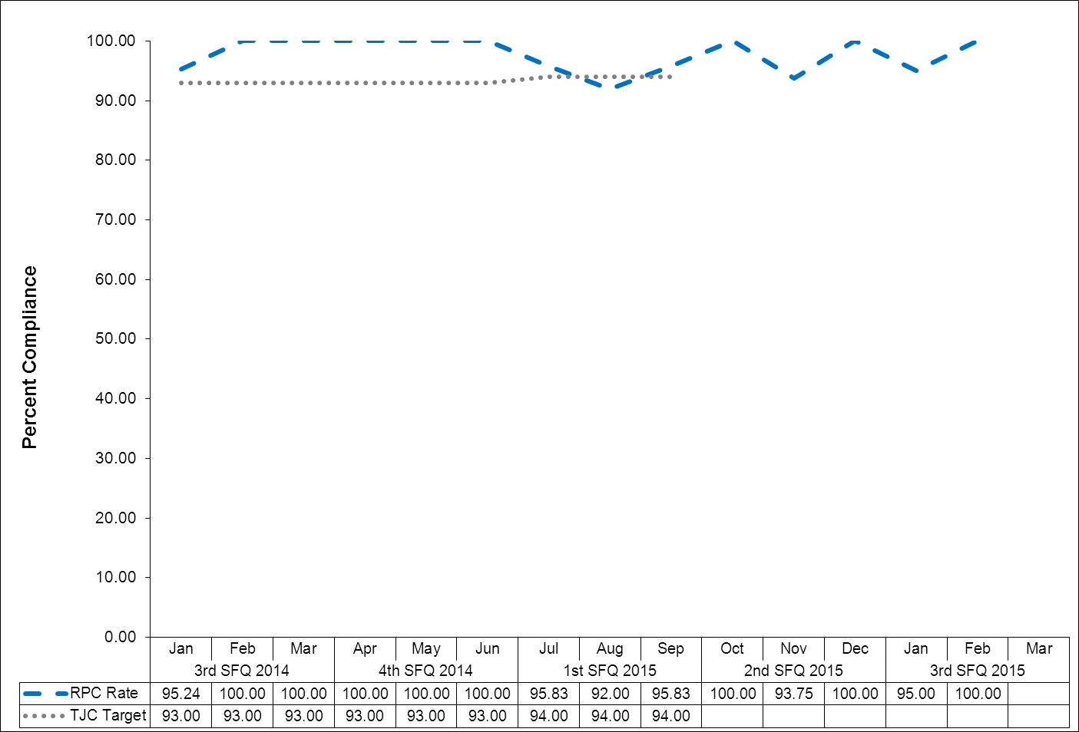

(Glossary of Terms, Acronyms & Abbreviations) (Back to Table of Contents)
JOINT COMMISSION

Physical Restraint (HBIPS 2)
Hours of Use
Description
The total number of hours that all patients admitted to a hospital-based inpatient psychiatric setting were maintained in physical restraint
Rationale
Mental health providers that value and respect an individual’s autonomy, independence and safety seek to avoid the use of dangerous or restrictive interventions at all times (Donat, 2003). The use of seclusion and restraint is limited to situations deemed to meet the threshold of imminent danger and when restraint and seclusion are used; such use is rigorously monitored and analyzed to prevent future use. Providers also seek to prevent violence or aggression from occurring in their treatment environments by focusing their attention on prevention activities that have a growing evidence base (Donat, 2003).
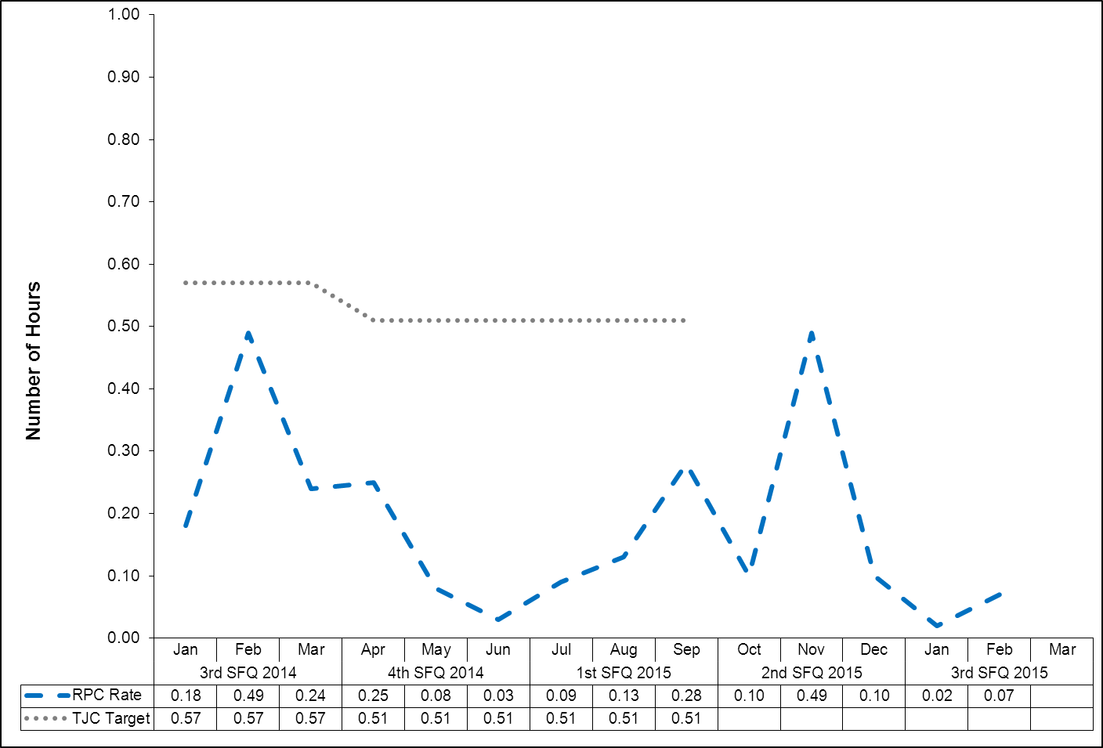

(Glossary of Terms, Acronyms & Abbreviations) (Back to Table of Contents)
JOINT COMMISSION

Seclusion (HBIPS 3)
Hours of Use
Description
The total number of hours that all patients admitted to a hospital-based inpatient psychiatric setting was held in seclusion
Rationale
Mental health providers that value and respect an individual’s autonomy, independence and safety seek to avoid the use of dangerous or restrictive interventions at all times (Donat, 2003). The use of seclusion and restraint is limited to situations deemed to meet the threshold of imminent danger and when restraint or seclusion are used; such use is rigorously monitored and analyzed to prevent future use. Providers also seek to prevent violence or aggression from occurring in their treatment environments by focusing their attention on prevention activities that have a growing evidence base (Donat, 2003).
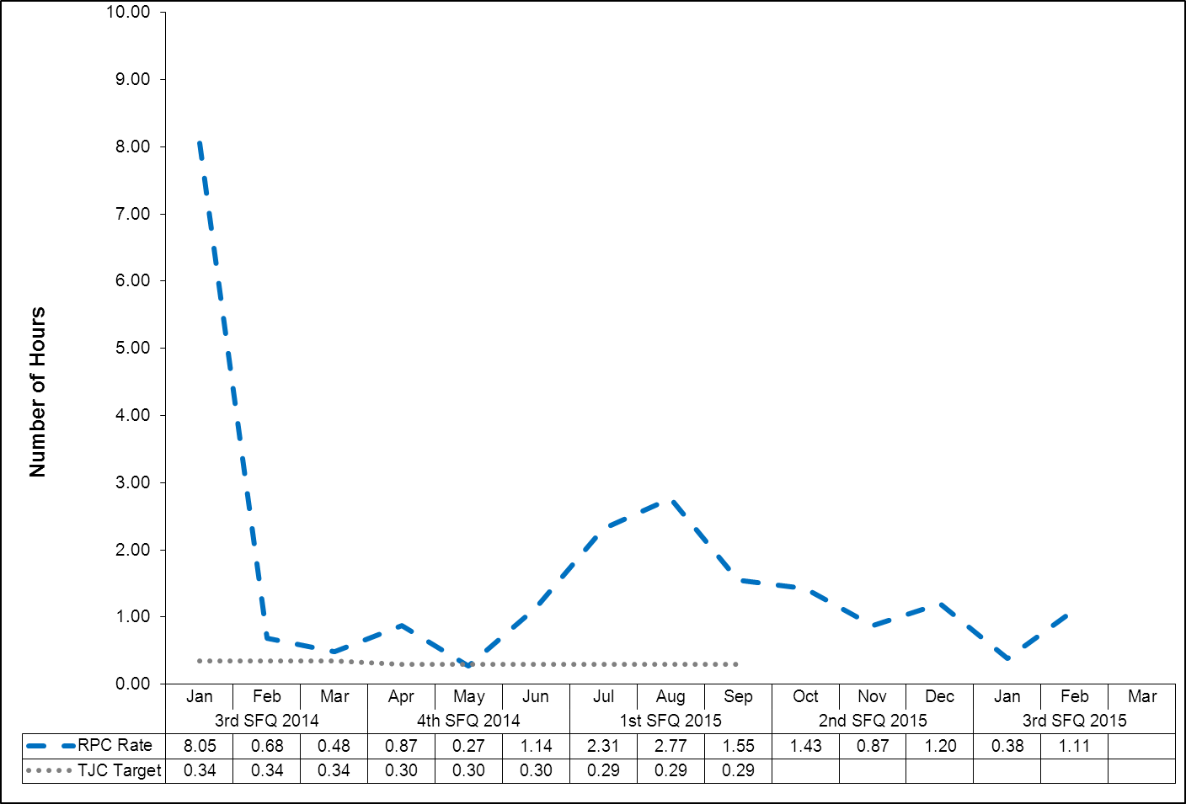

(Glossary of Terms, Acronyms & Abbreviations) (Back to Table of Contents)
JOINT COMMISSION

Multiple Antipsychotic Medications on Discharge (HBIPS 4)
Description
Patients discharged from a hospital-based inpatient psychiatric setting on two or more antipsychotic medications
Rationale
Research studies have found that 4-35% of outpatients and 30-50% of inpatients treated with an antipsychotic medication concurrently received 2 or more antipsychotics (Covell, Jackson, Evans, & Essock, 2002; Ganguly, Kotzan, Miller, Kennedy, & Martin, 2004; Gilmer, Dolder, Folsom, Mastin, & Jeste, 2007; Kreyenbuhl, Valenstein, McCarthy, Ganocyz, & Blow, 2006; Stahl & Grady, 2004). One study reported 4.6% of patients concurrently received 3 or more antipsychotics (Jaffe & Levine, 2003). These findings are seen across diverse sectors: state mental health authorities, the Veterans Health System and Medicaid-financed care. Antipsychotic polypharmacy can lead to greater side effects, often without improving clinical outcomes (Ananth, Parameswaran, & Gunatilake, 2004; Stahl & Grady, 2004). As a result, a range of stakeholders have called for efforts to reduce unnecessary use of multiple antipsychotics (Centorrino, Gören, Hennen, Salvatore, Kelleher, & Baldessarini, 2004; Gilmer, Dolder, Folsom, Mastin, & Jeste, 2007; National Association of State Mental Health Program Directors, 2001; University HealthSystem Consortium, 2006). Practice guidelines recommend the use of a second antipsychotic only after multiple trials of a single antipsychotic have proven inadequate (American Psychiatric Association [APA] Practice Guidelines, 2004). Randomized controlled trials (RCTs) provide some evidence to support augmentation with a second antipsychotic in treatment resistant patients. Most of these studies were limited to augmentation of clozapine with another second-generation antipsychotic (Tranulis, Skalli, Lalonde, & Nicole, 2008). Among patients without a documented history of previous treatment failures of antipsychotic monotherapy, multiple RCTs and other controlled trials failed to show a benefit of antipsychotic polypharmacy over monotherapy (Ananth, Parameswaran, & Gunatilake, 2004; Centorrino, Gören, Hennen, Salvatore, Kelleher, & Baldessarini, 2004; Potkin, Thyrum, Alva, Bera, Yeh, & Arvanitis, 2002; Shim et al., 2007; Stahl,& Grady, 2004). Clinical circumstances, such as shorter inpatient stays, may require hospitals to discharge a patient on multiple antipsychotics with an aftercare plan to transition to monotherapy. In such cases, effective communication between the inpatient and aftercare clinician is an essential element of care.

(Glossary of Terms, Acronyms & Abbreviations) (Back to Table of Contents)
JOINT COMMISSION

Multiple Antipsychotic Medications on Discharge (HBIPS 4)

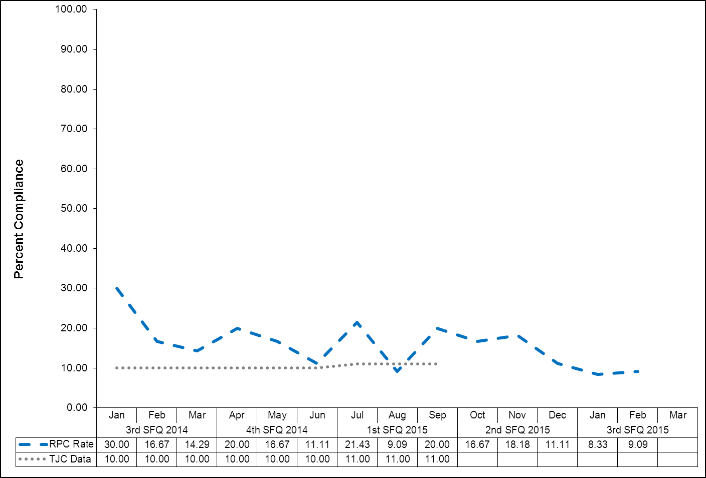
(Glossary of Terms, Acronyms & Abbreviations) (Back to Table of Contents)
JOINT COMMISSION

Multiple Antipsychotic Medications at Discharge with Justification (HBIPS 5)
Description
Patients discharged from a hospital-based inpatient psychiatric setting on two or more antipsychotic medications with appropriate justification
Rationale
Research studies have found that 4-35% of outpatients and 30-50% of inpatients treated with an antipsychotic medication concurrently received 2 or more antipsychotics (Covell, Jackson, Evans, & Essock, 2002; Ganguly, Kotzan, Miller, Kennedy, & Martin, 2004; Gilmer, Dolder, Folsom, Mastin, & Jeste, 2007; Kreyenbuhl, Valenstein, McCarthy, Ganocyz, & Blow, 2006; Stahl & Grady, 2004). One study reported 4.6% of patients concurrently received 3 or more antipsychotics (Jaffe & Levine, 2003). These findings are seen across diverse sectors: state mental health authorities, the Veterans Health System and Medicaid-financed care. Antipsychotic polypharmacy can lead to greater side effects, often without improving clinical outcomes (Ananth, Parameswaran, & Gunatilake, 2004; Stahl & Grady, 2004). As a result, a range of stakeholders have called for efforts to reduce unnecessary use of multiple antipsychotics (Centorrino, Gören, Hennen, Salvatore, Kelleher, & Baldessarini, 2004; Gilmer, Dolder, Folsom, Mastin, & Jeste, 2007; National Association of State Mental Health Program Directors, 2001; University HealthSystem Consortium, 2006).
Practice guidelines recommend the use of a second antipsychotic only after multiple trials of a single antipsychotic have proven inadequate (American Psychiatric Association [APA] Practice Guidelines, 2004). Randomized controlled trials (RCTs) provide some evidence to support augmentation with a second antipsychotic in treatment resistant patients. Most of these studies were limited to augmentation of clozapine with another second-generation antipsychotic (Tranulis, Skalli, Lalonde, & Nicole, 2008). Among patients without a documented history of previous treatment failures of antipsychotic monotherapy, multiple RCTs and other controlled trials failed to show a benefit of antipsychotic polypharmacy over monotherapy (Ananth, Parameswaran, & Gunatilake, 2004; Centorrino, Gören, Hennen, Salvatore, Kelleher, & Baldessarini, 2004; Potkin, Thyrum, Alva, Bera, Yeh, & Arvanitis, 2002; Shim et al., 2007; Stahl,& Grady, 2004). Clinical circumstances, such as shorter inpatient stays, may require hospitals to discharge a patient on multiple antipsychotics with an aftercare plan to transition to monotherapy. In such cases, effective communication between the inpatient and aftercare clinician is an essential element of care.
(Glossary of Terms, Acronyms & Abbreviations) (Back to Table of Contents)
JOINT COMMISSION

Multiple Antipsychotic Medications at Discharge with Justification (HBIPS 5)
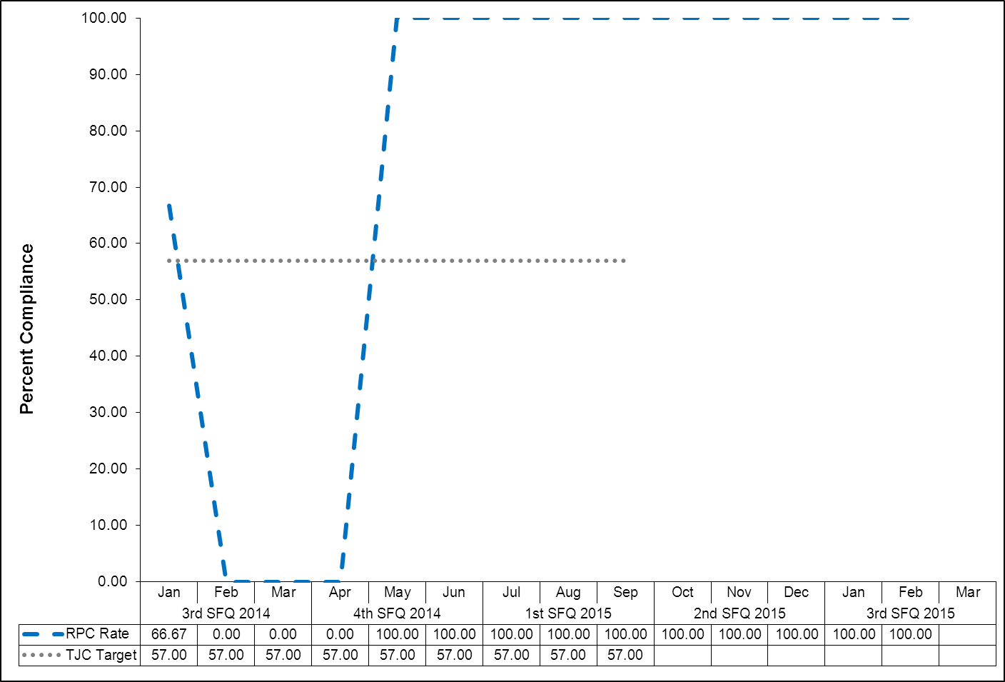

Note: when the RPRC Rate is blank for a month it means that no patients in that month were discharged on multiple antipsychotic medications.
(Glossary of Terms, Acronyms & Abbreviations) (Back to Table of Contents)
JOINT COMMISSION

Post Discharge Continuing Care Plan (HBIPS 6)
Description
Patients discharged from a hospital-based inpatient psychiatric setting with a continuing care plan created
Rationale
Patients may not be able to fully report to their next level of care health-care provider their course of hospitalization or discharge treatment recommendations. The aftercare instructions given the patient may not be available to the next level of care provider at the patient’s initial intake or follow-up appointment. In order to provide optimum care, next level of care providers need to know details of precipitating events immediately preceding hospital admission, the patient’s treatment course during hospitalization, discharge medications and next level of care recommendations (American Association of Community Psychiatrists [AACP], 2001).

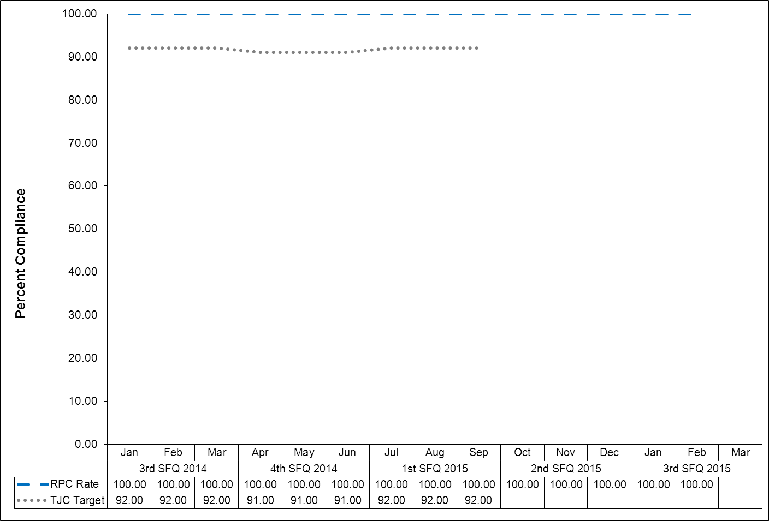

(Glossary of Terms, Acronyms & Abbreviations) (Back to Table of Contents)
JOINT COMMISSION

Post Discharge Continuing Care Plan Transmitted (HBIPS 7)
To Next Level of Care Provider on Discharge
Description
Patients discharged from a hospital-based inpatient psychiatric setting with a continuing care plan provided to the next level of care clinician or entity
Rationale
Patients may not be able to fully report to their next level of care health-care provider their course of hospitalization or discharge treatment recommendations. The aftercare instructions given the patient may not be available to the next level of care provider at the patient’s initial intake or follow-up appointment. In order to provide optimum care, next level of care providers need to know details of precipitating events immediately preceding hospital admission, the patient’s treatment course during hospitalization, discharge medications and next level of care recommendations (American Association of Community Psychiatrists [AACP], 2001).

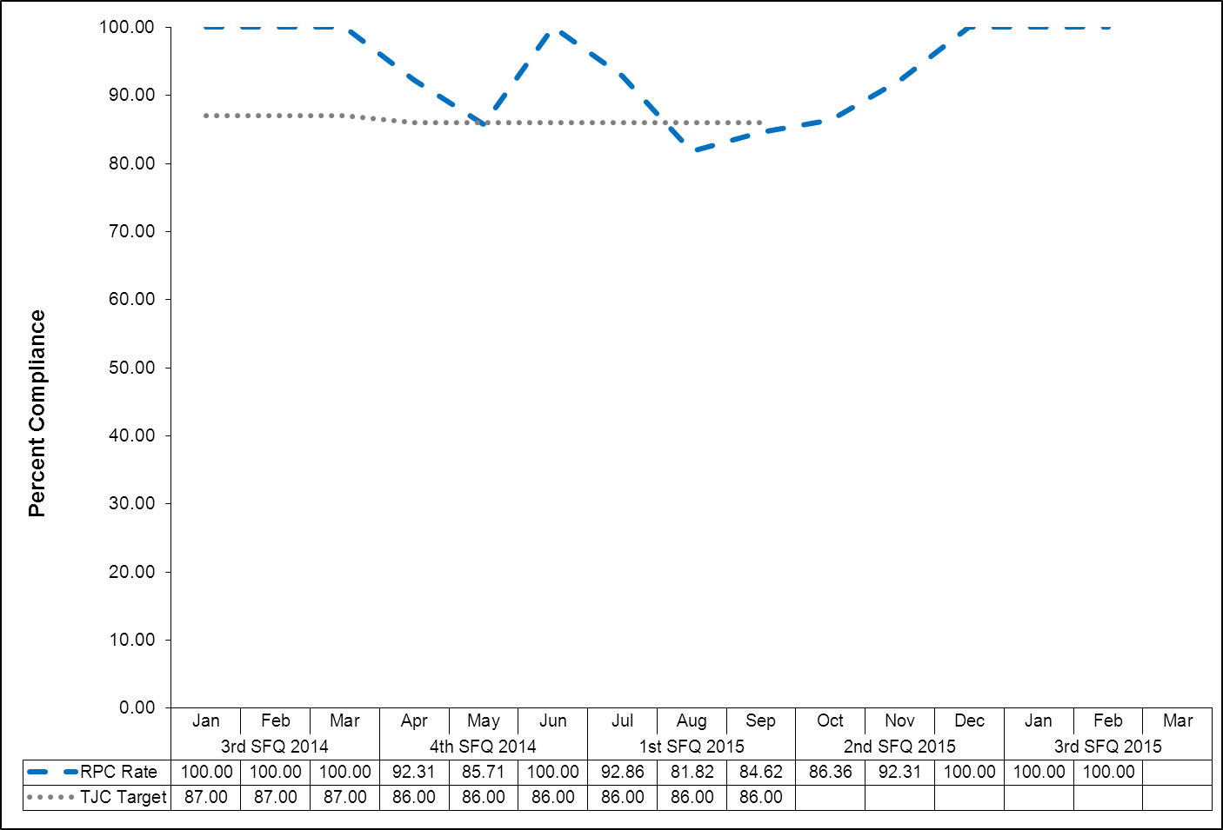

(Glossary of Terms, Acronyms & Abbreviations) (Back to Table of Contents)
JOINT COMMISSION

Contract Performance Indicators

TJC LD.04.03.09 The same level of care should be delivered to patients regardless of whether services are provided directly by the hospital or through contractual agreement. Leaders provide oversight to make sure that care, treatment, and services provided directly are safe and effective. Likewise, leaders must also oversee contracted services to make sure that they are provided safely and effectively.

FY 2015 Quarter 3 Results
Contractor | Program Administrator | Summary of Performance
Amistad Peer Support Services | Stephanie George-Roy  Director of Social Services | One indicator did not meet standards: 100% of grievances were not responded to on time, 98% were. All other indicators met or exceeded standards.
Community Dental, Region II | Dr. Brendan Kirby  Clinical Director | All indicators met standards.
Comprehensive Pharmacy Services | Dr. Brendan Kirby  Clinical Director | All indicators met standards.
Comtec Security | Debora Proctor  Executive Housekeeper | All indicators met standards.
Cummins Northeast | Richard Levesque  Director of Support Services | All indicators met standards.
Dartmouth Medical School | Robert J. Harper  Acting Superintendent | All indicators exceeded standards.
Disability Rights Center | Robert J. Harper  Superintendent | All indicators met standards.
G & E Roofing | Richard Levesque  Director of Support Services | No services were provided during this timeframe.
Goodspeed & O’Donnell | Dr. Brendan Kirby  Clinical Director | No services were provided during this timeframe.
Lavallee Brensinger Architects | Richard Levesque  Director of Support Services | No services were provided during this timeframe.
Liberty Healthcare – After Hours Coverage | Dr. Brendan Kirby  Clinical Director | All indicators met or exceeded standards.
Liberty Healthcare – Physician Staffing | Dr. Brendan Kirby  Clinical Director | All indicators met standards.
Maine General Community Care/Healthreach | Dr. Brendan Kirby  Medical Director | All indicators met standards.
Maine General Medical Center – Laboratory Services | Dr. Brendan Kirby  Clinical Director | All indicators met standards.
Main Security Surveillance | Debora Proctor  Executive Housekeeper | All indicators met or exceeded standards.
MD-IT Transcription Service | Amy Tasker  Director of Health Information | All indicators met standards.
Mechanical Services | Richard Levesque  Director of Support Services | All indicators met or exceeded standards.
Medical Staffing and Services of Maine | Dr. Brendan Kirby  Clinical Director | All indicators met standards.
Motivational Services | Dr. Brendan Kirby  Clinical Director | All indicators met or exceeded standards.

(Glossary of Terms, Acronyms & Abbreviations) (Back to Table of Contents)
JOINT COMMISSION

FY 2015 Quarter 3 Results
Contractor | Program Administrator | Summary of Performance
Occupational Therapy Consultation and Rehabilitation Services | Janet Barrett  Director of Rehabilitation | All indicators met or exceeded standards.
Otis Elevator | Richard Levesque  Director of Support Services | All indicators met or exceeded standards.
Pine Tree Legal Assistance | Dr. Brendan Kirby  Clinical Director | No services were provided during this timeframe.
Project Staffing – Outpatient Services Coordinator | Lisa Manwaring,  Acting Program Service Director, Outpatient Services | Evaluation not received.
Project Staffing – Barber | Janet Barrett  Director of Rehabilitation | Indicator met standards.
Project Staffing – Multi Cultural Training Specialist | Janet Barrett  Director of Rehabilitation | Indicator exceeded standards.
Project Staffing – Per Diem Nurses | Roland Pushard  Director of Nursing | All indicators met standards.
Project Staffing – Post Doctoral Fellowship | Dr. Brendan Kirby  Clinical Director | No services were provided during this timeframe.
Project Staffing – Pre-Doctoral Intern | Dr. Brendan Kirby  Clinical Director | All indicators met or exceeded standards.
Project Staffing – Recovery Training Specialist | Susan Bundy  Staff Development Coordinator | All indicators met standards.
Project Staffing – Teacher | Janet Barrett  Director of Rehabilitation | All indicators met standards.
Protection One | Richard Levesque  Director of Support Services | Indicator exceeded standards.
Securitas Security Services | Philip Tricarico  Safety Compliance Officer | All indicators met or exceeded standards.
Unifirst Corporation | Richard Levesque  Director of Support Services | All indicators met standards.
Waste Management | Debora Proctor  Executive Housekeeper | All indicators met standards.
(Glossary of Terms, Acronyms & Abbreviations) (Back to Table of Contents)
JOINT COMMISSION

Capital Community Clinic
Adverse Reactions to Sedation or Anesthesia

TJC PI.01.01.01 EP6: The hospital collects data on the following: adverse events related to using moderate or deep sedation or anesthesia. (See also LD.04.04.01, EP 2)

Dental Clinic Timeout/Identification of Client

Indicators | 4Q2014 | 1Q2015 | 2Q2015 | 3Q2015 | Total
National Patent Safety Goals  Goal 1: Improve the accuracy of Client  Identification.  Capital Community Dental Clinic assures accurate client identification by: asking the client to state his/her name and date of birth.  A time out will be taken before the procedure to verify location and numbered tooth. The time out section is in the progress notes of the patient chart. This page will be signed by the Dentist as well as the dental assistant. | April  100%  11/11  May  N/A  0/0  June  100%  2/2  Total  100%  13/13 | July  100%  5/5  August  100%  2/2  September  100%  3/3  Total  100%  10/10 | October  100%  9/9  November  100%  3/3  December  100%  2/2  Total  100%  14/14 | January  100%  4/4  February  100%  6/6  March  100%  4/4  Total  100%  14/14 | 100%  51/51

Dental Clinic Post Extraction Prevention of Complications and Follow-up

Indicators | 4Q2014 | 1Q2015 | 2Q2015 | 3Q2015 | Total
- All clients with tooth extractions, will be assessed and have teaching post procedure, on the following topics, as provided by the Dentist or Dental Assistant  - Bleeding  - Swelling  - Pain  - Muscle soreness  - Mouth care  - Diet  - Signs/symptoms of infection  - The client, post procedure tooth extraction, will verbalize understanding of the above by repeating instructions given by Dental Assistant/Hygienist.  - Post dental extractions, the clients will receive a follow-up phone call from the clinic within 24hrs of procedure to assess for post procedure complications | April  100%  11/11  May  N/A  0/0  June  100%  2/2  Total  100%  13/13 | July  100%  5/5  August  100%  2/2  September  100%  3/3  Total  100%  10/10 | October  100%  9/9  November  100%  3/3  December  100%  2/2  Total  100%  14/14 | January  100%  4/4  February  100%  6/6  March  100%  4/4  Total  100%  14/14 | 100%  51/51

(Glossary of Terms, Acronyms & Abbreviations) (Back to Table of Contents)
JOINT COMMISSION

Healthcare Acquired Infections Monitoring and Management

NPSG.07.03.01 Implement evidence-based practices to prevent health care–associated infections due to multidrug-resistant organisms in acute care hospitals.

Infection Control George Davis M.D. – Chairperson, IC Committee
Kathleen Mitton RN – Infection Control Nurse

Quality Assurance Measure

I. Measure Name: Hospital Associated Infection (HAI) Rate
Measure Description: Third Quarter Review of Hospital Associated Infections

Results
Target | Unit | Baseline | Q1 | Q2 | Q3 | Q4 | YTD
1 STDV within the Mean | Hospital Associated Infection Rate | FY 2014  78% | 9 HAI/IC Rate 1.6 | 4 HAI/IC Rate 2.2 | 7 HAI/IC Rate 1.1
Actual  Outcome | Hospital Associated Infection Rate | FY 2014  78% | 1 STDV within the mean | At 1 STDV | 1 STDV within the mean

Hospital Acquired Infection (HAI) is any infection present, incubating or exposed to more than 72 hours after admission (unless the patient is off hospital grounds during that time) or declared by a physician, a physician’s assistant or advanced practice nurse to be HAI.

A Community Acquired Infection (CAI) is any infection present, incubating or exposed to prior to admission, while on pass; during off-site medical, dental, or surgical care; by a visitor, any prophylaxis treatment of a condition or treatment of a condition for which the patient has a history of chronic infection no matter how long the patient has been hospitalized; or declared by the physician, physician’s assistant, or advanced practice nurse to be a community acquired infection.

Idiosyncratic Infection is any infection that occurs after admission and is the result of the patient’s action toward himself or herself.

Lower Kennebec Upper Kennebec
Hepatitis C – CAI Dental Infection - CAI
Scabies Infestation – CAI UTI - HAI
2 Dental Infections – CAI S & S URI/Probable Viral Bronchitis – CAI
Cheilosis with candida overgrowth due to Abrasion Right Great Toe - HAI
↑sialorrhea/high dose of medicine – HAI Tinea Pedis - HAI
Tentative diagnosis of UTI – CAI Conjunctivitis - HAI

Lower Saco Upper Saco
Tinea Corporis of Buttock – CAI 2 Dental Infections - CAI
Cold Sore - CAI Superficial Paronychia – CAI
Non-healing shoulder wound - CAI Conjunctivitis - HAI
Bronchitis - HAI
Lower Saco SCU
Fissure with superficial infection of helix of the ear - CAI
(Glossary of Terms, Acronyms & Abbreviations) (Back to Table of Contents)
JOINT COMMISSION

Data Analysis: There was a spike in the hospital associated infection rate in the second quarter due to an increase number of upper respiratory infections (URI) in November 2014. The HAI rate was at one standard deviation. The hospital associated infection rate for the third quarter fiscal year 2014-2015 is below the mean.

Plan of Action: Continue total house surveillance.

Performance Improvement Measure

II. Measure Name: Patient Hand Hygiene Practice
Measure Description: Third Quarter - Staff offer hand gel to patients prior to breakfast, lunch, & dinner, thirty (30) days per month

Results
Target | Unit | Baseline | Q1 | Q2 | Q3 | Q4 | YTD
90% | Staff Compliance Rate - assisting patients with hygiene | FY Jan. 2014-June 2014: Compliance Rate 73% | 98/97/  95% | 96/94/  96% | 98/99/  96%
Actual  Outcome | Staff Compliance Rate - assisting patients with hygiene | FY Jan. 2014-June 2014: Compliance Rate 73% | 97% | 95% | 98%

Data Analysis: Staff have sustained a high compliance rate for the first three quarters of fiscal year 2014-2015. The mean rate is 97%.

Plan of Action: We will continue to track patient hand hygiene practice as a QA measure for fiscal year 2015-2016.

(Glossary of Terms, Acronyms & Abbreviations) (Back to Table of Contents)
JOINT COMMISSION

Medication Management
Medication Errors and Adverse Reactions

TJC PI.01.01.01 EP14: The hospital collects data on the following: Significant medication errors. (See also LD.04.04.01, EP 2; MM.08.01.01, EP 1)

TJC PI.01.01.01 EP15: The hospital collects data on the following: Significant adverse drug reactions. (See also LD.04.04.01, EP 2; MM.08.01.01, EP 1)

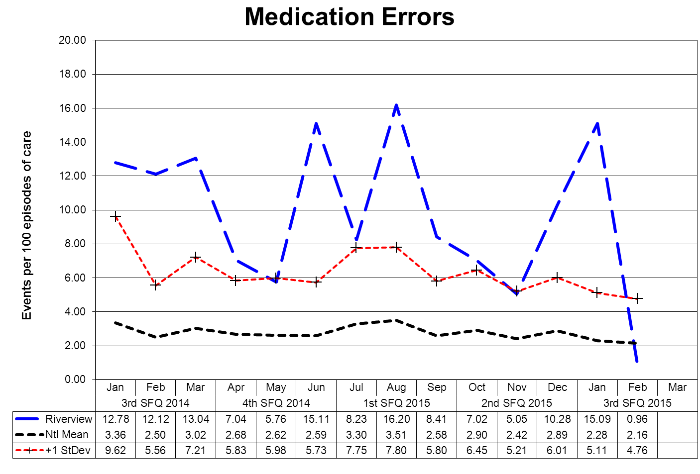

This graph depicts the number of medication error events that occurred for every 100 episodes of care (duplicated client count). For example, a rate of 1.6 means that 2 medication error events occurred for each 125 episodes of care.
(Glossary of Terms, Acronyms & Abbreviations) (Back to Table of Contents)
JOINT COMMISSION

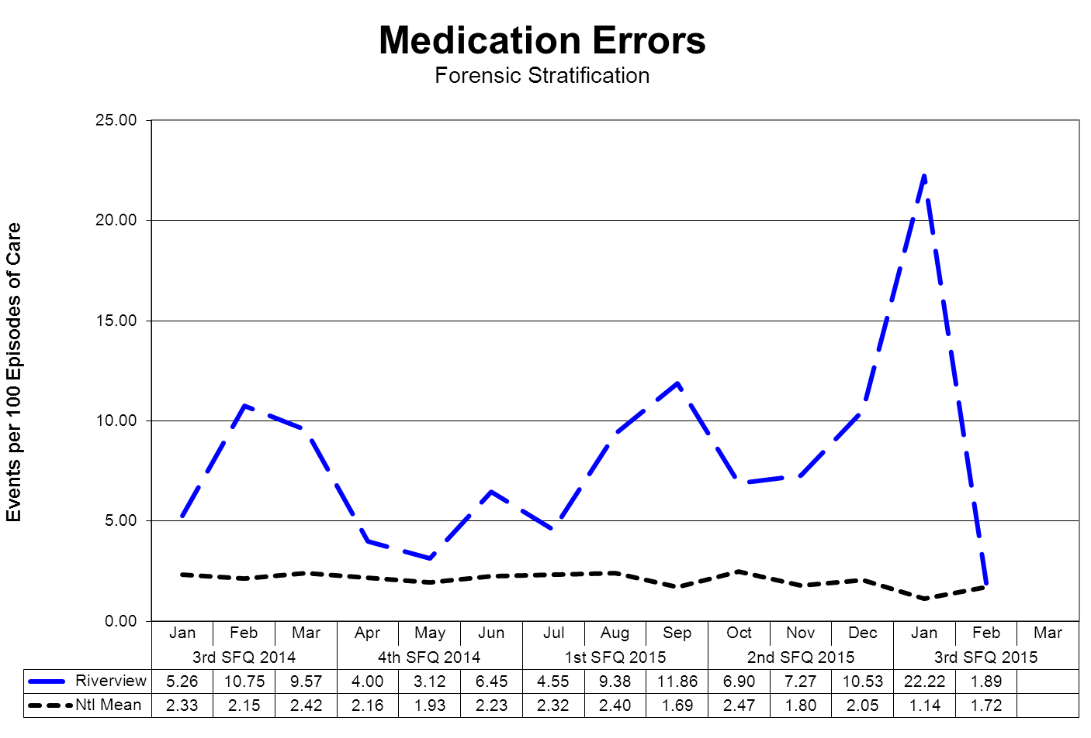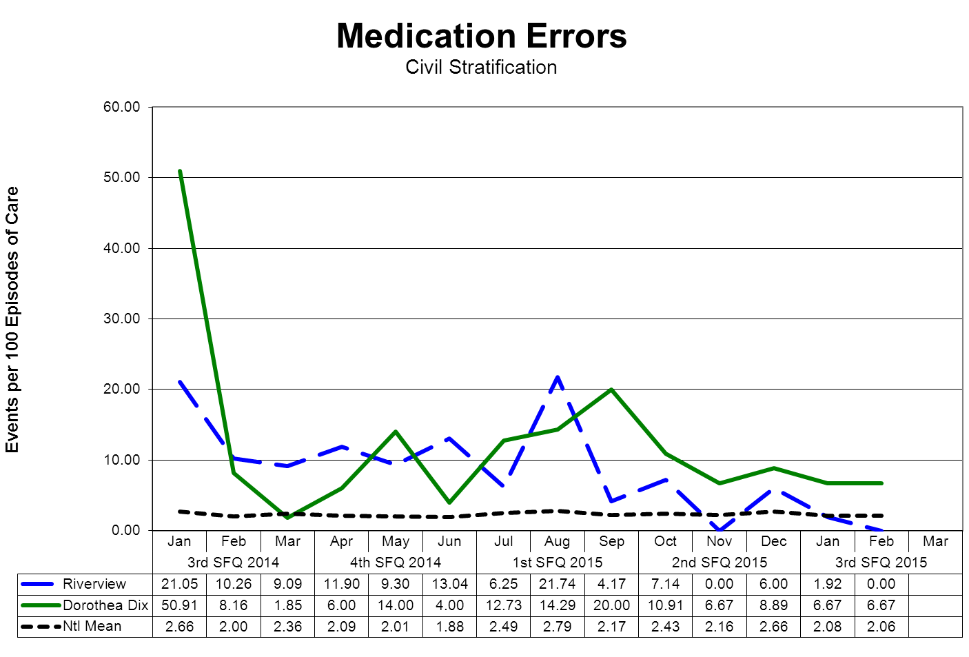
(Glossary of Terms, Acronyms & Abbreviations) (Back to Table of Contents)
JOINT COMMISSION

Medication Management – Medication Variances

Medication variances are classified according to four major areas related to the area of service delivery. The error must have resulted in some form of variance in the desired treatment or outcome of care. A variance in treatment may involve one incident but multiple medications; each medication variance is counted separately irrespective of whether it involves one error event or many. Medication error classifications include:
Prescribing
An error of prescribing occurs when there is an incorrect selection of drug, drug dose, dosage form, quantity, route, concentration, rate of administration, or instructions for use of a drug product ordered or authorized by physician or other legitimate prescriber. Errors may occur due to improper evaluation of indications, contraindications, known allergies, existing drug therapy and other factors. Illegible prescriptions or medication orders that lead to client level errors are also defined as errors of prescribing. in identifying and ordering the appropriate medication to be used in the care of the client.
Dispensing
An error of dispensing occurs when the incorrect drug, drug dose or concentration, dosage form, or quantity is formulated and delivered for use to the point of intended use.
Administration
An error of administration occurs when there is an incorrect selection and administration of drug, drug dose, dosage form, quantity, route, concentration, rate of administration, or instructions for use of a drug product ordered or authorized by physician or other legitimate prescriber.
Complex
An error which resulted from two or more distinct errors of different types is classified as a complex error.
Review, Reporting and Follow-up Process

The Medication Variances Process Review Team (PRT) meets weekly to evaluate the causation factors related to the medication variances reported on the units and in the pharmacy and makes recommendations, through its multi-disciplinary membership, for changes to workflow, environmental factor, and client care practices. The team consists of the Medical Director (or designee), the Director of Nursing (or designee), the Director of Pharmacy (or designee), and the Clinical Risk Manager or the Performance Improvement Manager.

The activities and recommendations of the Medication Variances PRT are reported monthly to the Integrated Performance Excellence Committee.

(Glossary of Terms, Acronyms & Abbreviations) (Back to Table of Contents)
JOINT COMMISSION

Medication Management - Administration Process
Medication Errors Related to Staffing Effectiveness

Date | Omit | Type of Error | Float | New | O/T | Unit | Staff Mix
 |  |  |  |  |  |  | RN | LPN | MHW
10/28/2014 | Y | Omission x2 | NA | NA | NA | LK
11/1/2014 | N | Wrong Time | N | N | N | US | 2 | 1 | 4
11/3/2014 | Y | Omission x2 Antibiotic | Y | N | N | UK | 3 | 0 | 4
11/8/2014 | Y | Omission x1 | Y | N | N | UK | 2 | 0 | 4
11/8/2014 | N | Wrong Time | Y | Y | N | US | 1 | 0 | 3
11/20/2014 | N | Wrong Time | N | Y | N | LS | 3 | 0 | 7
11/21/2014 | Y | Omission x1 | N | N | N | US | 2 | 1 | 4
11/21/2014 | N | Wrong Time | Y | N | N | LS | 3 | 0 | 7
11/25/2014 | N | Wrong Dose x2 | Y | N | N | US | 2 | 0 | 4
11/27/2014 | Y | Omission x1 Risperdal | NA | NA | NA | US
12/4/2014 | Y | Omission x1 | Y | N | N | LS | 2 | 0 | 6
12/5/2014 | N | Wrong Time | N | N | N | US | 3 | 0 | 4
12/5/2014 | N | Wrong Time | Y | N | N | UK | 3 | 0 | 4
12/10/2014 | Y | Omission x3 | Y | N | N | LK | 3 | 0 | 6
12/15/2014 | N | Wrong Time x4 | N | N | N | US | 3 | 0 | 4
12/26/2014 | Y | Omission x1 | N | N | N | US | 2 | 1 | 4
12/26/2014 | Y | Omission x6 | N | N | N | LK | 2 | 1 | 7
12/29/2014 | Y | Dosing (2 extra doses) | Y | Y | N | LS | 3 | 0 | 7
12/29/2014 | Y | Omission x3 | N | N | N | LS | 3 | 0 | 7
1/3/2015 | N | Wrong Dose | N | N | N | UK | 3 | 0 | 4
1/3/2015 | N | Wrong Time | Y | N | N | UK | 3 | 0 | 4
1/5/2015 | Y | Omission x3 | N | N | N | LK | 3 | 1 | 6
1/24/2015 | N | Wrong Dose | Y | N | Y | LS | 2 | 1 | 8
1/26/2015 | N | Wrong Time | N | N | N | LS | 3 | 0 | 7
2/4/2015 | Y | Omission x3 Lyrics | N | N | N | OPS
2/7/2015 | Y | Omission x1 | N | N | N | LK | 4 | 0 | 6
2/8/2015 | Y | Omission x1 | Y | Y | Y | LK | 2 | 0 | 5
2/8/2015 | Y | Omission x1 Synthroid | Y | N | Y | LK | 2 | 0 | 5
2/9/2015 | N | Wrong Med | N | N | N | US | 2 | 1 | 4
2/11/2015 | Y | Omission x2 Cloazaril | Y | N | N | US | 3 | 0 | 4
2/15/2015 | Y | Omission x1 Insulin | Y | N | Y | US | 1 | 0 | 3
2/18/2015 | N | Wrong Time | NA | NA | NA | US
(Glossary of Terms, Acronyms & Abbreviations) (Back to Table of Contents)
JOINT COMMISSION

Date | Omit | Type of Error | Float | New | O/T | Unit | Staff Mix
 |  |  |  |  |  |  | RN | LPN | MHW
2/24/2015 | N | Dosing (Extra Dose) | Y | N | N | LS | 3 | 0 | 7
2/24/2015 | Y | Omission x7 Flexeril | N | N | N | US | 3 | 0 | 4
2/24/2015 | N | Wrong Dose | N | N | N | US | 3 | 0 | 4
2/26/2015 | N | Wrong Dose | N | N | N | LS | 3 | 0 | 7
2/26/2015 | N | Wrong Time x2 | Y | Y | N | US | 2 | 1 | 4
3/1/2015 | Y | Omission x1 | Y | N | N | LS | 3 | 0 | 7
3/2/2015 | N | Given after order expired x3 | N | N | N | US | 3 | 1 | 4
3/2/2015 | N | Wrong Form | N | N | N | LS | 3 | 0 | 7
3/4/2015 | N | Dosing (Extra Dose) | Y | N | N | US | 2 | 0 | 4
3/4/2015 | N | Wrong Time | N | N | N | US | 3 | 0 | 4
3/7/2015 | N | Expired Order | Y | N | N | US | 3 | 0 | 4
3/12/2015 | Y | Omission x1  Tizandine | N | N | N | LS | 3 | 0 | 7
3/14/2015 | N | Wrong Med (Insulin) | N | N | N | US | 3 | 0 | 4
3/16/2015 | Y | Omission x1 | N | N | N | US | 3 | 0 | 4
3/17/2015 | Y | Omission x2 | N | N | N | US | 3 | 0 | 4
3/24/2015 | Y | Omission x1 | N | N | N | US | 3 | 0 | 4
3/24/2015 | Y | Omission x1 | Y | N | N | LS | 3 | 0 | 8
12/13/2015 | Y | Omission x2 | N | Y | N | LS | 3 | 1 | 7
Totals | 53 |  | 30 | 11 | 4 | LS:  20 | US:  38 | LK:  17 | UK:  6
Percent | 63% |  | 36% | 13% | 5% | 24% | 45% | 20% | 7%

*Each dose of medication is documented as an individual variance (error)

Summary
There were a total of 84 errors for this quarter. This represents an increase of 58 errors this quarter compared to 26 errors last quarter. Fifty three (63%) were errors of omission. Ten of the errors involved wrong doses or extra doses which exceeded the limit of the order. Sixteen of the errors related to being given at the wrong time.

The errors were distributed among the units as follows:
Lower Saco = 20 errors
Upper Saco = 38 errors
Lower Kennebec = 17 errors
Upper Kennebec = 6 errors
OPS = 3

Of the errors committed, 30 were by float staff, 11 were by new staff, and 4 were by staff working
(Glossary of Terms, Acronyms & Abbreviations) (Back to Table of Contents)
JOINT COMMISSION

overtime.

During this quarter, two of the regular LPNs, both on the Saco side had requested and were in an acting capacity positions (TTC) that took them out of the medications rooms. With these two LPNs assigned elsewhere, RNs were assigned the medication room which was inconsistent with multiple different nurses administering medications.

There was a significant increase in nursing vacancies this past quarter due to nurses leaving, some injuries and people moving onto different jobs within the facility. This contributed to the lack of consistency in the medications rooms as well which further compounded errors and tracking of them.
.
Actions
Nursing has pushed to put LPNs in the medication rooms on all four units for first and second shift. This involved hiring two new LPNS to replace the one that accepted the permanent position as TTC and to fill a vacancy on second shift in the medication room.

Nurse Pharmacy Committee meets twice monthly and we continue to discuss different functions of the Pyxis medication machine that nurses may be able to utilize to self-check for thoroughness of medication administration each shift.

All nursing related medication errors were noted to have appropriate staffing levels. Consistency of staffing is looked at related to errors and not having consistent staff on each unit does appear to impact the number of errors. The RN IV for each unit continues to review errors on their assigned units with the staff who made the error.

(Glossary of Terms, Acronyms & Abbreviations) (Back to Table of Contents)
JOINT COMMISSION

Medication Management - Dispensing Process

Medication Management | Unit | Baseline  2014 | Q1 Target | Q2 Target | Q3 Target | Q4 Target | Goal | Comments
Controlled Substance Loss Data | All | 0.875% | 0% | 0% | 0% | 0% | 0% | No discrepancies between Pyxis and CII Safe transactions in Q1, Q2, and Q3
Daily Pyxis-CII Safe Compare Report
Quarterly Results |  |  | 0% | 0% | 0%
Monthly CII Safe Vendor Receipt | Rx | 0 | 0 | 0 | 0 | 0 | 0 | No discrepancies between CII Safe and vendor transactions for Q1, Q2, and Q3
Quarterly Results |  |  | 0 | 0 | 0
Monthly Pyxis Controlled Drug discrepancies | All | 22 | 0 | 0 | 0 | 0 | 0 | Goal of “0” controlled drug discrepancies dispensed from Pyxis trended from Knowledge Portal for Q1, Q2, and Q3.
Quarterly Results |  |  | 58  (19/  month) | 66  (22/  month) | 42  (14/  month)
Medication Management Monitoring | Rx | 8/year | 0 | 0 | 0 | 0 |  | 2 ADR’s reported in Q1, 1 ADR in Q2, and 2 in Q3.
Measures of drug reactions, adverse drug events and other management data
Quarterly Results |  |  | 2 | 1 | 2
Resource Documentation Reports of Clinical Interventions | Rx | 395 reports in 2014
Quarterly Results |  |  | 84 | 79 | 73

(Glossary of Terms, Acronyms & Abbreviations) (Back to Table of Contents)
JOINT COMMISSION

Medication Management | Unit | Baseline  2014 | Q1 Target | Q2 Target | Q3 Target | Q4 Target | Goal | Comments
Psychiatric Emergency Process | All | 90% | 100% | 100% | 100% | 100% | 100% | Goal of 100% compliance as measured by monthly audit tool
Monthly audit of all psych emergencies measured against 9 criteria
Quarterly Results |  |  | 93% | 95% | 93% |  |  | Follow up by RxRemote needs further improvement
Contract KPI’s
Operational Audit | Rx |  | 100% | 100% | 100% | 100% | 100% | Goal of 100% compliance as measured by monthly audit tool for Q1, Q2, and Q3.
Weekly audit of 3 operational indicators from CPS contract
Quarterly Results |  |  | 100% | 100% | 100%

(Glossary of Terms, Acronyms & Abbreviations) (Back to Table of Contents)
JOINT COMMISSION

Inpatient Consumer Survey

TJC PI.01.01.01 EP16: The hospital collects data on the following: Patient perception of the safety and quality of care, treatment, and services.

The Inpatient Consumer Survey (ICS) is a standardized national survey of customer satisfaction. The National Association of State Mental Health Program Directors Research Institute (NRI) collects data from state psychiatric hospitals throughout the country in an effort to compare the results of client satisfaction in five areas or domains of focus. These domains include Outcomes, Dignity, Rights, Participation, Environment, and Empowerment.
Inpatient Consumer Survey (ICS) has been recently endorsed by NQF, under the Patient Outcomes Phase 3: Child Health and Mental Health Project, as an outcome measure to assess the results, and thereby improve care provided to people with mental illness. The endorsement supports the ICS as a scientifically sound and meaningful measure to help standardize performance measures and assures quality of care.
Rate of Response for the Inpatient Consumer Survey

Due to the operational and safety need to refrain from complete openness regarding plans for discharge and dates of discharge for forensic clients, the process of administering the inpatient survey is difficult to administer. Whenever possible the peer support staff work to gather information from clients on their perception of the care provided to then while at Riverview Psychiatric Recovery Center.
The Peer Support group has identified a need to improve the overall response rate for the survey. This process improvement project is defined and described in the section on Client Satisfaction Survey Return Rate of this report.
There is currently no aggregated date on a forensic stratification of responses to the survey.

When the Riverview field is blank for a month it means that no patients responded to the survey questions on that page in that particular month.
(Glossary of Terms, Acronyms & Abbreviations) (Back to Table of Contents)
JOINT COMMISSION

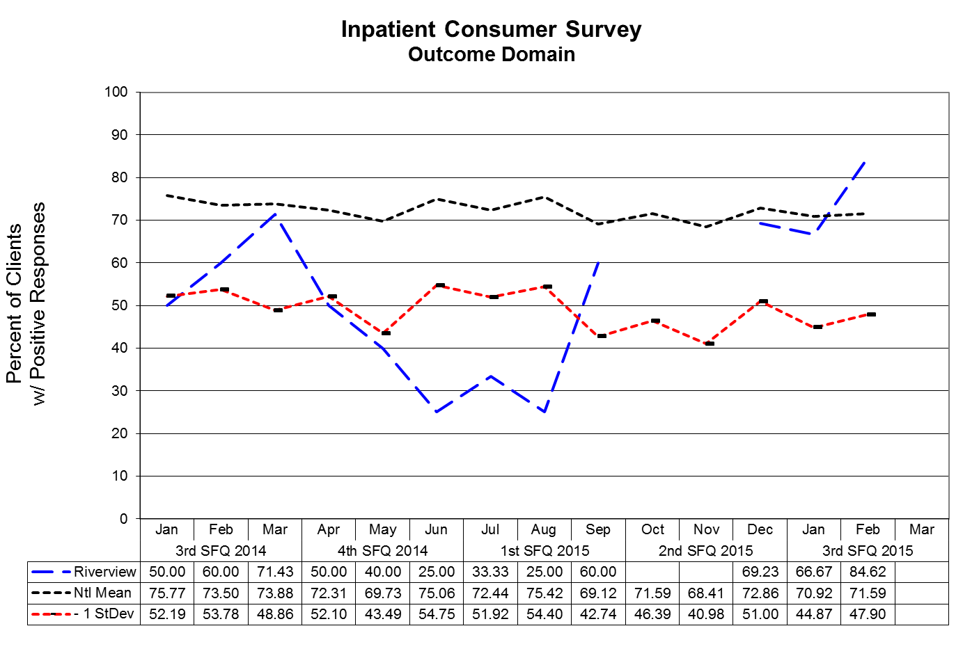
Outcome Domain Questions
- I am better able to deal with crisis.
- My symptoms are not bothering me as much.
- I do better in social situations.
- I deal more effectively with daily problems.
(Glossary of Terms, Acronyms & Abbreviations) (Back to Table of Contents)
JOINT COMMISSION

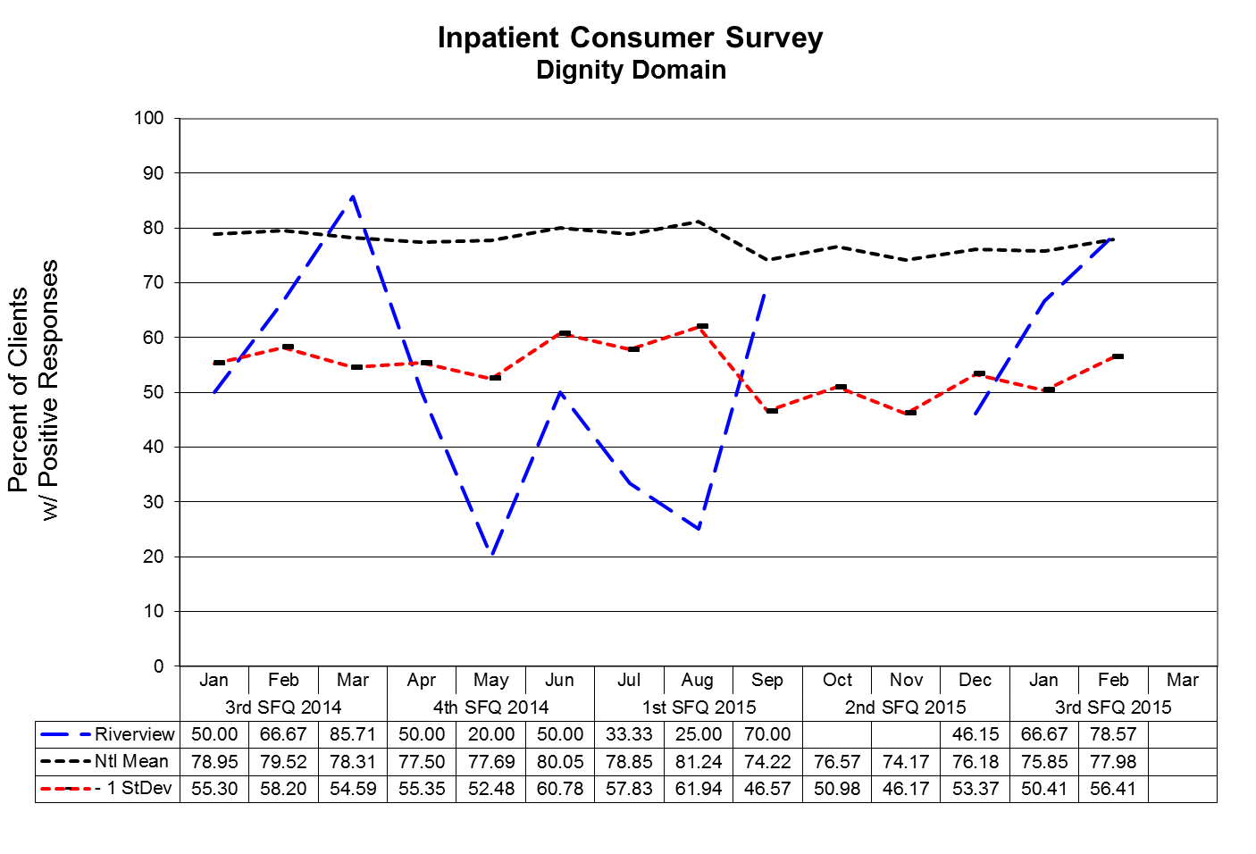
Dignity Domain Questions
- I was treated with dignity and respect.
- Staff here believed that I could grow, change and recover.
- I felt comfortable asking questions about my treatment and medications.
- I was encouraged to use self-help/support groups.
.

(Glossary of Terms, Acronyms & Abbreviations) (Back to Table of Contents)
JOINT COMMISSION

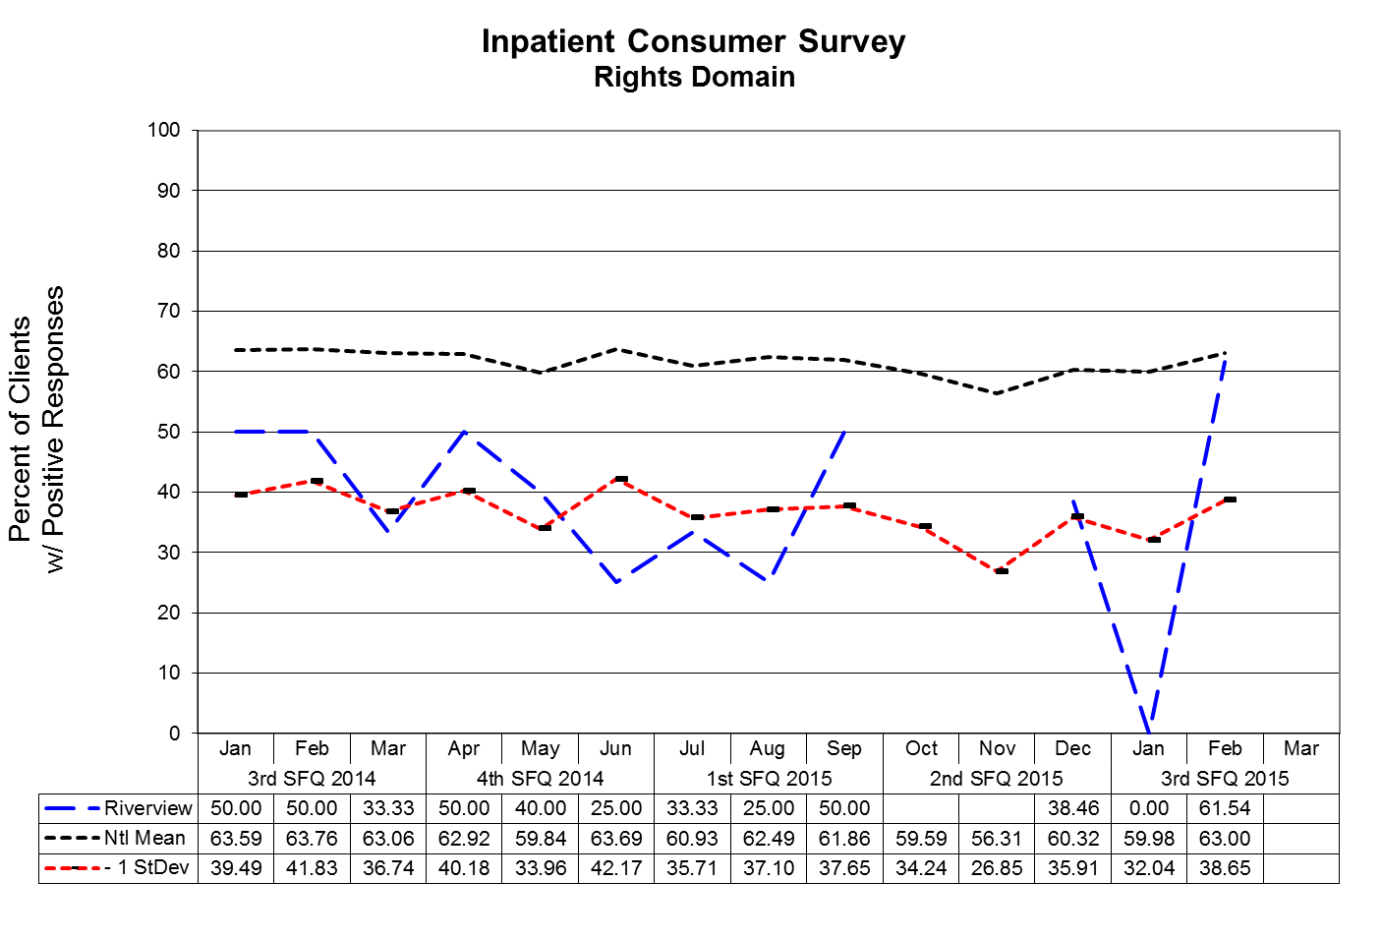
Rights Domain Questions
- I felt free to complain without fear of retaliation.
- I felt safe to refuse medication or treatment during my hospital stay.
- My complaints and grievances were addressed.

(Glossary of Terms, Acronyms & Abbreviations) (Back to Table of Contents)
JOINT COMMISSION

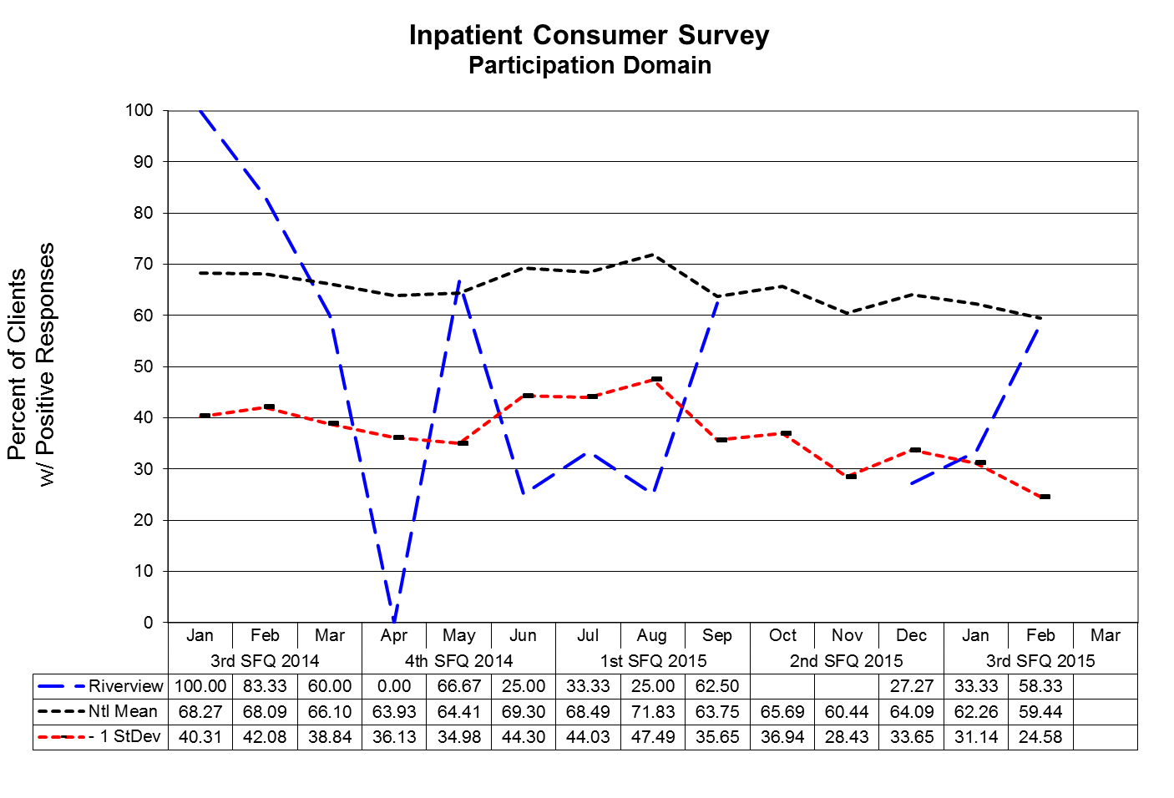
Participation Domain Questions
- I participated in planning my discharge.
- Both I and my doctor or therapists from the community were actively involved in my hospital treatment plan.
- I had an opportunity to talk with my doctor or therapist from the community prior to discharge.

(Glossary of Terms, Acronyms & Abbreviations) (Back to Table of Contents)
JOINT COMMISSION

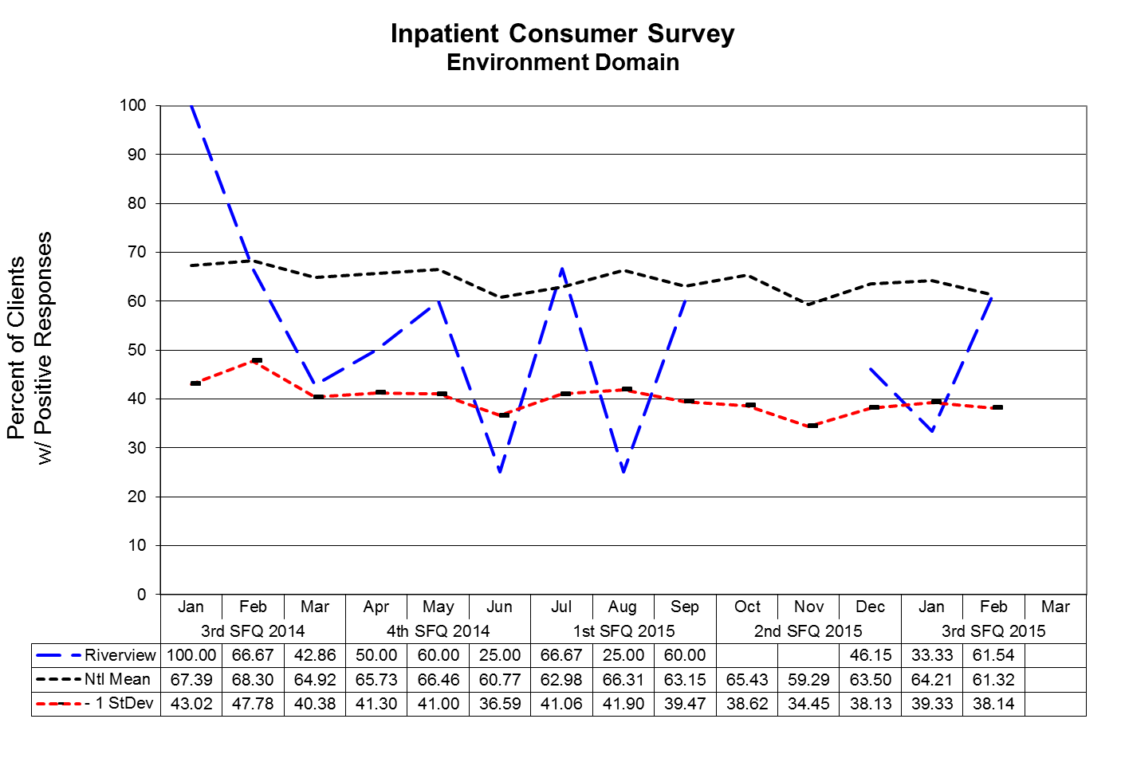
Environment Domain
- The surroundings and atmosphere at the hospital helped me get better.
- I felt I had enough privacy in the hospital.
- I felt safe while I was in the hospital.
- The hospital environment was clean and comfortable.

(Glossary of Terms, Acronyms & Abbreviations) (Back to Table of Contents)
JOINT COMMISSION

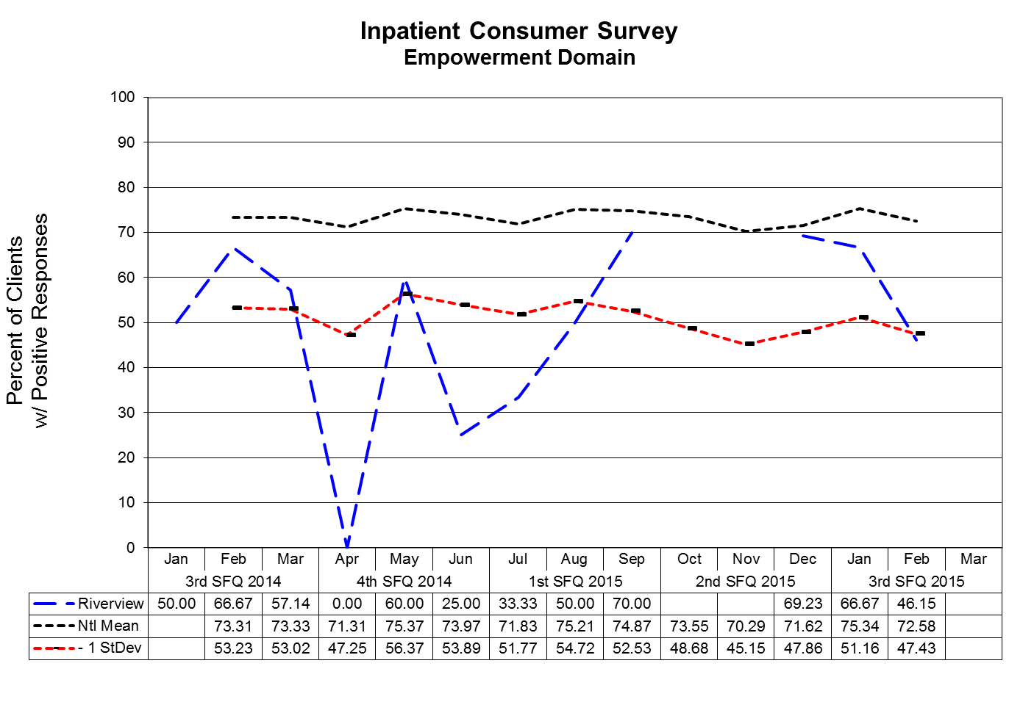Note: National Mean and Standard Deviation are unavailable for January 2014.

Empowerment Domain
- I had a choice of treatment options.
- My contact with my Doctor was helpful.
- My contact with nurses and therapists was helpful.
(Glossary of Terms, Acronyms & Abbreviations) (Back to Table of Contents)
JOINT COMMISSION

Pain Management

TJC PC.01.02.07: The hospital assesses and manages the patient's pain.

Indicator | 4Q2014 | 1Q2015 | 2Q2015 | 3Q2015
Pre-administration | 90%  2811/3114 | 84%  2481/2965 | 94%  3832/4082 | 96%  3760/3906
Post-administration | 80%  2477/3114 | 72%  2126/2965 | 89%  3624/4082 | 93%  3648/3906

SUMMARY

Total number of PRN pain medications administered decreased this quarter (3906 compared to 4082). Nursing pain assessment documentation has continued to improve (both pre-assessment and post-assessment of the patient’s pain), with percentages of compliance above 90% in both categories.

ACTIONS

Will give nursing positive feedback for their hard work and great improvement in documentation. Will continue to audit this area and will meet with clinical managers/individual nurses as needed.
(Glossary of Terms, Acronyms & Abbreviations) (Back to Table of Contents)
JOINT COMMISSION

Fall Reduction Strategies

TJC PI.01.01.01 EP38: The hospital evaluates the effectiveness of all fall reduction activities including assessment, interventions, and education.

TJC PC.01.02.08 The hospital assesses and manages the patient's risks for falls.
EP01: The hospital assesses the patient’s risk for falls based on the patient population and setting.
EP02: The hospital implements interventions to reduce falls based on the patient’s assessed risk.
Falls Risk Management Team has been created to be facilitated by a member of the team with data supplied by the Risk Manager. The role of this team is to conduct root cause analyses on each of the falls incidents and to identify trends and common contributing factors and to make recommendations for changes in the environment and process of care for those clients identified as having a high potential for falls.
Type of Fall by Client and Month

Fall Type | Client | JANUARY | FEBRUARY | MARCH | 3Q2015
Un-witnessed | MR7691 | 1 |  |  | 1
Un-witnessed | MR5199 | 1 |  | 1 | 2
Un-witnessed | MR091 |  |  | 1 | 1
Un-witnessed | Totals | 2 | 0 | 2 | 4
Fall Type | Client | JANUARY | FEBRUARY | MARCH | 3Q2015
Witnessed | MR94 |  |  | 1 | 1
Witnessed | MR83 | 1 |  |  | 1
Witnessed | MR5067 |  |  | 1 | 1
Witnessed | MR7045 | 1 |  |  | 1
Witnessed | MR4271 |  |  | 2 | 2
Witnessed | MR4647 |  | 1 |  | 1
Witnessed | MR7713 |  | 1 | 1 | 2
Witnessed | MR7690 | 1 |  |  | 1
Witnessed | MR7665 | 1 |  | 2 | 3
Witnessed | MR7662 | 2 |  |  | 3
Witnessed | MR175 |  | 1 |  | 1
Witnessed | Totals | 6 | 3 | 7 | 16

* Clients have experienced both witnessed and un-witnessed falls during the reporting quarter.

Note: This section includes falls that were injuries (caused harm or damage to patient) and incidents (no harm or damage caused to patient)

(Glossary of Terms, Acronyms & Abbreviations) (Back to Table of Contents)
JOINT COMMISSION

Measures of Success

PC.01.03.01 EP23 – The hospital revises plans and goals for care treatment and services based on the patient’s needs.

Action steps: After each seclusion or restraint event a safety meeting with the patient occurs within 24 hours and the patient’s treatment plan is reviewed and updated within 72 hours.

Month | February | March
Number of Events | 41 | 23
Complaint Events | 41 | 20
Percentage of Compliance | 100% | 87%

(Glossary of Terms, Acronyms & Abbreviations) (Back to Table of Contents)
STRATEGIC PERFORMANCE EXCELLENCE

Priority Focus Areas
for Strategic Performance Excellence

In an effort to ensure that quality management methods used within the Maine Psychiatric Hospitals System are consistent with modern approaches of systems engineering, culture transformation, and process focused improvement strategies and in response to the evolution of Joint Commission methods to a more modern systems-based approach instead of compliance-based approach
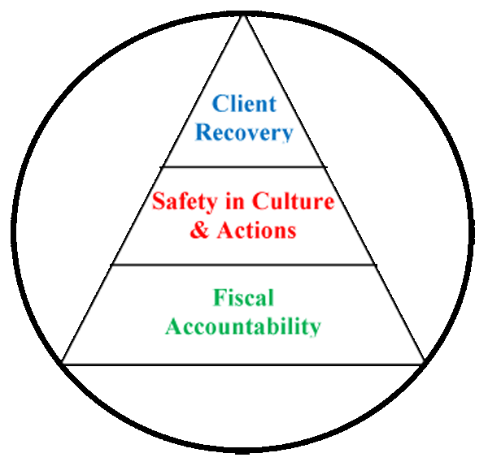
Building a framework for client recovery by
ensuring fiscal accountability
and a culture of organizational safety
through the promotion of…

- The conviction that staffs are concerned with doing the right thing in support of client rights and recovery;
- A philosophy that promotes an understanding that errors most often occur as a result of deficiencies in system design or deployment;
- Systems and processes that strive to evaluate and mitigate risks and identify the root cause of operational deficits or deficiencies without erroneously assigning blame to system stakeholders;
- The practice of engaging staffs and clients in the planning and implementing of organizational policy and protocol as a critical step in the development of a system that fulfills ethical and regulatory requirements while maintaining a practicable workflow;
- A cycle of improvement that aligns organizational performance objectives with key success factors determined by stakeholder defined strategic imperatives.
- Enhanced communications and collaborative relationships within and between cross-functional work teams to support organizational change and effective process improvement;
- Transitions of care practices where knowledge is freely shared to improve the safety of clients before, during, and after care;
- A just culture that supports the emotional and physical needs of staffs, clients, and family members that are impacted by serious, acute, and cumulative events.
(Glossary of Terms, Acronyms & Abbreviations) (Back to Table of Contents)
STRATEGIC PERFORMANCE EXCELLENCE

Strategic Performance Excellence Model Reporting Process

Department of Health and Human Services Goals
Protect and enhance the health and well-being of Maine people
Promote independence and self sufficiency
Protect and care for those who are unable to care for themselves
Provide effective stewardship for the resources entrusted to the department

Dorothea Dix and Riverview Psychiatric Recovery Centers
Priority Focus Areas
Ensure and Promote Fiscal Accountability by…
Identifying and employing efficiency in operations and clinical practice
Promoting vigilance and accountability in fiscal decision-making.

Promote a Safety Culture by…
Improving Communication
Improving Staffing Capacity and Capability
Evaluating and Mitigating Errors and Risk Factors
Promoting Critical Thinking
Supporting the Engagement and Empowerment of Staffs

Enhance Client Recovery by…
Develop Active Treatment Programs and Options for Clients
Supporting clients in their discovery of personal coping and improvement activities.

Each Department Determines Unique Opportunities and Methods
to Address the Hospital Goals
The Quarterly Report Consists of the Following

Define

Opportunities for Improvement (OFIs)

Performance Objectives

Measure

Current Performance

Analyze

Current Performance
Gaps

Current Work Flow Process

Identify Root Causes of Performance Gaps

Improve

Work Process Plans and Procedures

Implement the Planned Changes

Establish Incremental Goals & Measures

Control

Validate Improvements Achieved

Develop Systems to Sustain Improvements

(Glossary of Terms, Acronyms & Abbreviations) (Back to Table of Contents)
STRATEGIC PERFORMANCE EXCELLENCE

Admissions Office

Number of Admissions

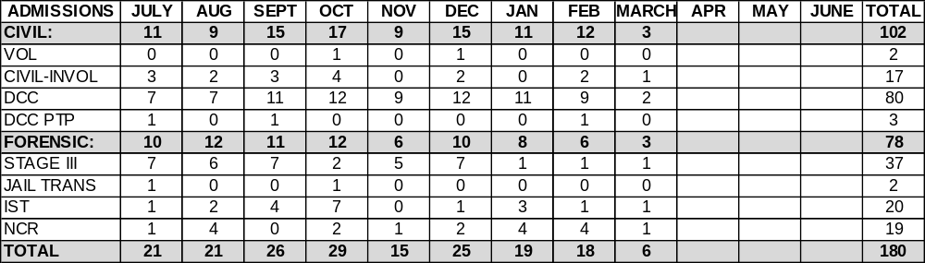

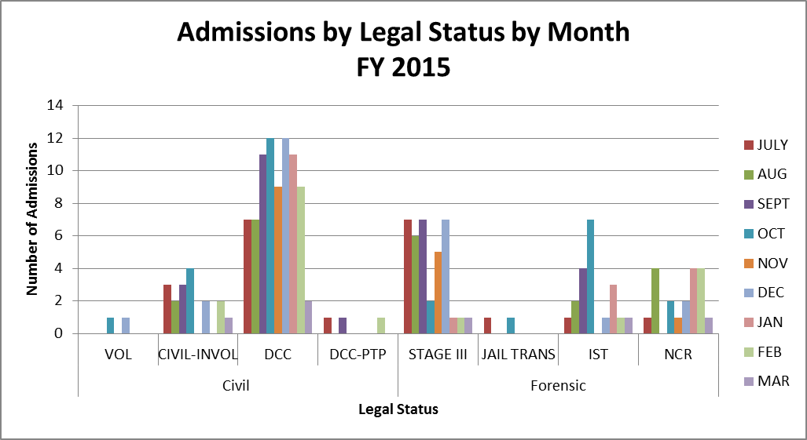

(Glossary of Terms, Acronyms & Abbreviations) (Back to Table of Contents)
STRATEGIC PERFORMANCE EXCELLENCE

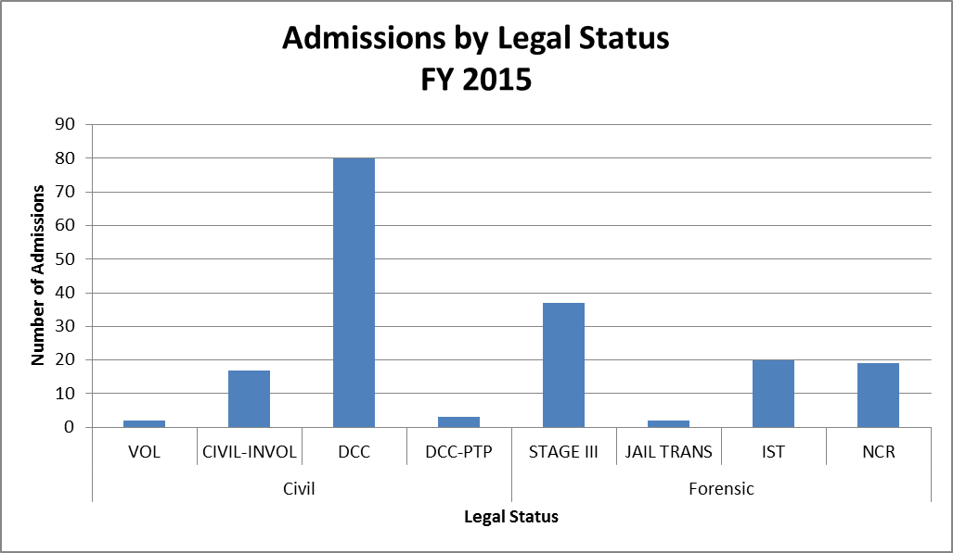

Average Number of Wait Days
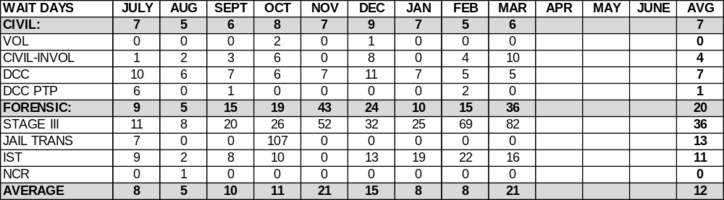
(Glossary of Terms, Acronyms & Abbreviations) (Back to Table of Contents)
STRATEGIC PERFORMANCE EXCELLENCE

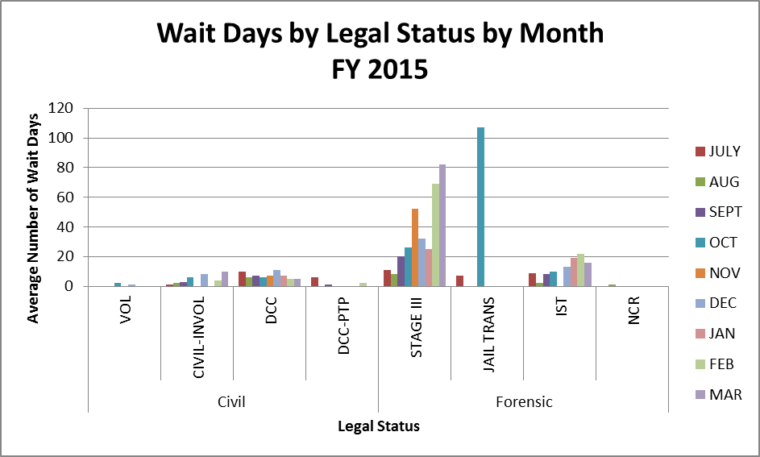

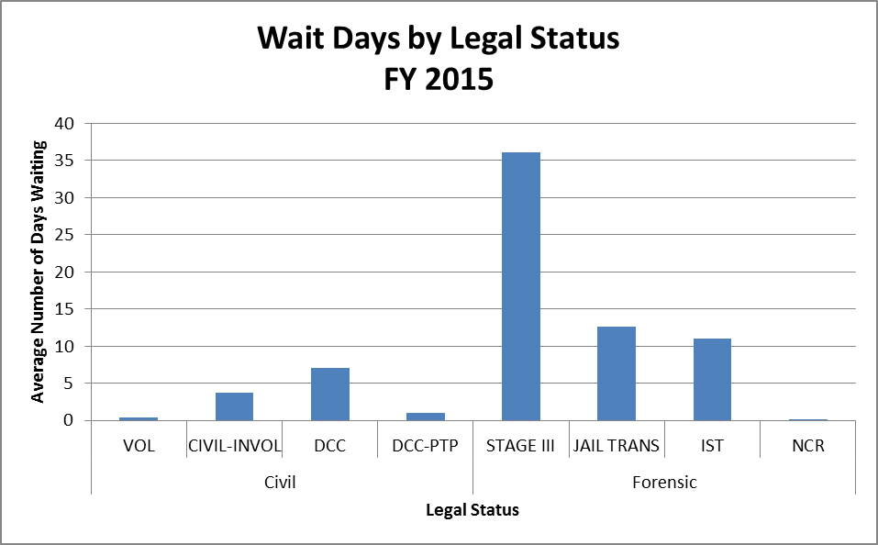
(Glossary of Terms, Acronyms & Abbreviations) (Back to Table of Contents)
STRATEGIC PERFORMANCE EXCELLENCE

Number of Discharges
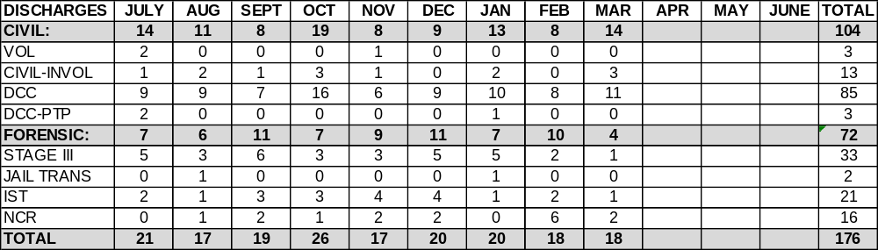

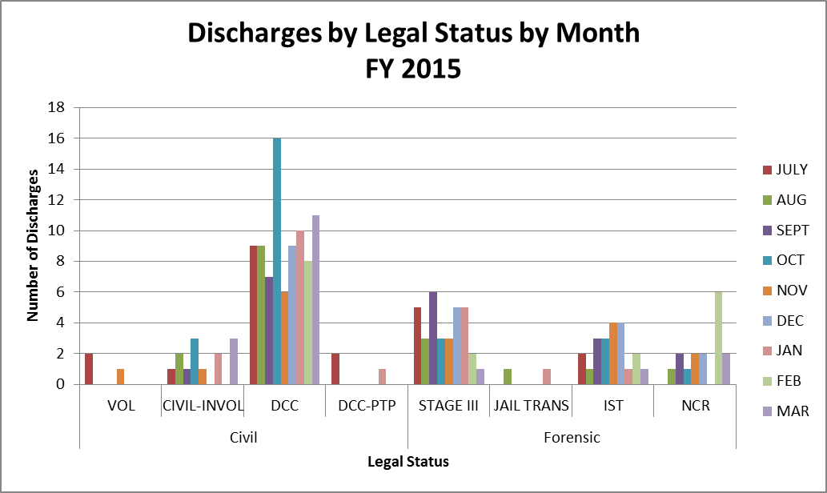
(Glossary of Terms, Acronyms & Abbreviations) (Back to Table of Contents)
STRATEGIC PERFORMANCE EXCELLENCE

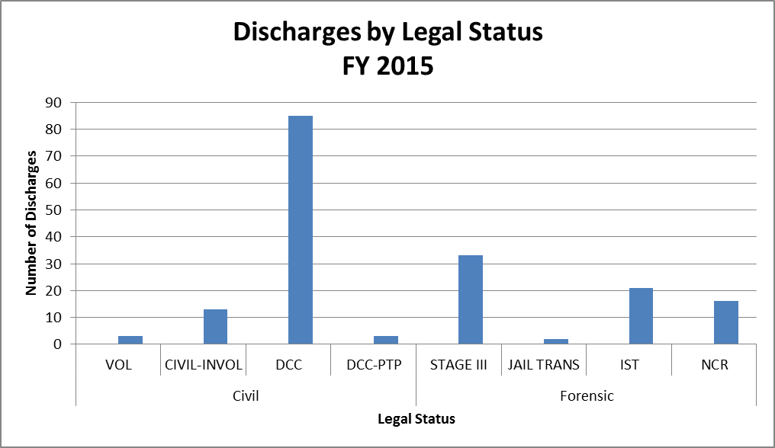

Average Length of Stay (Days)
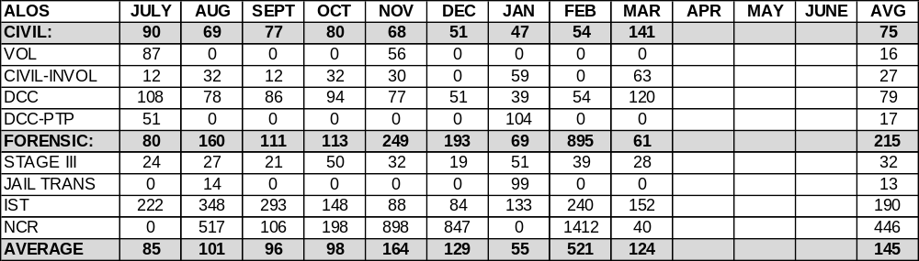
(Glossary of Terms, Acronyms & Abbreviations) (Back to Table of Contents)
STRATEGIC PERFORMANCE EXCELLENCE

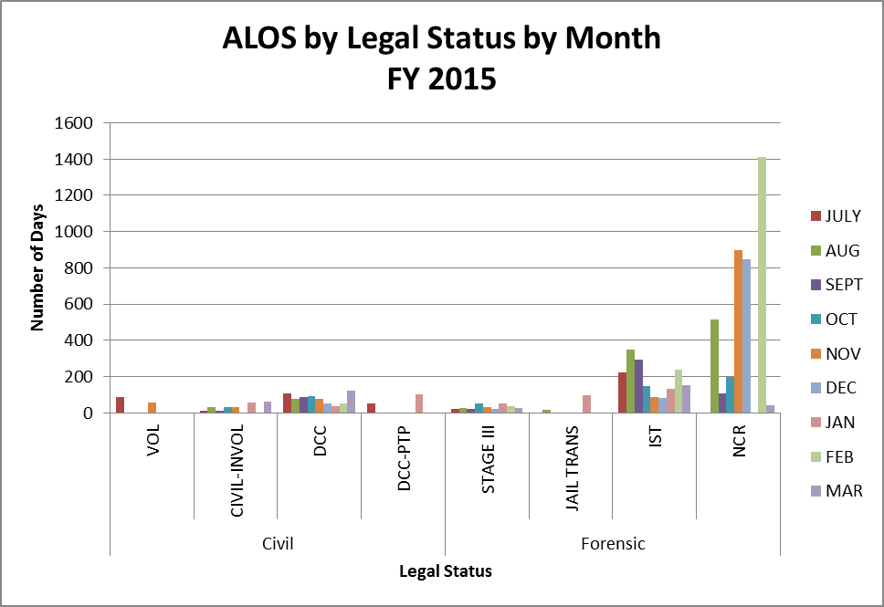

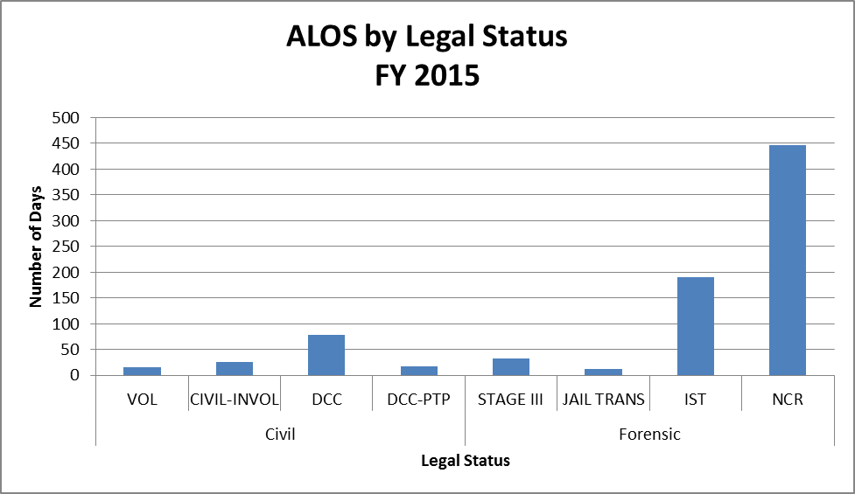
(Glossary of Terms, Acronyms & Abbreviations) (Back to Table of Contents)
STRATEGIC PERFORMANCE EXCELLENCE

Capital Community Clinic
Medication Management

Performance Improvement Measure

Measure Name: Reconciliation of Medication List
Measure Description: Each visit will cover Reconciliation of Medical & Psychotropic Medications with patients.

Results
 | Unit | Baseline | Q1 | Q2 | Q3 | Q4 | YTD
Target | 100%  Reconciliation completed per patient visit | FY 2014  100% | 52/100% | 54/100% | 46/100% | 100%
Actual | 100%  Reconciliation completed per patient visit | FY 2014  100% | 0/0% | 40/74/% | 46/100%

Comments: Not all patients know what they are taking for meds. Staff will call the residence, case manager or the pharmacy and ask for a med list. It is our goal to keep the care consistent with each patient. The goal is 100% for this PI.

Quality Improvement Measure

Measure Name: Vital signs
Measure Description: Taking vital signs each visit will give us an idea of the effects of the prescribed medications and early detection of possible medical problems with the patient.

Results
 | Unit | Baseline | Q1 | Q2 | Q3 | Q4 | YTD
Target | 100%  Vital signs completed  Each visit | FY 2014  100% | 52/100% | 54/100% | 46/100% | 100%
Actual | 100%  Vital signs completed  Each visit | FY 2014  100% | 38/73% | 40/74% | 28/61%

Comments: Goal is 100% which should be close to the end of the quarter. At this time the clinic is in process of hiring a nurse. Staff will continue to reach the goal of 100%

(Glossary of Terms, Acronyms & Abbreviations) (Back to Table of Contents)
STRATEGIC PERFORMANCE EXCELLENCE

Dietary Services

Responsible Party: Kristen Piela DSM

Strategic Objective: Safety in Culture and Actions
Hand Hygiene Compliance: In an effort to monitor, sustain and improve hand hygiene compliance, the Dietary department measures its results through observations of Dietary staff when returning from a scheduled break.
 | 1st Quarter 2015 |  |  | 2nd Quarter 2015 |  |  | 3rd Quarter 2015 |  |  | 4th Quarter 2015 |  |  | Goal
Baseline | Target – Baseline | Findings | Compliance | Target – Q1 + 12% | Findings | Compliance | Target – Q2 + 12% | Findings | Compliance | Target – Q3 + 12% | Findings | Compliance | Goal
53% | 58% | 138/  238 | 58% | 70% | 116/  189 | 61% | 82% | 621/  629 | 99% |  |  |  | 80-90%

Data:
621 compliant observations of 629 hand hygiene observations = 99% hand hygiene compliance rate

Summary:
- Hand hygiene compliance has increased by 38%.
- Hand hygiene observations have increased; from 189 observations last quarter to 629 observations this quarter.
- Adapting the current Hand Hygiene Monitoring Tool to include specific dates has improved the number of observations
- Including hand hygiene observations as part of the daily task assignments for supervisors has improved the number of observations.
- Supervisors are consistently reminding employees to adhere to hand hygiene. Thus, improving compliance.
- Employees are aware of the daily observances, by the supervisory staff. Thus, improving compliance.

Action Plan:
- The Dietetic Services Manager will review these findings with the supervisors to assure observances are being documented correctly.
- The Dietetic Services Manager will request unplanned observations are completed by managerial staff.
- The Food Service Manager will present this quarterly report at the departmental staff meeting.

(Glossary of Terms, Acronyms & Abbreviations) (Back to Table of Contents)
STRATEGIC PERFORMANCE EXCELLENCE

Strategic Objective: Safety in Culture and Actions
Nutrition Screen Completion: In an effort to monitor, improve and sustain timely completion of the nutrition screen for all admissions to RPRC. The Registered Dietitian will review each Nutrition Screen within the Initial Nursing Admission Data. This screen will be completed by Nursing within 24 hours of admission.
 | 1st Quarter 2015 |  |  | 2nd Quarter 2015 |  |  | 3rd Quarter 2015 |  |  | 4th Quarter 2015 |  |  | Goal
Baseline | Target – Baseline | Findings | Compliance | Target – Q1 + 3% | Findings | Compliance | Target – Q2 + 2% | Findings | Compliance | Target – Q3 + 3% | Findings | Compliance | Goal
96% | 96% | 75/80 | 94% | 97% | 71/72 | 99% | 100% | 43/43 | 100% |  |  |  | 95-100%

Data:
43 Nutrition screens completed w/in 24 hours of admission
43 Total Admissions = 100% of nutrition screens completed within 24 hours of admission

Summary:
- The Registered Dietitian reviewed the nutrition screens of 43 admissions for this quarter.
- Upon review, the RD discovered all nutrition screens complete.
- Continued correspondence with unit nursing staff has improved completion of this monitor.

Action Plan:
- RD will continue to correspond with the admission nurse to assure completion of the nutrition screens.
- Present quarterly report at departmental staff meeting and IPEC meeting.

(Glossary of Terms, Acronyms & Abbreviations) (Back to Table of Contents)
STRATEGIC PERFORMANCE EXCELLENCE

Emergency Management (Support Services)

Quality Assessment and Performance Improvement Program

DEPARTMENT: EMERGECNY MANAGEMENT
DEPARTMENT HEAD: Rick Levesque, Director of Support Services
REPORTED BY: Robert Patnaude, Emergency Management Coordinator

Measure Name: Communications Equipment/Two-way radios

Measure Description:
The Joint Commission states the following in EM.02.02.01: “As part of its Emergency Operations Plan, the hospital prepares for how it will communicate during emergencies. The hospital maintains reliable communications capabilities for the purpose of communicating response efforts to staff, patients, and external organizations.”
In the event of an unforeseen emergency which could impact the safety and security of patients, staff, and visitors, communications equipment, more specifically, two-way radios are a major solution to getting accurate information to and from staff in a timely manner. The objective of the Emergency Management Communications PI is to ensure compliance with the Joint Commission standard with the overall objective of ensuring that the two-way radio system is fully functional and that staff are proficient in its use.

Type of Measure: Performance Improvement

METHODOLOGY: Each month, the Emergency Management Coordinator or designee will perform a combination of partial and hospital-wide radio drills. Such drills will utilize a specific form to track the drills. (See attached). In conjunction with the drills, environmental rounds will be conducted for the purpose of inspecting communications equipment. Any deficiencies shall have the appropriate corrective measure immediately instituted until compliance is met.
The numerator is the number of timely and appropriate responses by staff utilizing the two-way radios by assignments. The denominator will be the total number of two-way radios by assignments.

BASELINE DATA: To assure that critical emergency information is disseminated in a timely and accurate manner, a minimum of 90% compliance has been established. This data will be reported monthly to the Emergency Management Committee, IPEC, and the Environment of Care Committee (EOC). Areas that fail to meet the Threshold will be immediately reported to the aforementioned committees.

(Glossary of Terms, Acronyms & Abbreviations) (Back to Table of Contents)
STRATEGIC PERFORMANCE EXCELLENCE

Results
 | Unit | Baseline | Q1 | Q2 | Q3 | Q4 | YTD
Target | Percent of timely and appropriate responses | FY 2016  90/51  90% | ** | ** | *76/51 | 76/51  90% | 76/51  90%
Actual | Percent of timely and appropriate responses | FY 2016  90/51  90% | ** | ** | *39/51 | /51 | 39/51  76%
**This is a new indicator as of March 1, 2015, therefore no data for Q1 and Q2.
* Since this is a new indicator as of March 1st, there is only data for March of Q3.

Data Analysis: Data showed that staff were not familiar with operating the radio beyond the primary channel.

Action Plan: Remedial training to staff along with supporting handouts.

Comments: Units were timely in the initial response but were unable to change to the TAC channel. Security immediately responded to all units to instruct them and then conducted a successful test.

Graph/Chart:
MONTHLY TOTALS/2015
AREAS/GROUPS MONITORED  n=numerator d= denominator | MAR  n/d | APR  n/d | MAY  n/d | JUN  n/d | JUL  n/d | AUG  n/d | SEPT  n/d | OCT  n/d | NOV  n/d | DEC  n/d
PATIENT CARE AREAS/#of radios
- JOB COACH/1 | 1/1*
- OUT-PATIENT SERVICES/2 | 2/2*
- TX MALL, CLINIC, DIETARY, MED RECORDS/5 | 5/5*
- US, UK, LS, LSSCU, LK, LKSCU/10 | 0/10
SUPPORT SERVICES/#of radios
- ADMINISTRATION/3 | 3/3*
- HOUSEKEEPING/8 | 8/8*
- MAINTENANCE/14 | 14/14*
- NOD/1 | 0/1
- NURSING SERVICES/1 | 1/1*
- OPERATIONS/1 | 1/1
- SECURITY/4 | 4/4
- STATE FORENSIC SERVICES/1 | 1/1*
PATIENT CARE AREAS | 7/18
SUPPORT SERVICES | 32/33
TOTAL | 39/51
*Radio units not on duty due to shift assignment therefore given same weight in order not to have a negative impact.
(Glossary of Terms, Acronyms & Abbreviations) (Back to Table of Contents)
STRATEGIC PERFORMANCE EXCELLENCE

Harbor Treatment Mall

Unit: All three units January, February, and March 2015
Accountability Area: Harbor Mall
Aspect: Harbor Mall Hand-off Communication
Overall Compliance: 86%

Objectives | 4Q2014 | 1Q2015 | 2Q2015 | 3Q2015
1. Hand-off communication sheet was received at the Harbor Mall within the designated time frame. | 71%  30/42 | 71%  30/42 | 76%  32/42 | 86%  36/42
2. SBAR information completed from the units to the Harbor Mall. | 79%  33/42 | 81%  34/42 | 86%  36/42 | 86%  36/42

DEFINE: To provide the exchange of client-specific information between the client care units and the Harbor Mall for the purpose of ensuring continuity of care and safety within designated time frames.

MEASURE: Indicator number one has increased from 76% last quarter to 86% for this quarter. Indicator number two has remained the same at 86% for last quarter and this quarter.

ANALYZE: Overall compliance has increased from 81% last quarter to 86% for this quarter. Indicator number one increased, increased and decreased for the three months. Indicator number two increased all three months. Ten HOC sheets were late for last quarter and six HOC were late for this quarter. Continue to concentrate on both indicators to improve current performance gaps.

IMPROVE: Lisa Manwaring will review the results at Nursing Leadership.

CONTROL: The plan is to continue to monitor the data and follow up with any unit(s) who may be having difficulties in developing a consistent system that works for them to meet the objectives.
(Glossary of Terms, Acronyms & Abbreviations) (Back to Table of Contents)
STRATEGIC PERFORMANCE EXCELLENCE

Health Information Technology (Medical Records)
Documentation and Timeliness

Indicators | 3Q15  Findings | 3Q15  Compliance | Threshold Percentile
Records will be completed within Joint Commission standards, state requirements and Medical Staff bylaws timeframes. | There were 56 discharges. Of those, 56 were completed within 30 days. | 100% | 80%
Discharge summaries will be completed within 15 days of discharge. | 53 out of 56 discharge summaries were completed within 15 days of discharge. | 95% | 100%
All forms/revisions to be placed in the medical record will be approved by the Medical Records Committee. | 4 forms were approved/ revised in quarter 3 2015 (see minutes). | 100% | 100%
Medical transcription will be timely and accurate. | Out of 809 dictated reports, 809 were completed within 24 hours. | 100% | 90%

Summary: The indicators are based on the review of all discharged records. There was 100% compliance with 30 day record completion. Weekly “charts needing attention” lists are distributed to medical staff, including the Medical Director, along with the Superintendent, Risk Manager and the Quality Improvement Manager. There was 100% compliance with timely & accurate medical transcription services.

Actions: Continue to monitor.

(Glossary of Terms, Acronyms & Abbreviations) (Back to Table of Contents)
STRATEGIC PERFORMANCE EXCELLENCE

Health Information Technology (Medical Records)
Confidentiality

Indicators | 3Q15  Findings | 3Q15  Compliance | Threshold Percentile
All client information released from the Health Information department will meet all Joint Commission, State, Federal & HIPAA standards. | 4,541 requests for information (108 requests for client information and 4,433 police checks) were released | 100% | 100%
All new employees/contract staff will attend confidentiality/HIPAA training. | 23 new employees/contract staff | 100% | 100%
Confidentiality/Privacy issues tracked through incident reports. | 1 privacy-related incident report |  | 100%

Summary: The indicators are based on the review of all requests for information, orientation for all new employees/contract staff and confidentiality/privacy-related incident reports.

No problems were found in 3Q2015 related to release of information from the Health Information department and training of new employees/contract staff, however compliance with current law and HIPAA regulations need to be strictly adhered to requiring training, education and policy development at all levels.

Actions: The above indicators will continue to be monitored.

(Glossary of Terms, Acronyms & Abbreviations) (Back to Table of Contents)
STRATEGIC PERFORMANCE EXCELLENCE

Health Information Technology (Medical Records)
Medical Record Compliance

Indicators | January 2015  Findings | Compliance | Threshold Percentile
All Progress notes are authenticated within 7 days | 428 progress notes were created for January. Out of those 4 were not authenticated within 7 days. | 99% | 90%
Discharge Instructions are in a manner that the client and/or family member/caregiver understand. | 18 Closed records were reviewed, 17 of those included the D/C pharmacy labels, 18 were documented that medication teaching was Completed In Client Friendly Language at Discharge | 94% | 90%

Summary: Indicators are based on 100% of progress notes created per month. Physicians’ progress notes are audited to ensure authentication is occurring within 7 days of availability in the EMR per RPRC’s Medical Record Completion Policy (MS.3.20).

The indicators for the Discharge Instructions (consolidated aftercare form) are based on 100% of discharges occurring each month over 4 consecutive months.

Actions: The above indicators will be reviewed for 4 consecutive months (beginning in January 2014) providing review yields 90% threshold or above per TJC corrective action plan

(Glossary of Terms, Acronyms & Abbreviations) (Back to Table of Contents)
STRATEGIC PERFORMANCE EXCELLENCE

Health Information Technology (Medical Records)
Medical Record Compliance

Indicators | February 2015  Findings | Compliance | Threshold Percentile
All Progress notes are authenticated within 7 days | 397 progress notes were created for February. Out of those 0 were not authenticated within 7 days. | 100% | 90%
Discharge Instructions are in a manner that the client and/or family member/caregiver understand. | 18 Closed records were reviewed, 17 of those included the D/C pharmacy labels, 18 were documented that medication teaching was Completed In Client Friendly Language at Discharge | 94% | 90%

Summary: Indicators are based on 100% of progress notes created per month. Physicians’ progress notes are audited to ensure authentication is occurring within 7 days of availability in the EMR per RPRC’s Medical Record Completion Policy (MS.3.20).

The indicators for the Discharge Instructions (consolidated aftercare form) are based on 100% of discharges occurring each month over 4 consecutive months.

Actions: The above indicators will be reviewed for 4 consecutive months (beginning in January 2014) providing review yields 90% threshold or above per TJC corrective action plan.

(Glossary of Terms, Acronyms & Abbreviations) (Back to Table of Contents)
STRATEGIC PERFORMANCE EXCELLENCE

Health Information Technology (Medical Records)
Medical Record Compliance

Indicators | March 2015  Findings | Compliance | Threshold Percentile
All Progress notes are authenticated within 7 days | 467 progress notes were created for March. Out of those 0 were not authenticated within 7 days. | 100% | 90%
Discharge Instructions are in a manner that the client and/or family member/caregiver understand. | 18 Closed records were reviewed, 17 of those included the D/C pharmacy labels, 18 were documented that medication teaching was Completed In Client Friendly Language at Discharge | 94% | 90%

Summary: Indicators are based on 100% of progress notes created per month. Physicians’ progress notes are audited to ensure authentication is occurring within 7 days of availability in the EMR per RPRC’s Medical Record Completion Policy (MS.3.20).

The indicators for the Discharge Instructions (consolidated aftercare form) are based on 100% of discharges occurring each month over 4 consecutive months.

Actions: The above indicators will be reviewed for 4 consecutive months (beginning in January 2014) providing review yields 90% threshold or above per TJC corrective action plan.
(Glossary of Terms, Acronyms & Abbreviations) (Back to Table of Contents)
STRATEGIC PERFORMANCE EXCELLENCE

Health Information Technology (Medical Records)
Discharge Instructions Process Improvement
January 2015

Define:
The hospital provides written discharge instructions in a manner that the patient and/or patient’s family member or caregiver can understand.

Measure:
20 Discharges in January 2015 were reviewed. The consolidated aftercare forms are being utilized as a form of discharge instruction and accompanying the aftercare forms are the pharmacy labels which clearly define the medication, its frequency, and its use.

Analyze:
After review of 20 closed charts the following was discovered; 2 charts missing D/C pharmacy labels. 1 chart not documented given in patient friendly language. A trend found is the lack of a patient signature or documentation as to why pages 2, 3& 5 of the aftercare are not being signed by the patient/guardian for acknowledgement.
- L.L – missing pharmacy labels (D/C to homeless)
- M.M. – missing pharmacy labels (D/C to home)
- P.O. – Pt friendly language not documented as completed ( D/C to jail)

Improve:
Improvements could be made by assessing the discharge process to ensure pharmacy labels are being created for all patients leaving the facility with medications. Improvement could be made by utilizing typed formats. A “page four of the aftercare” has been created and implemented as a work type in Meditech. All providers have access to use that and are encouraged to do so. Also, as we utilize the aftercare format as the discharge instruction it has been made available as a fillable form electronically. Please note the use of abbreviations is strongly discouraged in the discharge instruction. Handwriting is discouraged.

Control: 100% of the closed records are being audited.

(Glossary of Terms, Acronyms & Abbreviations) (Back to Table of Contents)
STRATEGIC PERFORMANCE EXCELLENCE

Health Information Technology (Medical Records)
Discharge Instructions Process Improvement
February 2015

Define:
The hospital provides written discharge instructions in a manner that the patient and/or patient’s family member or caregiver can understand.

Measure:
18 Discharges in February 2015 were reviewed. The consolidated aftercare forms are being utilized as a form of discharge instruction and accompanying the aftercare forms are the pharmacy labels which clearly define the medication, its frequency, and its use.

Analyze:
After review of 18 closed charts the following was discovered; 1 chart did not have the patient friendly language selected nor was it signed by the patient prior to discharge. 2 charts were missing the pharmacy labels required for discharge. One chart had med education in patient friendly language done however was not signed by the patient.
- A.L. – aftercare patient friendly language not selected and not signed by patient (pt. D/C to group home from LK)
- L.D. – not pharmacy labels in chart and no patient signature on pg. 5 (med edu.) ( Pt. D/C to group home from US)
- D.B. – No pharmacy labels. (Pt. transferred to DDPC)

Improve:
Improvements could be made by assessing the discharge process to ensure pharmacy labels are being created for all patients leaving the facility with medications. Improvement could be made by utilizing typed formats. A “page four of the aftercare” has been created and implemented as a work type in Meditech by transcription. All providers have access to use that and are encouraged to do so. Also, as we utilize the aftercare format as the discharge instruction it has been made available as a fillable form electronically. Please note the use of abbreviations is strongly discouraged in the discharge instruction. Handwriting is discouraged.

Control: 100% of the closed records are being audited.

(Glossary of Terms, Acronyms & Abbreviations) (Back to Table of Contents)
STRATEGIC PERFORMANCE EXCELLENCE

Health Information Technology (Medical Records)
Discharge Instructions Process Improvement
March 2015

Define:
The hospital provides written discharge instructions in a manner that the patient and/or patient’s family member or caregiver can understand.

Measure:
18 Discharges in March 2015 were reviewed. The consolidated aftercare forms are being utilized as a form of discharge instruction and accompanying the aftercare forms are the pharmacy labels which clearly define the medication, its frequency, and its use.

Analyze:
After review of 18 closed charts the following was discovered; 1 chart is missing the pharmacy labels required for discharge. One chart had med education in patient friendly language done however was not signed by the patient.
- D.S. – No pharmacy labels (Pt. discharged to nursing home)

Improve:
Improvements could be made by assessing the discharge process to ensure pharmacy labels are being created for all patients leaving the facility with medications. Improvement could be made by utilizing typed formats. A “page four of the aftercare” has been created and implemented as a work type in Meditech by transcription. All providers have access to use that and are encouraged to do so. Also, as we utilize the aftercare format as the discharge instruction it has been made available as a fillable form electronically. Please note the use of abbreviations is strongly discouraged in the discharge instruction. Handwriting is discouraged.

Control: 100% of the closed records are being audited.
(Glossary of Terms, Acronyms & Abbreviations) (Back to Table of Contents)
STRATEGIC PERFORMANCE EXCELLENCE

Health Information Technology (Medical Records)
Release of Information for Concealed Carry Permits

Define
The process of conducting background checks on applicants for concealed carry permits is the responsibility of the two State psychiatric hospitals. Clients admitted to private psychiatric hospitals, voluntarily or by court order, are not subject to this review. Delays in the processing of background checks has become problematic due to an increasing volume of applications and complaints received regarding delays in the processing of these requests
Analyze
Data collected for the 3Q2015 showed that we received 2055 applications. This is a small decrease from last quarter 2Q2015 when we received 2094 applications.
Improve
The process has been streamlined as we have been working with the state police by eliminating the mailing of the applications from them to RPRC and DDPC. RPRC has reactivated the medical records email to receive lists of the applicants from the state police that include the DOB and any alias they may have had. This has cut down on paper as well as time taken sorting all the applications.

NOTE: At the end of the reporting period, there were 0 police checks outstanding for Riverview Psychiatric Recovery Center. We are now processing requests for concealed weapons checks via an emailed listing from the State Police.

OIT has also created a new patient index in which we are in the process of consolidating sources we search into this one system. Over time this will decrease time spent searching as we will no longer have to search several sources. This is ongoing.

Year | FY 2014 |  |  | FY 2015 |  |  |  |  |  |  |  |  | Total
Month | Apr | May | Jun | Jul | Aug | Sep | Oct | Nov | Dec | Jan | Feb | Mar | Total
# Applications Received | 895 | 816 | 614 | 681 | 598 | 629 | 842 | 640 | 612 | 655 | 594 | 806 | 8382
(Glossary of Terms, Acronyms & Abbreviations) (Back to Table of Contents)
STRATEGIC PERFORMANCE EXCELLENCE

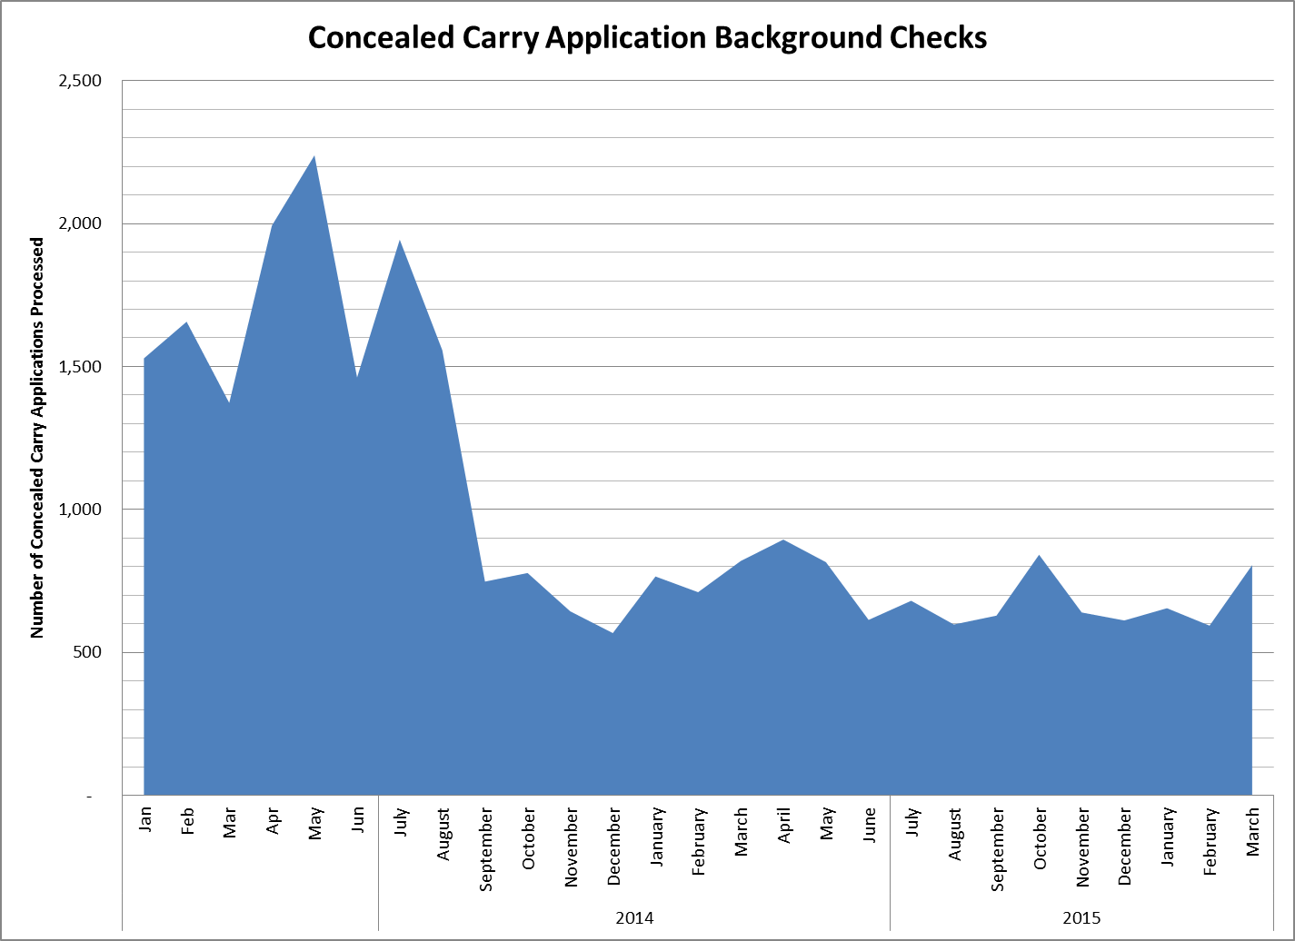

(Glossary of Terms, Acronyms & Abbreviations) (Back to Table of Contents)
STRATEGIC PERFORMANCE EXCELLENCE

Human Resources

Define
Completion of performance evaluations according to scheduled due dates continues to be problematic.
Measure
Current results are consistently below the 85% average quarterly performance goal.
Analyze
A thorough analysis of the root causes for lack of compliance with this performance standard is indicated.
Improve
In the interim, the Personnel Director has begun the process of reporting to hospital leadership the status of performance evaluation completion at least monthly so follow-up with responsible parties can be accomplished.
Control
Plans to modify hospital performance evaluation goals for supervisory personnel will include the completion of subordinate performance evaluations in a timely manner as a critical supervisory function.
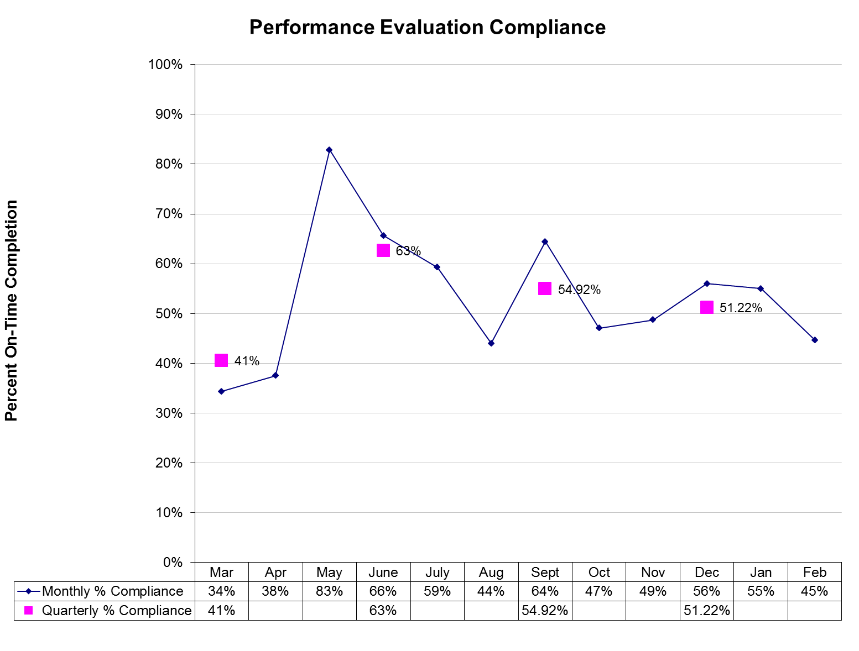
*Data not yet available for March 2015
(Glossary of Terms, Acronyms & Abbreviations) (Back to Table of Contents)
STRATEGIC PERFORMANCE EXCELLENCE

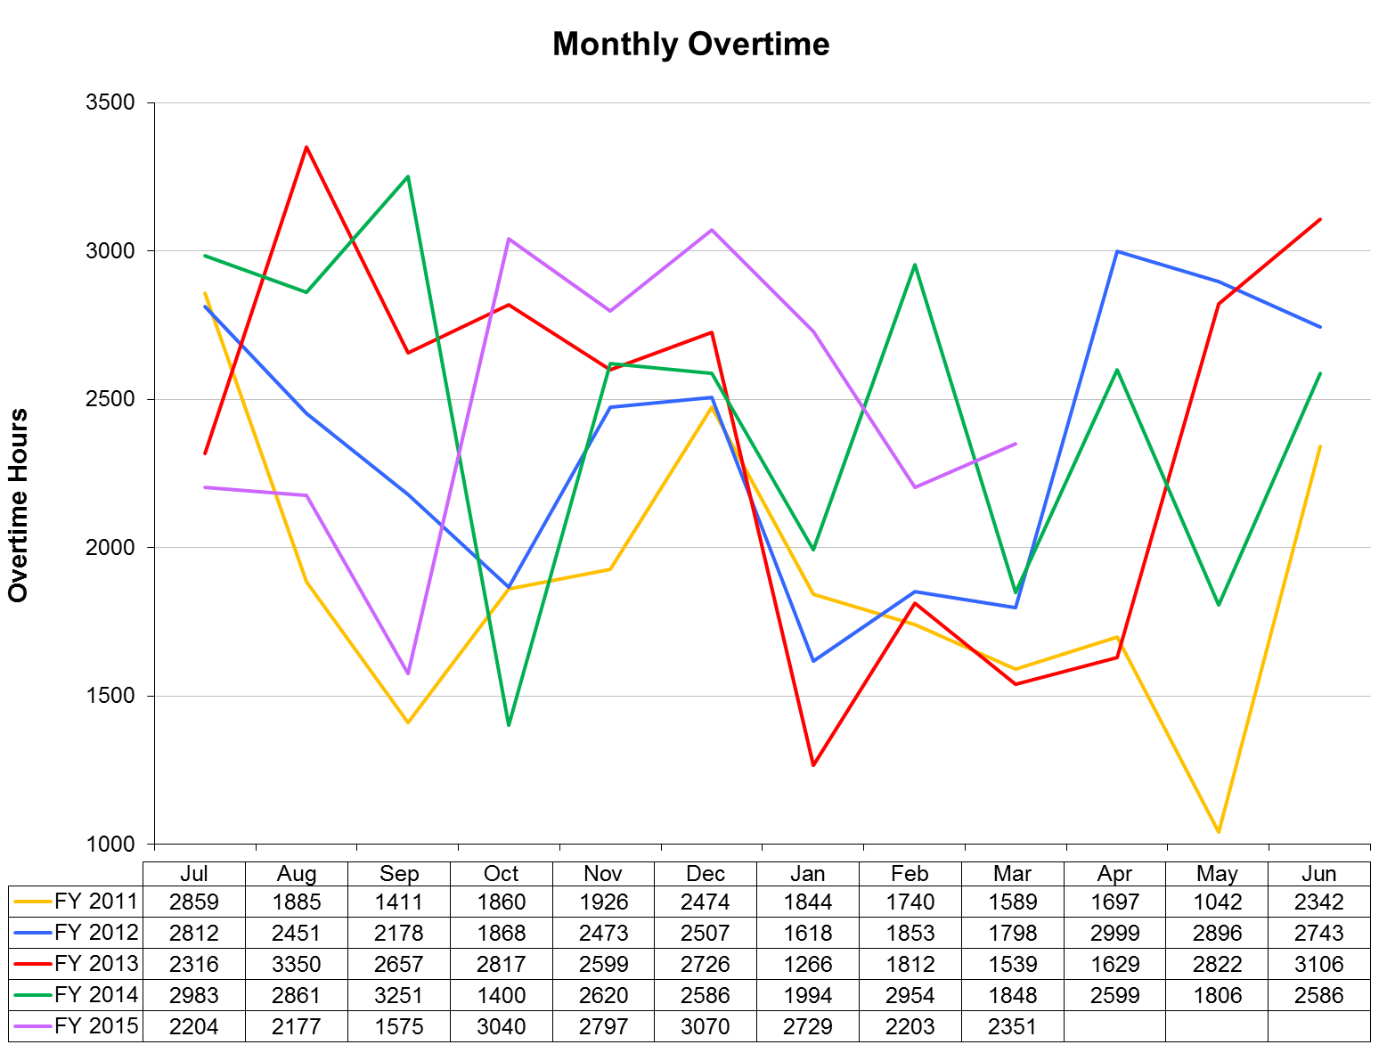
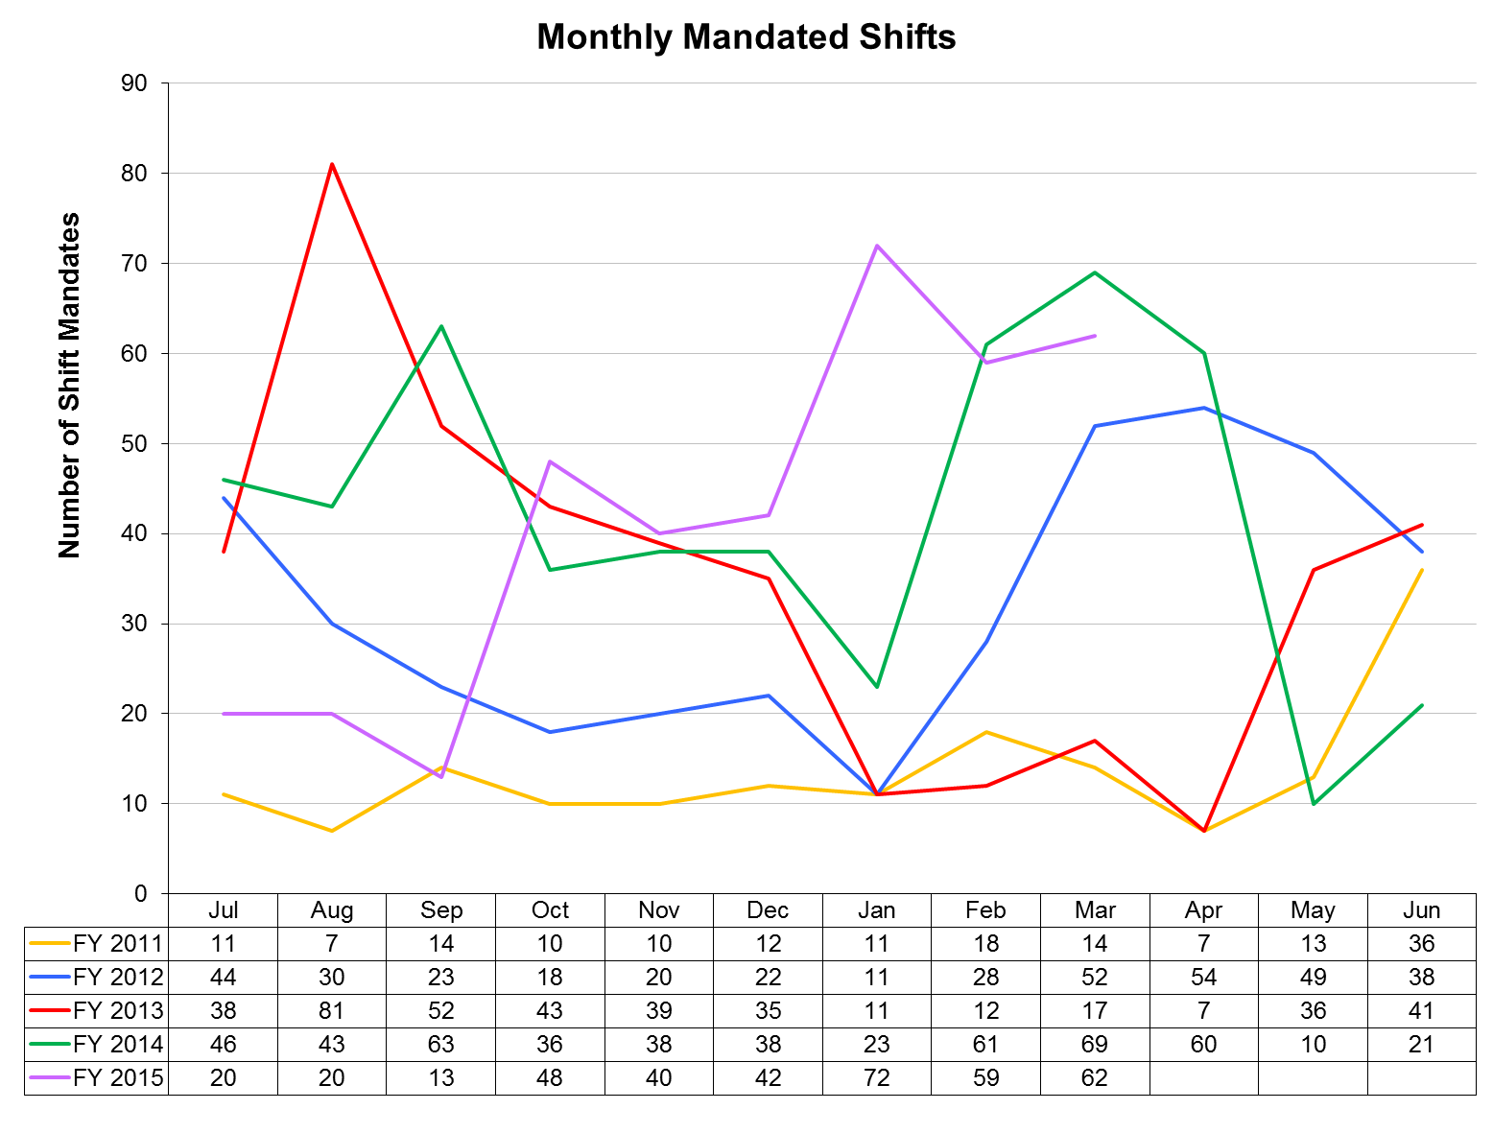
(Glossary of Terms, Acronyms & Abbreviations) (Back to Table of Contents)
STRATEGIC PERFORMANCE EXCELLENCE

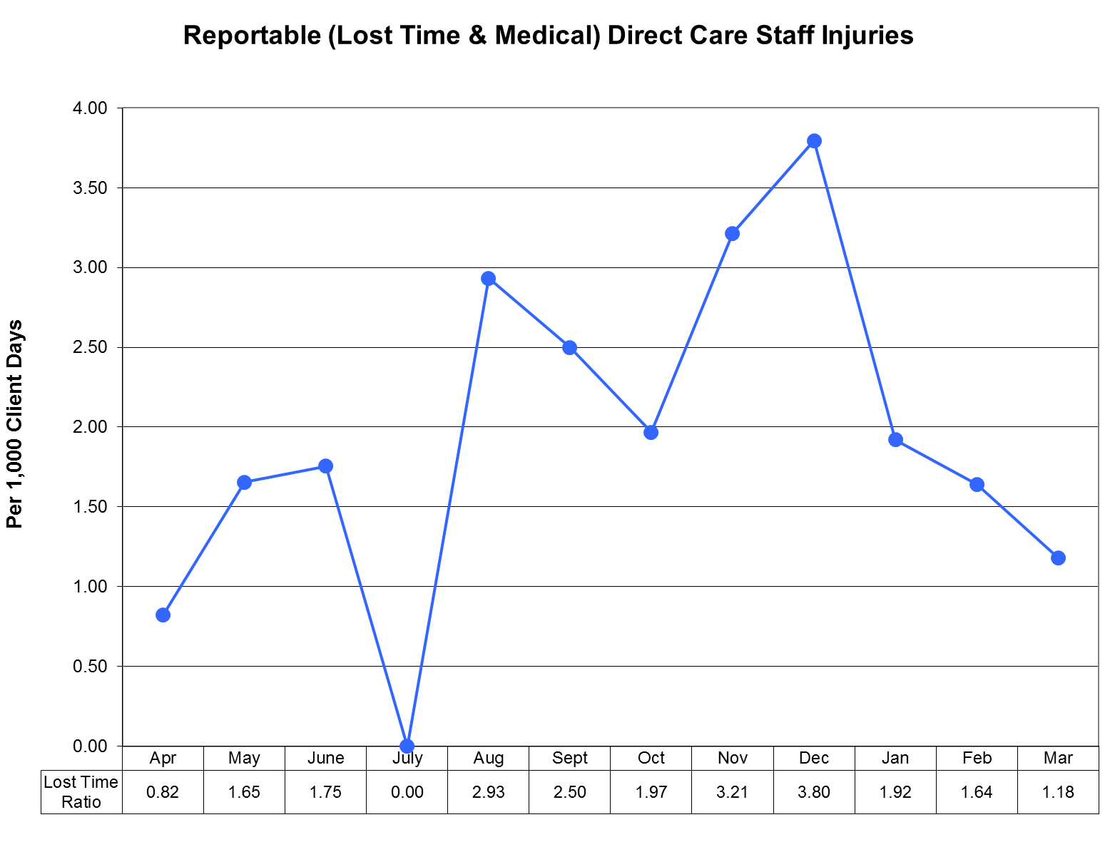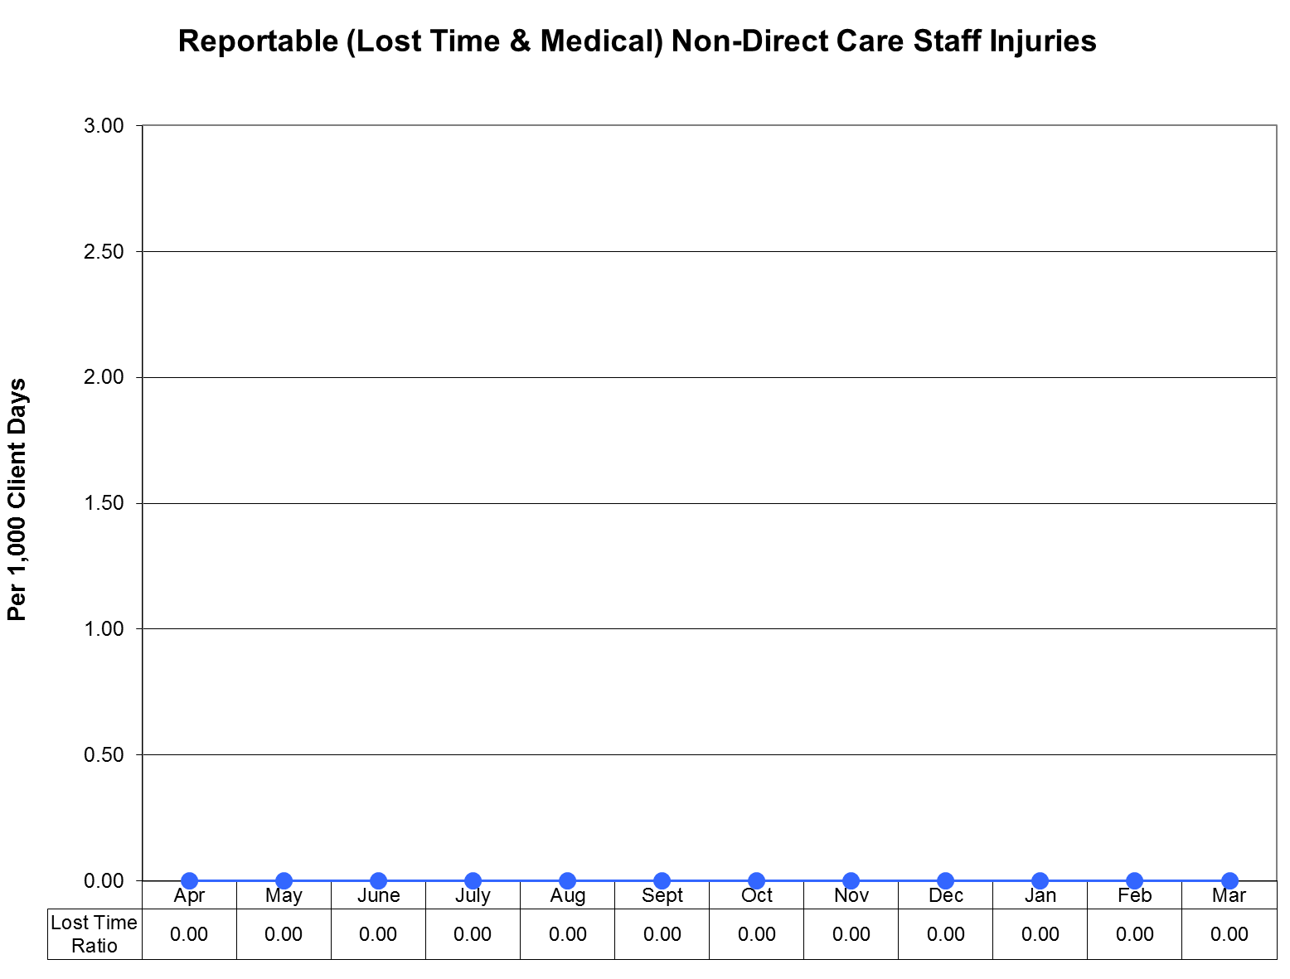
(Glossary of Terms, Acronyms & Abbreviations) (Back to Table of Contents)
STRATEGIC PERFORMANCE EXCELLENCE

Medical Staff
Quality Improvement Plan
FY 2015

As specified in Article Seven of the Medical Staff Bylaws, the improvement and assurance of medical staff quality and performance is of paramount importance to the hospital. This plan insures that the standards of patient care are consistent across all clinical services and all specialties and categories of responsible practitioners. Through a combination of internal and external peer review, indicator monitoring, focused case reviews of adverse outcomes or sentinel events, routine case reviews of patients with less than optimal outcomes, and the establishment of performance improvement teams when clinical process problems arise, the medical staff will insure quality surveillance and intervention activities appropriate to the volume and complexity of Riverview’s clinical workload. Medical Staff Quality Improvement efforts will be fully integrated with the hospital-wide Integrated Performance Excellence Committee (IPEC) so that information can be sent to and received from other clinical and administrative units of the hospital. The Clinical Director, assisted by the President of the Medical Staff, will serve as the primary liaison between the MEC and IPEC. Oversight of the Medical Staff Performance Improvement Plan is primarily delegated to the Clinical Director in conjunction with the President of the Medical Staff, the Director of Integrated Quality and Informatics, the Superintendent, and ultimately to the Advisory Board.

The goal of the Medical Staff Quality Improvement Plan is to provide care that is:

SAFE
EFFECTIVE
PATIENT CENTERED
TIMELY
EFFICIENT
EQUITABLE
DESIGNED TO IMPROVE CLINICAL OUTCOMES

To achieve this goal, medical staff members will participate in ongoing and systematic performance improvement efforts. The performance improvement efforts will focus on direct patient care processes and support processes that promote optimal patient outcomes. This is accomplished through peer review, clinical outcomes review, variance analysis, performance appraisals, and other appropriate quality improvement techniques.

1. Peer Review Activities:
- Regularly scheduled internal peer review by full time medical staff occurs on a monthly basis at the Peer Review and Quality Assurance Committee. The group of assembled clinicians will review case histories and treatment plans, and offer recommendations for possible changes in treatment plans, for any patient judged by the attending physician or psychologist, or others (including nursing, administration, the risk manager, or the Clinical Director), and upon request, to not be exhibiting a satisfactory response to their medical, psychological, or psychiatric regimens. Our goal is to discuss a case monthly. Detailed minutes of these reviews will be maintained, and the effectiveness of the reviews will be determined by recording feedback from the reviewed clinician as to the helpfulness of the recommendations, and by subsequent reports of any clinical improvements or changes noted in the patients discussed over time. Such intensive case reviews can also serve as the generator of new clinical monitors if frequent or systematic problem areas are uncovered.

(Glossary of Terms, Acronyms & Abbreviations) (Back to Table of Contents)
STRATEGIC PERFORMANCE EXCELLENCE

In addition all medical staff members (full and part-time) will have a minimum of one chart every other month peer reviewed and rated for clinical pertinence of diagnosis and treatment as well as for documentation. These may include admission histories and physicals, discharge summaries, and progress notes. The results of these chart audits are available to the reviewed practitioners and trends will be monitored by the Clinical Director as part of performance review and credentialing decisions.
- Special internal peer review or focused review. At the direction of the Clinical Director a peer chart review is ordered for any significant adverse clinical event or significant unexpected variance. Examples would be a death, seclusion or restraint of one patient for eight or more continuous hours, patient elopement, the prescribing of three or more atypical antipsychotics for the same patient at the same time, or significant patient injury attributable to a medical intervention or error.
- External peer review occurs regularly through contracts with the Maine Medical Association and the Community Dental Clinic program. We plan to continue our recent tradition of a biannual assessment of the psychiatry service and the medical service by peers in those clinical areas based on random record assessment of 25 cases in each service. An outside dentist from Community Dental will also review 20 charts of the hospital dentist for clinical appropriateness at least annually. Our contract with the Maine Medical Association also allows for special focused peer reviews of any unexpected death or when there is a question of a significant departure from the standard of care.

- MEC Subcommittee and IPEC Indicator Monitoring Activities:
The subcommittees of the MEC and the Integrated Performance Excellence Committee are the primary methods by which the medical staff monitor and analyze for trends all hospital-wide quality performance data as well as trends more specific to medical staff performance. The subcommittees, in turn, report their findings on a monthly basis to the Medical Executive Committee and to the Clinical Director for any needed action. The respective committees monitor the following indicators:
- Integrated Performance Excellence Committee (this is not a subcommittee of the Medical Staff but the Clinical Director serves as a member and is the primary liaison to the Medical Executive Committee).
  - Psychiatric Emergencies
  - Seclusion and Restraint Events
  - Staff or Patient Injuries
  - Priority I Incident Reports
  - Other clinical/administrative department monitoring activity
- Pharmacy and Therapeutics Committee:
  - Medication Errors Including Unapproved abbreviations
  - Adverse Drug Reactions
  - Pharmacy Interventions
  - Antibiotic Monitoring
  - Medication Use Evaluations
  - Psychiatric Emergency process
- Medical Records Committee:
  - Chart Completion Rate/Delinquencies
  - Clinical Pertinence of Documentation of Closed Records
- Infection Control Committee:
  - Infection Rates (hospital acquired and community acquired)
  - Staff Vaccination Rates/Titers
- Utilization Management Committee:
  - Admission Denials
  - Timeliness of Discharges After Denials

(Glossary of Terms, Acronyms & Abbreviations) (Back to Table of Contents)
STRATEGIC PERFORMANCE EXCELLENCE

- Peer Review and Quality Assurance Committee:
- Hospital-wide Core Measures and NASMHPD Data
- Patient Satisfaction Surveys
- Administrative concerns about quality
- Special quality improvement monitors for the current year (see also the Appendix and number 6 below).
- Reports from the Human Rights Committee regarding patient rights and safety issues
- Specific case reviews

3. Performance or Process Improvement Teams:
When requested by or initiated by other disciplines or by hospital administration, or when performance issues are identified by the medical staff itself during its monitoring activities, the Clinical Director will appoint a medical staff member to an ad hoc performance improvement team. This is generally a multidisciplinary team looking at ways to improve hospital wide processes. Currently the following performance improvement teams involving medical staff are in existence or have recently completed their reviews:
- Review of treatment plans
- Lower Saco Unit

4. Miscellaneous Performance Improvement Activities:
In addition to the formal monitoring and peer review activities described above, the Clinical Director is vigilant for methods to improve the delivery of clinical care in the hospital from interactions with, and feedback from, other discipline chiefs, from patients or from their complaints and grievances, and from community practitioners who interact with hospital medical staff. These interactions may result in reports to the Medical Executive Committee, in the creation of performance improvement teams, performance of a root-cause analysis, or counseling of individual practitioners.

5. Reports of Practitioner-specific Data to Individual Practitioners:
The office of the Clinical Director will provide confidential outcomes of practitioner-specific data to each medical staff member within 30 days of the end of the fiscal year. This information will be available without the necessity of the practitioner requesting it. It will be placed in the confidential section of the practitioner’s medical staff file and freely accessible during normal business hours. The office of the Clinical Director will notify all medical staff members when the data is available for review. Each medical staff member may discuss the data with the Clinical Director at any time.

6. Process to amend the quality improvement plan, including adding or deleting any monitors or processes:
Upon the recommendation of the Clinical Director, upon recommendation of the MEC as a whole after a request from any member of the medical staff, from a recommendation of the Integrated Performance Excellence Committee, or upon recommendation of the Advisory Board, this plan may be amended with appropriate approvals at any time. Examples of when amendments might be necessary are the detection of new clinical problems requiring monitoring or when it is discovered that current monitors are consistently at or near target thresholds for six consecutive months. Should the number of active clinical monitors fall below four at any time, replacement monitors will be activated within two months of termination of the previous monitor (s). The Clinical Director, the Medical Staff President, and the MEC are jointly responsible for maintaining an active monitoring system at all times and to insure that all relevant clinical service areas or services are involved in monitoring. The Director of Integrated Quality will also assist in assuring the ongoing presence of appropriate monitors.
(Glossary of Terms, Acronyms & Abbreviations) (Back to Table of Contents)
STRATEGIC PERFORMANCE EXCELLENCE

Quality Improvement Reporting Schedule to
Medical Executive Committee

IPEC: Med. Director reports monthly

Pharmacy & Therapeutics Committee: Chair reports monthly

Medical Records Committee: Chair reports monthly

Infection Control Committee: Chair reports monthly

Utilization Management Committee: Chair reports bi-monthly

Medical Executive Committee Direct Indicators: Clinical Director reports monthly, directly to individual provider and to the MEC

Internal Peer Review outcomes: Clinical Director reports monthly to the Med Staff QA and Peer Review Committee, to the MEC, and to individual practitioners as necessary

(Glossary of Terms, Acronyms & Abbreviations) (Back to Table of Contents)
STRATEGIC PERFORMANCE EXCELLENCE

APPENDIX

October, 2014

Medical Staff Pharmacy Indicators

MULTIPLE ANTI-PSYCHOTICS DURING HOSPITALIZATION: We continue the indicator looking at multiple antipsychotic prescriptions during the hospitalization. This performance improvement indicator has resulted in a 10 percent to 20 percent drop of multiple antipsychotic prescribing. In addition, as of the latest performance improvement meeting, no patients in the hospital are on three or more antipsychotic medications. Further, medical staff have been educated and reminded of the intent to minimize the number of people being discharged on more than one antipsychotic and that, when this occurs, it should be for one of the approved indications; i.e., three or more monotherapy trials, cross titration, or adjunctive treatment with Clozaril.

Metabolic MonITOR: With the creation of the database looking at necessary metabolic monitoring for individuals on second- generation antipsychotics, completion of the database resulted in discussion and decision that medical staff education was the next appropriate intervention. On September 17, 2014, Miranda Cole Ph.D., Pharmacist, presented to the medical staff a monogram entitled ‘Metabolic Monitoring for Patients on Antipsychotic Medications’. The response from medical staff was very positive and the upshot will be a further meeting between Dr. Cole and Dr. Kirby to operationalize the material discussed into a performance improvement indicator. Baseline indicates that we are 55 percent to 60 percent compliant with ensuring that our patients meet the current recommendations for metabolic monitoring. Decisions to be made include: responsibility for this testing between psychiatry and primary care physicians; whether waist circumference, a more accurate measure of metabolic problems, will be incorporated; and a decision as to when the annual monitoring for longer term patients should occur. It is hoped at October's performance improvement meeting that a suitable indicator will have been formulated at that time, and clearly it is hoped we can readily display marked improvement over our baseline.

Antibiotic Prescribing: We have achieved 100 percent compliance for over 4 months with the new antibiotic order forms. This part of the performance indicator is appropriately concluded. Discussion as to whether appropriate choice of antibiotic, when necessary, should be a performance improvement indicator was discussed; however, feedback from the non-psychiatric physicians in the hospital indicated that there would be little to be gained from such a monitor as the vast majority of antibiotic choice is appropriate based on the new system. With this monitor ending, creation of a new performance improvement monitor in the pharmacy category will be discussed and implemented, again starting at the next performance improvement meeting.

PROPOSED INDICATOR - PATIENTS ON EXTREME NUMBERS OF MEDICATIONS: The monitor will focus on individuals in the hospital who are on a multitude of medications and a decision as to whether to review all patients who are one or two standard deviations above the norm will be taken when the initial data has been gathered.

ORDERS ENDING PSYCHIATRIC EMERGENCIES: Finally, a performance improvement indicator, which is run by pharmacy of direct relevance to medical staff, is ensuring that an order to end a psychiatric emergency is placed on the chart and that the emergency is not simply allowed lapse after 72 hours. Initial figures indicate that we are at a 50 percent success rate on this issue at baseline and we are monitoring the response to both e-mail and face-to-face medical staff education.

(Glossary of Terms, Acronyms & Abbreviations) (Back to Table of Contents)
STRATEGIC PERFORMANCE EXCELLENCE

Psychology Focused Medical Staff Performance Improvement:

The COTREI, an evaluative tool for mental health acquitees, has been implemented on all inpatient NCR patients and has been carried out both by the psychiatric provider and a psychologist. Our next performance improvement indicator is to show evidence that information from this tool is incorporated into the treatment plans of all inpatients in the NCR recovery program. Dr. Kirby and Dr. DiRocco continue to meet to discuss implementation of the next phase of this indicator.

DENTAL CLINIC INDICATORS:

Dental clinic has now commenced two indicators. This occurred as a result of Dr. Kirby meeting with Dr. Ingrid Prikryl, the dentist in our clinic. Having reviewed the quality assurance and performance improvement indicators, explanation as to what performance improvement is and how it differs from, but is related to quality assurance was undertaken. Coming out of this discussion, four indicators were considered, two of which were found to be clearly appropriate for performance improvement monitoring. Both indicators are in the baseline data collection stage.

TOTAL PLAQUE SCORES: The first will be an evaluation of total plaque score on patients, followed by research with intervention and re-measurement for improvement in oral hygiene of the patient population attending the dental clinic. Research on improving hygiene in chronic psychiatric populations will be sought to define likely useful information to bring about such improvement.

PERIODONTAL CHARTING: The second issue relates to ensuring that periodontal charting by staff improves to a level ensuring that such charting occurs once a year. Currently, it appears from baseline documentation that the baseline may be starting out well below 50 percent and rapid improvement will be expected on this monitor.

FURTHER INDICATOR:

A further indicator has been added tracking the behavior of after-hours physician's assistant staff. With the engagement of our new lead physician's assistant for after-hours staff, Reid Kincaid, a monitor has been set up to look at and ensure appropriate signature of telephone orders by after-hours staff prior to leaving the building. This will be associated with the possibility, in extreme cases, that after-hours staff would lose the privilege to be able to give telephone orders, if they were not compliant with ensuring appropriate signatures by the end of their shift.
(Glossary of Terms, Acronyms & Abbreviations) (Back to Table of Contents)
STRATEGIC PERFORMANCE EXCELLENCE

Medical Staff Dr. Brendan Kirby

3rd Quarter FY 2015

I. Measure Name: Polyantipsychotic Therapy
Measure Description: The use of two or more antipsychotic medications (polyantipsychotic therapy) is discouraged as current evidence suggests little to no added benefit with an increase in adverse effects when more than one antipsychotic is used. The Joint Commission Core (TJC) Measure HBIPS-5 requires that justification be provided when more than one antipsychotic is used. Three appropriate justifications are recognized: 1) Failure of 3 adequate monotherapy trials, 2) Plan to taper to monotherapy (cross taper) and 3) Augmentation of clozapine therapy. This measure aligns itself with the HBIPS-5 core measure and requires the attending psychiatrist to provide justification for using more than one antipsychotic. In addition to the justification, the clinical/pharmacological appropriateness is also evaluated.
Type of Measure: Quality Assurance

Results
 | Unit | Baseline | Q1 | Q2 | Q3 | Q4 | YTD
Target | Justified Polyantipsychotic Therapy | 90.2% (2014) | 90% | 90% | 90% | 90% | 90%
Actual | Justified Polyantipsychotic Therapy | 90.2% (2014) | 96.3% | 89.7% | 92.7% |  | 92.9%

Data Analysis: All medication profiles in the hospital are reviewed in each month of the quarter for antipsychotic medication orders. Attending psychiatrists are required to complete a Polyantipsychotic Therapy Justification Form when a patient is prescribed more than one antipsychotic. The percentage of justified polyantipsychotic therapy amongst those patients prescribed two or more antipsychotics is reported here. Secondarily, we report the number of antipsychotics each patient is prescribed.

Action Plan: This monitor was moved to Quality Assurance at the end of the last quarter. We will continue to monitor for appropriate justification of polyantipsychotic therapy. We have identified that locum psychiatrists may not be aware of the need to justify polyantipsychotic therapy so education on this program has been incorporated into their orientation.

Comments: This quarter saw an improvement from last December (and the quarter as a whole). This is possibly due to incorporating education on this monitor in the new Psychiatrist’s orientation.

(Glossary of Terms, Acronyms & Abbreviations) (Back to Table of Contents)
STRATEGIC PERFORMANCE EXCELLENCE

Graph/Chart:

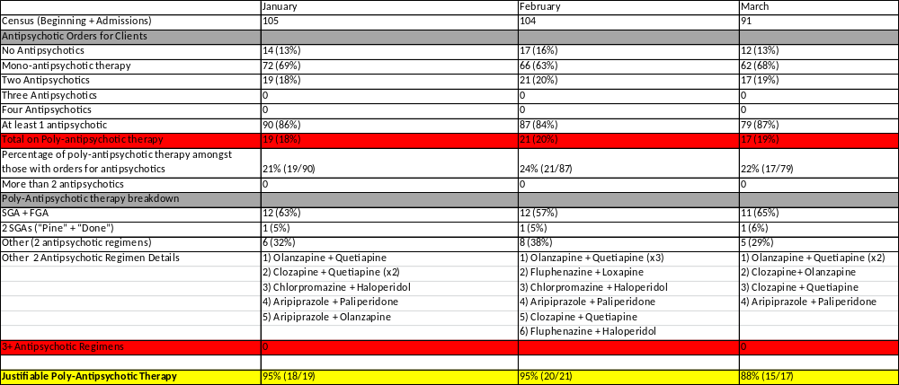

Census & Number of Patients with 0, 1, 2, 3 & 4 Orders for Antipsychotics
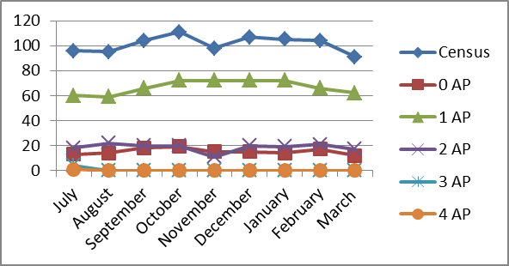

Number of Patients with 2+ Antipsychotic orders per Month
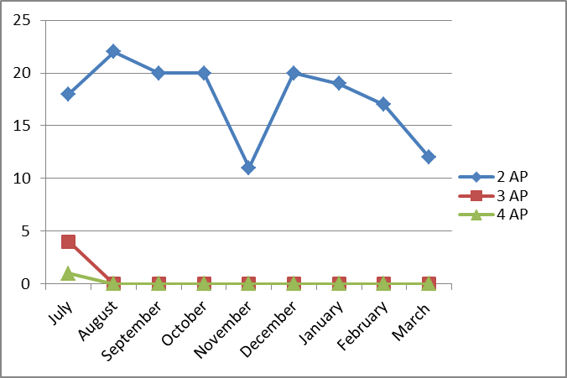
(Glossary of Terms, Acronyms & Abbreviations) (Back to Table of Contents)
STRATEGIC PERFORMANCE EXCELLENCE

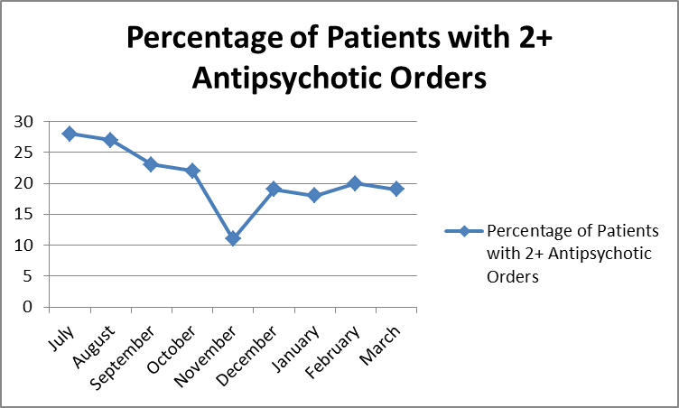

II. Measure Name: Metabolic monitoring
Measure Description: Metabolic syndrome is a well-known side effect of second generation antipsychotics (SGAs). The majority of patients prescribed antipsychotics are prescribed an entity from the SGA sub-class. The purpose of this monitor is to ensure that we are monitoring, or attempting to monitor, SGA therapy appropriately for those patients prescribed SGAs.
Type of Measure: Performance Improvement

Results
 | Unit | Baseline | Q1 | Q2 | Q3 | Q4 | YTD
Target | Complete/Up-to-date Metabolic Parameters | 56% | 75% | 75% | 75% | 75% | 75%
Actual | Complete/Up-to-date Metabolic Parameters | 56% | 56% | 86% | 71% |  | 71%

Data Analysis: The pharmacy completed data collection of metabolic monitoring parameters for all patients in the hospital who were receiving atypical antipsychotics during the quarter. Data elements collected on all patients included BMI (Body Mass Index) and BP (blood pressure) plus lab results including HDL cholesterol, triglycerides, fasting blood sugar, and hemoglobin A1C.

Action Plan: We will continue to monitor SGA therapy by monitoring for Metabolic Syndrome. The patient’s right to refuse assessment (weight, blood pressure and lab work) has been identified as a contributing factor to not being able to fully assess their metabolic status. Thus the goal of achieving 95% completed metabolic parameters is unrealistic and has been adjusted to a more reasonable goal of 75%. We have also started incorporating documentation of patient’s refusals. This indicates that the provider is making the attempt to monitor the medication. In an attempt to streamline lab work, the Medical Staff has decided to incorporate
(Glossary of Terms, Acronyms & Abbreviations) (Back to Table of Contents)
STRATEGIC PERFORMANCE EXCELLENCE

lab work with the annual physical. This may impact this monitor going forward as data has been collected based on the most recent lab work and addition or changes in SGA therapy.

Comments: We saw a slight decrease in our collection of metabolic parameters. This was expected as education was provided to the Medical Staff in September, increasing provider awareness for the following quarter (October – December). We also have a high number of locum Medical Staff that would not have been present for the education in September. Patient characteristics and turnover could also impact the ability to obtain parameters.

Graph/Chart:

 | January – March 2015 | October – December 2014 | July – September 2014
# of Patients on SGA | 90 | 100 | 105
# of Patients with Complete/Up-to-date Parameters | 64 (71%) | 86 (86%) | 59 (56%)
# of Patients Missing/ Not Up-to-date Parameters | 26 (29%) | 14 (14%) | 46 (44%)
# of Patients Meeting Criteria for Metabolic Syndrome | 31 (34%) | 29 (29%) | 32 (30%)
# of Patients without Metabolic Syndrome | 47 (52%) | 64 (64%) | 44 (42%)
# Unable to Determine | 12 (13%) | 7 (7%) | 29 (28%)
Documented Refusals | 5 (19%) | 6 (43%) | N/A

Collection of Monitoring Parameters
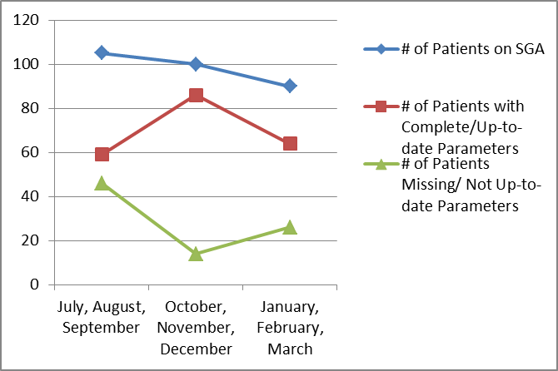

(Glossary of Terms, Acronyms & Abbreviations) (Back to Table of Contents)
STRATEGIC PERFORMANCE EXCELLENCE

Metabolic Syndrome Evaluation
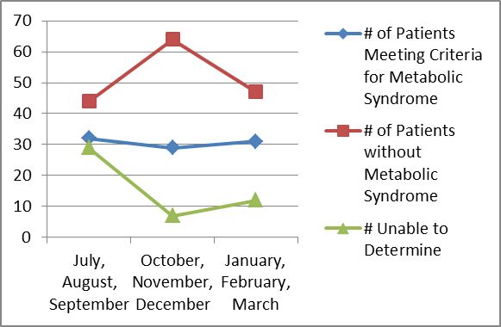

III. Measure Name: Polytherapy
Measure Description: Polytherapy is defined as “combined treatment of multiple conditions with multiple medications.” This differs from polypharmacy, the “treatment of a single condition with multiple medications from the same pharmacologic class or with the same mechanism of action” which our other monitor, Poly-antipsychotic therapy, addresses. Polypharmacy can lead to complex medication regimens and increases the chances of drug-drug interactions potentially negatively impacting or inhibiting another drug from exerting it intended therapeutic effect. When five or more medications are taken together there is almost a 100% chance of a drug-drug interaction. The purpose of this monitor is to evaluate polytherapy and actively discuss cases with the highest number of medications in an attempt to reduce polytherapy.
Type of Measure: Performance Improvement

Data Analysis: We have assessed a baseline group of patients with regards to their total number of medications prescribed and further broken it down to number of scheduled medications and number of PRN or “as needed” medications. Each month the patient medication profiles with the highest total number of medications for each unit will be reviewed at the Peer Review Committee to assess the potential for eliminating unnecessary medications. The number of actual profiles reviewed each month will be dependent on time constraints and presence/availability of the patient’s Psychiatric and Medical providers.

Action Plan: Our plan is to continue to review patients with numerous medication orders at the monthly Peer Review Committee Meeting. An effort will be made to obtain more information on medication adherence and PRN usage for the patients reviewed. This monitor will be reported and discussed with the Medical Staff at the Peer Review and Pharmacy & Therapeutics (P&T) Committees.

Comments: A shift towards a higher number of medications ordered was seen this quarter. It is difficult to determine if this is a result of patient specific factors or provider specific habits. We did have a patient readmitted who has historically been ordered a large number of medications,
(Glossary of Terms, Acronyms & Abbreviations) (Back to Table of Contents)
STRATEGIC PERFORMANCE EXCELLENCE

at the patient’s request. This could have skewed the average number of medications for patients.

Graph/Chart:

 | Baseline Average | Baseline Range |  | 12/9/14 Average | 12/9/14 Range |  | 3/16/15  Average | 3/16/15  Range
Total Orders | 11.4 | 4 - 37 |  | 10.4 | 0 - 29 |  | 12.1 | 0 – 31
Scheduled | 5.5 | 0 - 21 |  | 4.7 | 0 - 18 |  | 4.9 | 0 – 17
PRNs | 6 | 1 - 22 |  | 6 | 0 - 11 |  | 5.9 | 0 – 19

Medication Number Range | Number of Patients (Baseline) | 12/9/2014 | 3/16/2015
< 5 | 4 | 6 | 3
5 – 9 | 28 | 34 | 27
10 – 14 | 33 | 35 | 30
15 – 19 | 4 | 7 | 19
20 – 24 | 3 | 3 | 1
25 – 29 | 2 | 1 | 3
> 30 | 1 | 0 | 1

Number of Patients Falling into Range of Medication Orders

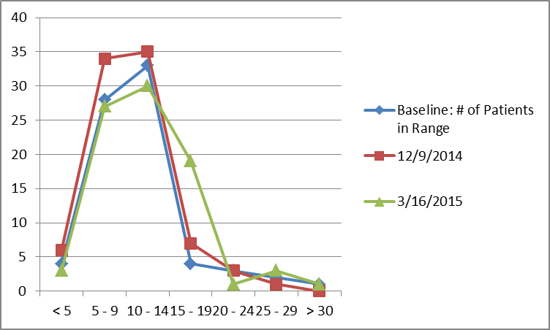
(Glossary of Terms, Acronyms & Abbreviations) (Back to Table of Contents)
STRATEGIC PERFORMANCE EXCELLENCE

Nursing

INDICATOR
Mandate Occurrences
DEFINITION
When no volunteers are found to cover a required staffing need, an employee is mandated to cover the staffing need according to policy. This creates difficulty for the employee who is required to unexpectedly stay at work up to 16 hours. It also creates a safety risk.
OBJECTIVE
Through collaboration among direct care staff and management, solutions will be identified to improve the staffing process in order to reduce and eventually eliminate mandate occurrences. This process will foster safety in culture and actions by improving communication, improving staffing capacity, mitigating risk factors, supporting the engagement and empowerment of staff. It will also enhance fiscal accountability by promoting accountability and employing efficiency in operations.
THOSE RESPONSIBLE FOR MONITORING
Monitoring will be performed by members of the Staffing Improvement Task Force which includes representation of Nurses and Mental Health Workers on all units, Staffing Office and Nursing Leadership.
METHODS OF MONITORING
Monitoring would be performed by;
- Staffing Office Database Tracking System
METHODS OF REPORTING
Reporting would occur by one or all of the following methods;
- Staffing Improvement Task Force
- Nursing Leadership
- Riverview Nursing Staff Communication
UNIT
Mandate shift occurrences
BASELINE
September 2013: Nurse Mandates 14 shifts, Mental Health Worker Mandates 49 shifts
MONTHLY TARGETS
10% reduction monthly x4 from baseline
(Glossary of Terms, Acronyms & Abbreviations) (Back to Table of Contents)
STRATEGIC PERFORMANCE EXCELLENCE

Nursing Department Mandates
Staffing Improvement Task Force

Mandate Occurrences: When no volunteers are found to cover a required staffing need, an employee is mandated to cover the staffing need according to policy.
 | New Baseline  Sept 2013 | FY14 Q4 |  |  | FY15 Q1 |  |  | FY15 Q2 |  |  | FY15 Q3 |  |  | Goal
 | New Baseline  Sept 2013 | Apr 2014 | May 2014 | June 2014 | July 2014 | Aug2014 | Sep 2014 | Oct 2014 | Nov 2014 | Dec 2014 | Jan 2015 | Feb 2015 | Mar 2015 | Goal
Nursing Mandates | 14 | 21 | 2 | 8 | 4 | 2 | 1 | 3 | 1 | 4 | 6 | 20 | 11 | 10% reduction monthly x4 from baseline)
Mental Health Worker (MHW) Mandates | 49 | 39 | 8 | 13 | 16 | 18 | 12 | 45 | 39 | 38 | 66 | 39 | 51 | 10% reduction monthly x4 from baseline)

Nursing mandates increased from 8 last quarter to 37 this quarter.
MHW mandates increased from 122 last quarter to 156 this quarter.

Summary:

After two years we are back to where we started with mandates and overtime. There are several known reasons for this. Significant number of workers out of work due to patient induced injury. For the past quarter, we have had between 15 and 22 staff weekly, not at work due to workers compensation, FML or vacation time, with workers compensation being the largest portion of the vacancies.

In an attempt to improve the staffing, the hospital has offered 12 hours shifts to nurses and MHWs. Flex schedules have also been implemented to improve morale and increase staffing when needed. We continue to utilize approximately 3 contract nurses for a thirteen week period and then re-evaluate the need. RPRC has a per diem pool of nurses contracted through Maine Staffing. Most recently RPRC split a MHW block to accommodate two MHWs who wanted to remain working but were not able to commit to a 40 hour work week. Another incentive was a $3.00 an hour stipend to RNs to encourage recruitment and retention. Unit based staffing is another idea being considered for staff morale and improvement, but with the number of FTEs out, unit based staffing is not realistic at this point.

FMLs have significantly reduced the pool of available workers thus increasing the frequency of mandates on others. Several nurses have been assigned to or applied for positions that work Monday thru Friday, no weekend coverage which increases the workload and mandates on the nurses who work weekends and get mandated.
(Glossary of Terms, Acronyms & Abbreviations) (Back to Table of Contents)
STRATEGIC PERFORMANCE EXCELLENCE

Nursing Department Initial Chart Compliance
January – March 2015
Lower Saco

Indicator | Findings | Compliance
1. Universal Assessment completed by RN within 24 hours | 16 of 16 | 100%
2. All sections completed or deferred within document | 15 of 16  1 unable | 100%
3. Initial Safety Treatment Plan initiated | 16 of 16 | 100%
4. All sheets required signature authenticated by assessing RN | 2 of 16  14 n/a | 100%
5. Medical Care Plan initiated if Medical problems identified | 13 of 16 | 81%
6. Informed Consent sheet signed | 13 of 16  1 ref.  2 loc | 100%
7. Potential for violence assessment upon admission | 16 of 16 | 100%
8. Suicide potential assessed upon admission | 16 of 16 | 100%
9. Fall Risk assessment completed upon admission | 3 of 16  13 n/a | 100%
1 10. Score of 5 or above incorporated into problem need list | 15 of 16 | 94%
11. Dangerous Risk Tool done upon admission | 11 of 16  4 n/a  1 unknown | 100%
12. Score of 11 or above incorporated into Safety Problem | 13 of 16  1 ref.  2 loc | 100%
13. Evidence that clients are routinely informed of their rights upon admission in accordance with ¶ 150 of the settlement agreement is found in the document of the charts reviewed. | 14 of 16 | 88%

(Glossary of Terms, Acronyms & Abbreviations) (Back to Table of Contents)
STRATEGIC PERFORMANCE EXCELLENCE

Nursing Department Initial Chart Compliance
January – March 2015
Lower Kennebec

Indicator | Findings | Compliance
1. Universal Assessment completed by RN within 24 hours | 26 of 26 | 100%
2. All sections completed or deferred within document | 26 of 26 | 100%
3. Initial Safety Treatment Plan initiated | 26 of 26 | 100%
4. All sheets required signature authenticated by assessing RN | 7 of 26  19 n/a | 100%
5. Medical Care Plan initiated if Medical problems identified | 26 of 26 | 100%
6. Informed Consent sheet signed | 23 of 26  3 ref. | 100%
7. Potential for violence assessment upon admission | 26 of 26 | 100%
8. Suicide potential assessed upon admission | 26 of 26 | 100%
9. Fall Risk assessment completed upon admission | 9 of 26  17 n/a | 100%
1 10. Score of 5 or above incorporated into problem need list | 26 of 26 | 100%
11 11. Dangerous Risk Tool done upon admission | 15 of 26  11 n/a | 100%
12. Score of 11 or above incorporated into Safety Problem | 24 of 26  2 ref. | 100%
13. Evidence that clients are routinely informed of their rights upon admission in accordance with ¶ 150 of the settlement agreement is found in the document of the charts reviewed. | 26 of 26 | 100%

(Glossary of Terms, Acronyms & Abbreviations) (Back to Table of Contents)
STRATEGIC PERFORMANCE EXCELLENCE

Nursing Department Initial Chart Compliance
January – March 2015
Total – All Units

Indicator | Findings | Compliance
1. Universal Assessment completed by RN within 24 hours | 42 of 42 | 100%
2. All sections completed or deferred within document | 41 of 42  1 unable | 100%
3. Initial Safety Treatment Plan initiated | 42 of 42 | 100%
4. All sheets required signature authenticated by assessing RN | 9 of 42  33 n/a | 100%
5. Medical Care Plan initiated if Medical problems identified | 39 of 42 | 93%
6. Informed Consent sheet signed | 36 of 42  4 ref.  1 loc | 100%
7. Potential for violence assessment upon admission | 42 of 42 | 100%
8. Suicide potential assessed upon admission | 42 of 42 | 100%
9. Fall Risk assessment completed upon admission | 12 of 42  30 n/a | 100%
1 10. Score of 5 or above incorporated into problem need list | 41 of 42 | 98%
11 11. Dangerous Risk Tool done upon admission | 26 of 42  15 n/a  1 unknown | 100%
12. Score of 11 or above incorporated into Safety Problem | 37 of 42  3 ref.  2 loc | 100%
13. Evidence that clients are routinely informed of their rights upon admission in accordance with ¶ 150 of the settlement agreement is found in the document of the charts reviewed. | 40 of 42 | 95%

Note: There were no admissions to Upper Saco or Upper Kennebec in 3Q2015
(Glossary of Terms, Acronyms & Abbreviations) (Back to Table of Contents)
STRATEGIC PERFORMANCE EXCELLENCE

Peer Support

INDICATOR
Client Satisfaction Survey Return Rate
DEFINITION
There is a low number of satisfaction surveys completed and returned once offered to clients due to a number of factors.
OBJECTIVE
To increase the number of surveys offered to clients, as well as increase the return rate.
THOSE RESPONSIBLE FOR MONITORING
Peer Services Director and Peer Support Team Leader will be responsible for developing tracking tools to monitor survey due dates and surveys that are offered, refused, and completed. Full-time peer support staff will be responsible for offering surveys to clients and tracking them until the responsibility can be assigned to one person.
METHODS OF MONITORING
- Biweekly supervision check-ins
- Monthly tracking sheets/reports submitted for review
METHODS OF REPORTING
- Client Satisfaction Survey Tracking Sheet
- Completed surveys entered into spreadsheet/database
UNIT
All client care/residential units
BASELINE
Determined from previous year’s data.
QUARTERLY TARGETS
Quarterly targets vary based on unit baseline with the end target being 50%.
(Glossary of Terms, Acronyms & Abbreviations) (Back to Table of Contents)
STRATEGIC PERFORMANCE EXCELLENCE

Peer Support
Inpatient Client Survey – Improving the Rate of Return

Department: |  | Peer Support |  |  |  |  | Responsible Party: |  |  | Samantha St. Pierre
Strategic Objectives
Client Recovery |  |  | Unit | Baseline | FY14  Q4 | FY15  Q1 |  | FY15  Q2 | FY15  Q3 |  | Goal | Comments
CSS Return Rate |  |  | LK  LS  UK  US | 15%  5%  45%  30% | 12%  0%  12%  100% | 23%  23%  36%  0% |  | 17%  25%  28%  25% | 37%  62%  26%  100% |  | 50%  50%  50%  50% | Percentages are calculated based on number of people eligible to receive a survey vs. the number of people who completed the surveys.
The client satisfaction survey is the primary tool for collecting data on how clients feel about the services they are provided at the hospital. Data collection has been low on all units and the way in which the surveys are administered has challenges based on the unit operations and performance of the peer support worker.

(Glossary of Terms, Acronyms & Abbreviations) (Back to Table of Contents)
STRATEGIC PERFORMANCE EXCELLENCE

Summary of Inpatient Client Survey Results

# | Indicators | 4Q2014  Findings | 1Q2015  Findings | 2Q2015  Findings | 3Q2015  Findings | Average Score
1 | I am better able to deal with crisis. | 59% | 66% | 79% | 75% | 70%
2 | My symptoms are not bothering me as much. | 59% | 63% | 71% | 73% | 67%
3 | The medications I am taking help me control symptoms that used to bother me. | 59% | 72% | 73% | 71% | 69%
4 | I do better in social situations. | 53% | 67% | 69% | 73% | 66%
5 | I deal more effectively with daily problems. | 53% | 67% | 69% | 75% | 66%
6 | I was treated with dignity and respect. | 63% | 67% | 65% | 69% | 66%
7 | Staff here believed that I could grow, change and recover. | 63% | 72% | 75% | 74% | 71%
8 | I felt comfortable asking questions about my treatment and medications. | 56% | 67% | 73% | 71% | 67%
9 | I was encouraged to use self-help/support groups. | 66% | 69% | 77% | 77% | 72%
10 | I was given information about how to manage my medication side effects. | 47% | 61% | 67% | 60% | 59%
11 | My other medical conditions were treated. | 57% | 73% | 56% | 69% | 64%
12 | I felt this hospital stay was necessary. | 44% | 64% | 67% | 50% | 56%
13 | I felt free to complain without fear of retaliation. | 47% | 69% | 67% | 54% | 59%
14 | I felt safe to refuse medication or treatment during my hospital stay. | 56% | 42% | 60% | 49% | 52%
15 | My complaints and grievances were addressed. | 56% | 70% | 50% | 63% | 60%
16 | I participated in planning my discharge. | 72% | 72% | 60% | 66% | 68%
17 | Both I and my doctor or therapists from the community were actively involved in my hospital treatment plan. | 63% | 58% | 50% | 52% | 56%
18 | I had an opportunity to talk with my doctor or therapist from the community prior to discharge. | 59% | 63% | 57% | 47% | 57%
19 | The surroundings and atmosphere at the hospital helped me get better. | 66% | 66% | 58% | 61% | 63%
20 | I felt I had enough privacy in the hospital. | 63% | 64% | 63% | 66% | 64%
21 | I felt safe while I was in the hospital. | 59% | 67% | 50% | 72% | 62%
22 | The hospital environment was clean and comfortable. | 59% | 70% | 71% | 74% | 69%
23 | Staff were sensitive to my cultural background. | 59% | 52% | 60% | 65% | 59%
24 | My family and/or friends were able to visit me. | 59% | 61% | 50% | 68% | 60%
25 | I had a choice of treatment options. | 50% | 70% | 75% | 60% | 64%
26 | My contact with my doctor was helpful. | 47% | 63% | 69% | 55% | 59%
27 | My contact with nurses and therapists was helpful. | 66% | 72% | 69% | 57% | 66%
28 | If I had a choice of hospitals, I would still choose this one. | 56% | 55% | 67% | 54% | 58%
29 | Did anyone tell you about your rights? | 59% | 58% | 62% | 74% | 63%
30 | Are you told ahead of time of changes in your privileges, appointments, or daily routine? | 47% | 66% | 60% | 60% | 58%
31 | Do you know someone who can help you get what you want or stand up for your rights? | 69% | 80% | 73% | 77% | 75%
32 | My pain was managed. | 59% | 58% | 68% | 65% | 63%
 | Overall Score | 58% | 65% | 65% | 65% | 63%

(Glossary of Terms, Acronyms & Abbreviations) (Back to Table of Contents)
STRATEGIC PERFORMANCE EXCELLENCE

Pharmacy Services

The IPEC reporting reflects three major areas of focus for performance improvement that have pharmacy specific indicators: Safety in Culture and Actions, Fiscal Accountability and Medication Management (see Medication Management – Dispensing Process). The pharmacy specific indicators for each of the priority focus areas utilizes measurable and objective data that is trended and analyzed to support performance improvement efforts and medication safety, as well as, ensure regulatory compliance and best practice in key areas.
Safety in Culture and Actions
RPRC’s primary medication distribution system uses the Pyxis Medstations to provide an electronic “closed loop” system to dispense medications for patients. Within the Pyxis system, key data elements are reported, trended and analyzed to ensure medication safety and regulatory compliance are maintained. Pyxis Discrepancies created by nursing staff are monitored daily and analyzed by Pharmacy with follow up to Nursing as needed for resolution. A quarterly summary is provided to the Nursing-Pharmacy Committee for further review and discussion of trends and ideas to minimize the occurrence of discrepancies by Nursing. Pyxis Overrides of Controlled Drugs by nursing staff is another indicator that is closely monitored and trended with follow up for resolution as needed. A quarterly summary is also reviewed by the Nursing-Pharmacy Committee for action steps. The goal with each of these indicators is to minimize the occurrence of either discrepancies or overrides by action steps to address performance issues via education or system changes which help satisfy TJC requirements for monitoring the effectiveness of the Medication Management system. Veriform Medication Room Audits are performed on each medication room to determine compliance with established medication storage procedures and requirements. The results of the audits are shared with the nursing managers for their respective corrective actions or staff education. Additionally, adverse drug reactions and clinical interventions are monitored, documented and analyzed for review by the P&T Committee. ADR’s are reported monthly and Clinical Interventions are reported on a quarterly basis.
Fiscal Accountability
The Discharge Prescriptions indicator tracks the cost and number of prescription drugs dispensed to patients at discharge. This baseline data will be used to determine the best approach to implement steps to decrease this expense. The lack of a resource to perform insurance verification and research prior authorizations needed so clinicians’ can make timely and informed prescribing decisions is believed to be inherent in the discharge process. Without this resource, RPRC is obliged to provide discharge medications to prevent a gap in medication coverage as the patient is being transitioned to another facility. The plan of correction is to explore options and propose a resolution to RPRC’s Clinical Director.

(Glossary of Terms, Acronyms & Abbreviations) (Back to Table of Contents)
STRATEGIC PERFORMANCE EXCELLENCE

Pharmacy Services

Pharmacy |  |  |  | Responsible Party: |  |  | Garry Miller, R.Ph.
Strategic Objectives
Safety in Culture and Actions | Unit | Baseline  2014 | Q1 Target |  | Q2 Target | Q3 Target |  | Q4 Target | Goal | Comments
Pyxis CII Safe Comparison | Rx | 0.875% | 0% |  | 0% | 0% |  | 0% |  | No discrepancies between Pyxis and CII Safe transactions during Q1, Q2, Q3
Daily and monthly comparison of Pyxis vs CII Safe transactions
Quarterly Results |  |  | 0% |  | 0% | 0%
Veriform Medication Room Audits | All | 98% | 100% |  | 100% | 100% |  | 100% | 90% | Overall compliance is 97%
Monthly comprehensive audits of
criteria
Quarterly Results |  |  | 97% |  | 97% | 98%
Pyxis Discrepancies | All | 22/mo | 25 |  | 25 | 25 |  | 25 | 25/mo | Trending of monthly data from Knowledge Portal for Q1, Q2, and Q3
Monthly monitoring and trending of Pyxis discrepancies.
Quarterly Results |  |  | 38  (19/mo) |  | 70  (23/mo) | 68  (23/mo)
Fiscal Accountability | Unit | Baseline  2014 | Q1 Target |  | Q2 Target | Q3 Target |  | Q4 Target | Goal | Comments
Discharge Prescriptions | Rx | $3998  343 drugs | $3293  135  drugs |  | $2731  170  drugs* | $4474  295  drugs |  |  |  | Significant costs are incurred in providing discharge drugs.*October data was lost due to incorrect Windows 7 update on QS/1.
Monitoring and Tracking of dispensed Discharge Prescriptions

(Glossary of Terms, Acronyms & Abbreviations) (Back to Table of Contents)
STRATEGIC PERFORMANCE EXCELLENCE

Pharmacy Services

Psychiatric Emergency New Process QI Review/Analysis – January 2015

Number in Sample (n) = 9

Process Element | Raw Score | % Compliance | Reasons for Non-Compliance
Pharmacy notified of PE | 9/9 | 100%
PE Notice Posted in Pharmacy for Reference | 9/9 | 100%
RPh check to resolve order issues arising from PE orders (med rec) | 9/9 | 100%
Notice of end of PE received by Pharmacy | 8/9 | 89% | New prescriber accounts for 1/9,  Later performance improved.
Medication Reorder Form Printed/Faxed by Pharmacy to Nursing Floor | 9/9 | 100%
Completed Med Reorder Form Received by Pharmacy from Nursing Unit | 9/9 | 100%
Orders Updated in Medics | 9/9 | 100% | RxRemote failed to reorder 1/9, but later performance improved
New MARs printed/brought to Unit by RPh | 9/9 | 100%
RPh check of new MARs vs updated MARs completed by nursing, reconciliation performed | 9/9 | 100%

Recommendations

Continue to monitor.

(Glossary of Terms, Acronyms & Abbreviations) (Back to Table of Contents)
STRATEGIC PERFORMANCE EXCELLENCE

Pharmacy Services

Psychiatric Emergency New Process QI Review/Analysis – February 2015

Number in Sample (n) = 10

Process Element | Raw Score | % Compliance | Reasons for Non-Compliance
Pharmacy notified of PE | 10/10 | 100%
PE Notice Posted in Pharmacy for Reference | 10/10 | 100%
RPh check to resolve order issues arising from PE orders (med rec) | 10/10 | 100%
Notice of end of PE received by Pharmacy | 9/10 | 90% | Note: expired. Provider’s order incomplete (did not specify end of PE).
Medication Reorder Form Printed/Faxed by Pharmacy to Nursing Floor | 10/10 | 100%
Completed Med Reorder Form Received by Pharmacy from Nursing Unit | 10/10 | 100%
Orders Updated in Medics | 5/10 | 50% | Note: although Medication Reorder forms were sent successfully, opportunity still remains for RxRemote staff to learn how to reorder meds in Medics.
New MARs printed/brought to Unit by RPh | 10/10 | 100%
RPh check of new MARs vs updated MARs completed by nursing, reconciliation performed | 10/10 | 100%

Recommendations

- Learning opportunity provided for per diem provider to improve documentation of PE termination/expiry. Will continue to monitor.
- Review non-compliance with reorder of medications with RxRemote pursuant to faxed medication re-order form as a training opportunity.

(Glossary of Terms, Acronyms & Abbreviations) (Back to Table of Contents)
STRATEGIC PERFORMANCE EXCELLENCE

Pharmacy Services

Psychiatric Emergency New Process QI Review/Analysis – March 2015

Number in Sample (n) = 12

Process Element | Raw Score | % Compliance | Reasons for Non-Compliance
Pharmacy notified of PE | 12/12 | 100%
PE Notice Posted in Pharmacy for Reference | 12/12 | 100%
RPh check to resolve order issues arising from PE orders (med rec) | 12/12 | 100%
Notice of end of PE received by Pharmacy | 11/12 | 92% | One weekend PA wrote orders to discontinue all IM injections, but did not discontinue PE in same order.
Medication Reorder Form Printed/Faxed by Pharmacy to Nursing Floor | 10/12 | 83% | Rx Remote was advised to do this with written instructions on the weekend, but failed to execute.
Completed Med Reorder Form Received by Pharmacy from Nursing Unit | 9/12 | 75% | Rx Remote/one day relief staff pharmacist account for deficiency, required follow up
Orders Updated in Medics | 9/12 | 75% | Contingent on previous function
New MARs printed/brought to Unit by RPh | 9/12 | 75% | MAR contents coincided with what was issued Friday pm
RPh check of new MARs vs updated MARs completed by nursing, reconciliation performed | 12/12 | 100% | Followed up by daytime regular staff.

Recommendations

During this reporting period, additional instructions were hand-written, then typed for RxRemote and relief staff to be able to follow, and do the necessary follow-up. Will continue to monitor in April. Non-compliance will result in a variance report.

(Glossary of Terms, Acronyms & Abbreviations) (Back to Table of Contents)
STRATEGIC PERFORMANCE EXCELLENCE

Pharmacy Services

Contract Verification Audit: Turnaround Times January 2015
Contract Parameters: |  |  | 1) All orders will be delivered within 3 hours of request
 |  |  | 2) All STAT orders will be delivered within 1 hour
 |  |  | 3) All requests for clinical pharmacy consultation will be responded to within 2 working days
Order Date/Time | Rx Remote | On Call RPh | Staff RPh |  |  | Fax Time | OE Time | In Pyxis? |  | STAT? | Delivery Time Saco |  | Delivery Time Kenn
1/20/15 1700 | X |  |  |  |  | 1712 | 1747 | Y |  | N
1/20/15 1721 | X |  |  |  |  | 1726 | 1749 | N |  | N | 0830 1/21/15 (KSP)
1/21/15 0855 |  |  | X |  |  | 9:41 | 9:46 | Y |  | N |  |  | 1030 1/21/15 (BM)
1/21/15 0945 |  |  | X |  |  | 9:46 | 9:50 | Y |  | Y | 1043 1/21/15 (KSP)
1/21/15 0939 |  |  | X |  |  | 1007 | 1009 | Y |  | N
1/21/15 1020 |  |  | X |  |  | 1026 | 1031 | Y |  | N
1/21/15 1030 |  |  | X |  |  | 1038 | 1039 | Y |  | N
1/21/15 0930 |  |  | X |  |  | 1111 | 1114 | Y |  | N
1/21/15 1115 |  |  | X |  |  | 1116 | 1125 | N |  | Y | 1135 (EAD)
1/21/15 1100 |  |  | X |  |  | 1256 | 1300 | N |  | N
1/21/15 1330 |  |  | X |  |  | 1336 | 1419 | N |  | Y | 1430 (EAD)
1/21/15 1400 |  |  | X |  |  | 1356 | 1413 | Y |  | N
1/21/15 1400 |  |  | X |  |  | 1413 | 1423 | N |  | Y | 1430 (EAD)
1/21/15 1350 |  |  | X |  |  | 1403 | 1427 | Y |  | N
1/21/15 1350 |  |  | X |  |  | 1436 | 1459 | Y |  | N

*Pulled out of Pyxis on override

Drug Information Request: none

% Contract Compliance: 100

Date of Audit: 1/21/15
Performed by: Elizabeth Dragatsi, RPh, BCPS
(Glossary of Terms, Acronyms & Abbreviations) (Back to Table of Contents)
STRATEGIC PERFORMANCE EXCELLENCE

Pharmacy Services

Contract Verification Audit: Turnaround Times February 2015
Contract Parameters: |  |  | 1) All orders will be delivered within 3 hours of request
 |  |  | 2) All STAT orders will be delivered within 1 hour
 |  |  | 3) All requests for clinical pharmacy consultation will be responded to within 2 working days
Order Date/Time | Rx Remote | On Call RPh | Staff RPh |  |  | Fax Time | OE Time | In Pyxis? |  | STAT? | Delivery Time Saco |  | Delivery Time Kenn
2/24/15 2010 | X |  |  |  |  | 2029 |  | N |  | N |  |  | 830
2/25/15 0945 |  |  | X |  |  | 949 | 1003 | Y |  | N | 940 |  | 945
2/25/15 1000 |  |  | X |  |  | 1005 | 1009 | Y |  | N
2/25/15 1130 |  |  | X |  |  | 1153 | 1158 | Y |  | N
2/25/15 1145 |  |  | X |  |  | 1154 | 1208 | Y |  | N
2/25/15 1150 |  |  | X |  |  | 1247 | 1250 | Y |  | N
2/25/15 1205 |  |  | X |  |  | 1243 | 1246 | y |  | N
2/25/15 1210 |  |  | X |  |  | 1241 | 1247 | Y |  | N
2/25/15 1215 |  |  | X |  |  | 1240 | 1249 | Y |  | N
2/25/15 1215 |  |  | X |  |  | 1246 | 1253 | Y |  | N
2/25/15 1250 |  |  | X |  |  | 1335 | 1340 | Y |  | N
2/25/15 1315 |  |  | X |  |  | 1359 | 1405 | Y |  | N
2/25/15 1245 |  |  | X |  |  | 1359 | 1407 | Y |  | N
2/25/15 1440 |  |  | X |  |  | 1501 | 1510 | Y |  | N | 1530 |  | 1530
2/25/15 1430 |  |  | X |  |  | 1534 | 1539 | Y |  | N
2/25/15 1516 |  |  | X |  |  | 1552 | 1553 | N |  | N |  |  | 1558

*Pulled out of Pyxis on override

Drug Information Request:

Time/Date | Time/Date | RPh
Request | Provided
2/24/2015 1615 | 2/25/15 1530 | EAD

% Contract Compliance: 100

Date of Audit: 2/25/15
Performed by: Elizabeth Dragatsi, RPh, BCPS
Kennebec Delivery Tech: Kathy St. Pierre
Saco Delivery Tech: Betty Monteith
(Glossary of Terms, Acronyms & Abbreviations) (Back to Table of Contents)
STRATEGIC PERFORMANCE EXCELLENCE

Pharmacy Services

Contract Verification Audit: Turnaround Times March 2015
Contract Parameters: |  |  | 1) All orders will be delivered within 3 hours of request
 |  |  | 2) All STAT orders will be delivered within 1 hour
 |  |  | 3) All requests for clinical pharmacy consultation will be responded to within 2 working days
Order Date/Time | Rx Remote | On Call RPh | Staff RPh |  |  | Fax Time | OE Time | In Pyxis? |  | STAT? | Delivery Time Saco |  | Delivery Time Kenn
3/25/15 1900 | X |  |  |  |  | 2210 | 2235 | Y |  | Y
3/25/15 1150 |  |  | X |  |  | 825 3/26 | 826 | N |  | Y | 830
3/26/15 0912 |  |  | X |  |  | 913 | 915 | Y |  | N | 950 |  | 940
3/26/15 0900 |  |  | X |  |  | 927 | 930 | Y |  | N
3/26/15 0845 |  |  | X |  |  | 936 | 943 | Y |  | N
3/26/15 0930 |  |  | X |  |  | 944 | 945 | Y |  | N
3/26/15 0915 |  |  | X |  |  | 941 | 942 | Y |  | N
3/26/15 0945 |  |  | X |  |  | 1008 | 1010 | Y |  | N
3/26/15 1031 |  |  | X |  |  | 1049 | 1059 | N |  | N
3/26/15 1125 |  |  | X |  |  | 1132 | 1134 | Y |  | Y
3/26/15 1009 |  |  | X |  |  | 1139 | 1143 | Y |  | N
3/26/15 1056 |  |  | X |  |  | 1224 | 1228 | N/A |  | N
3/26/15 1245 |  |  | X |  |  | 1305 | 1307 | Y |  | N
3/26/15 1530 |  |  | X |  |  | 1548 | 1549 | Y |  | N | 1500 |  | 1445

*Pulled out of Pyxis on override

Drug Information Request:

Time/Date | Time/Date | RPh
Request | Provided
3/26/15 0915 | 3/26/15 1030 | EAD

% Contract Compliance: 100

Date of Audit: 3/26/15
Performed by: Elizabeth Dragatsi, RPh, BCPS
Kennebec Delivery Tech: Kathy St. Pierre
Saco Delivery Tech: Betty Monteith
(Glossary of Terms, Acronyms & Abbreviations) (Back to Table of Contents)
STRATEGIC PERFORMANCE EXCELLENCE

Program Services

Define
Client participation in on-unit groups and utilization of resources to relieve distress is variable but should be promoted to encourage activities that support recovery and the development of skills necessary for successful community integration.
Measure
The program services team will measure the current status of program participation and resource utilization to identify a baseline for each of the four units.
Analyze
Analysis of the barriers to utilization will be conducted in an attempt to determine causation factors for limited participation.
Improve
Strategies for encouraging increased participation in on-unit groups and the utilization of resources to relieve distress will be identified in a collaborative manner with client and staff participation.
Control
Ongoing review of utilization of programs and resources will be conducted to determine whether unit practice has changed and improvements are sustainable.
INDICATOR | Baseline | Quarterly  Improvement  Target | Improvement Objective
1. How many on unit groups were offered each week  Day shift →  Evenings → |  |  | 14
2. Number of clients attending day groups on unit
or facilitated by day staff
(# of clients in all of day groups divided by # of
day groups provided)
3. Number of clients attending evening groups on
unit or facilitated by evening staff
(# of clients in all of evenings groups divided by
# of evening groups provided)
4. Of the 10 charts reviewed, how many  treatment plans reflected the on unit groups  attended. |  |  | 100%
5. The client can identify distress tolerance tools  on the unit |  |  | 100%
6. The client is able to can identify his or her primary  staff. |  |  | 100%
(Glossary of Terms, Acronyms & Abbreviations) (Back to Table of Contents)
STRATEGIC PERFORMANCE EXCELLENCE

Program Services Lower Kennebec

INDICATOR | FINDINGS | % | THRESHOLD
1. How many on unit groups were offered each week  Day shift →  Evenings → | Main / SCU  5 per week  7 per week | 71%  100% | Days/ Evenings  12 out of 14 per week
2. Number of clients attending day groups on unit  or facilitated by day staff  (# of clients in all of day groups divided by # of  day groups provided) | 5 avg. |  | N/A
3. Number of clients attending evening groups on  unit or facilitated by evening staff  (# of clients in all of evenings groups divided by  # of evening groups provided) | 7 avg. |  | N/A
4. Of the 10 charts reviewed, how many  treatment plans reflected the on unit groups  attended | 29/30 | 97% | 100%
5. The client can identify distress tolerance tools  on the unit | 28/30 | 91% | 100%
6. The client is able to state who his primary  staff is | 29/30 | 97% | 100%

EVALUATION OF EFFECTIVENESS
ISSUES
LK has improved in consistency unit groups and attendance. We continue to look at ways to decrease the acuity & increase patient interest / participation in unit groups. RNs have been directed to take more of a leadership role in group facilitation & to facilitate educational groups vs leisure activity.

ACTIONS
We continue to encourage patient participation in groups & in relating the patients’ Recovery Goal/s to the groups offered. A new hab aide has added significantly to group / activity participation on the unit. Music continues to be one of the more popular de-escalation tools. LK has added to its own collection of movies for patients to watch in the evening hours once activities are done.

(Glossary of Terms, Acronyms & Abbreviations) (Back to Table of Contents)
STRATEGIC PERFORMANCE EXCELLENCE

Program Services Upper Kennebec

INDICATOR | FINDINGS | % | THRESHOLD
1. How many on unit groups were offered each week  Day shift →  Evenings → | 7 per week  7 per week | 100% | Days/ Evenings  14 out of 14 per week
2. Number of clients attending day groups on unit  or facilitated by day staff  (# of clients in all of day groups divided by # of  day groups provided) | 4 avg. |  | N/A
3. Number of clients attending evening groups on  unit or facilitated by evening staff  (# of clients in all of evenings groups divided by  # of evening groups provided) | 3 avg. |  | N/A
4. Of the 10 charts reviewed, how many  treatment plans reflected the on unit groups  attended | 30/30 | 100% | 100%
5. The client can identify distress tolerance tools  on the unit (re named coping tools) | 28/30 | 96% | 100%
6. The client is able to state who his primary  staff is | 27/30 | 90% | 100%

EVALUATION OF EFFECTIVENESS
ISSUES
Upper Kennebec continues to work on getting patients to on unit groups but it has been challenging at times because some clients will not participate in treatment.

ACTIONS
We will continue to try to encourage patients to attend on unit groups and also work with patients towards recovery. We now have a more consistent nursing staff and the group leaders are very strong and engaging.
(Glossary of Terms, Acronyms & Abbreviations) (Back to Table of Contents)
STRATEGIC PERFORMANCE EXCELLENCE

Program Services Lower Saco

INDICATOR | FINDINGS | % | THRESHOLD
1. How many on unit groups were offered each week  Day shift →  Evenings → | Main/SCU  33 / 10  24 / 7 | 100%  100% | 7 / 7 = 14  7 / 7 = 14
2. Number of clients attending day groups on unit  or facilitated by day staff  (# of clients in all of day groups divided by # of  day groups provided) | 3.0 / 1.5 |  | N/A
3. Number of clients attending evening groups on  unit or facilitated by evening staff  (# of clients in all of evenings groups divided by  # of evening groups provided) | 2.5 / 1 |  | N/A
4. Of the 10 charts reviewed, how many  treatment plans reflected the on unit groups  attended | 30/30 | 100% | 100%
5. The client can identify distress tolerance tools  on the unit | 30/30 | 100% | 100%
6. The client is able to state who his primary  staff is | 30/30 | 100% | 100%

EVALUATION OF EFFECTIVENESS
ISSUES
As noted previously, in early November 2014 the unit was no longer closed to the rest of the hospital. Even with this expansion, the unit based groups have stayed on track with fluctuation in attendance as noted in the previous report. Attendance at the hospital treatment mall has been low mostly due to patient acuity. The number of groups offered and documented attendance far exceed the thresholds established for this review. Perhaps new indicators are needed to identify areas that need to be addressed.

ACTIONS
As noted previously, RT staff members are very important in providing leisure and therapy groups to Lower Saco clients, which needs to be maintained. The unit is offering many more groups weekly than the threshold; the acuity specialist positions continue to address acuity situations and have helped maintain overall quality of groups.

(Glossary of Terms, Acronyms & Abbreviations) (Back to Table of Contents)
STRATEGIC PERFORMANCE EXCELLENCE

Program Services Upper Saco

INDICATOR | FINDINGS | % | THRESHOLD
1. How many on unit groups were offered each week  Day shift →  Evenings → | 3 (4-3-2)  6 (7-7-6) | Avg 3  Avg 7 | 7  7
2. Number of clients attending day groups on unit  or facilitated by day staff  (# of clients in all of day groups divided by # of  day groups provided) | 44/16  27/11  20/10 | Avg 3 | Average  3  patients/group
3. Number of clients attending evening groups on  unit or facilitated by evening staff  (# of clients in all of evenings groups divided by  # of evening groups provided) | 171/31  162/28  141/27 | Avg 5.5 | Average  5.5 patients/group
4. Of the 10 charts reviewed, how many  treatment plans reflected the on unit groups  attended | 30/30 | 100% | 100%
5. The client can identify distress tolerance tools  on the unit | 30/30 | 100% | 100%
6. The client is able to state who his primary  staff is | 30/30 | 100% | 100%

EVALUATION OF EFFECTIVENESS
ISSUES
Inconsistent occurrence/documentation of groups on days.

ACTIONS
E-mail sent to remind staff that groups need to be held and to always complete the attendance sheets
(Glossary of Terms, Acronyms & Abbreviations) (Back to Table of Contents)
STRATEGIC PERFORMANCE EXCELLENCE

Psychology Department
Department: | Psychology Services | Responsible Party: | Arthur DiRocco, PhD

Psychology Performance Improvement Goal

Having completed phase one of a performance improvement activity assessing the NCR patients currently in residence at Riverview Psychiatric Recovery Center the second phase of this performance improvement plan is to apply the results from phase one to the treatment of patients. The information collected from these assessments is being used to identify treatment needs and to provide a measure of outcomes for this population of patients.

Medical Staff Performance Improvement Activity

Target Goal: 90% of NCR Treatment plans will have one or more treatment goals identified and measured by treatment team use of COTREI within 4 months from October 1st, 2014. As of March 25, 2015 54% of the NCR clients have treatment goals derived from findings from the ORS.

Strategic Objectives
NCR Patient Recovery | Baseline | M1 Met | M2 Met | M3 Target | M4  Target | Goal
Utilization of COTREI to assist in Treatment Team Planning and Goals for NCR patients | 5% | 33% | 74% | 85% | 100% | NCR patients will be assessed using the COTREI within 60 days of admission; every 8 months after starting their residency at RPRC; and at the time of a new institutional report for a court petition.
The COTREI will be administered to each NCR patient at Riverview Psychiatric Recovery Center (RPRC). Areas of need identified by COTREI will be incorporated into NCR patient's treatment plan. Performance improvement will be assessed by documentation of at least one goal derived from the COTREI in 90% of NCR patients' treatment plans within 4 months of the October 1st, 2014 starting date.

(Glossary of Terms, Acronyms & Abbreviations) (Back to Table of Contents)
STRATEGIC PERFORMANCE EXCELLENCE

Rehabilitation Services
Department: | Rehabilitation Services | Responsible Party: | Janet Barrett

Client Recovery |  | Baseline | Q1 Target | Q2 Target | Q3 Target | Q4 Target | Goal | Comments
 | Recreational Therapy Assessments & Treatment Plans | 100% | 45/45 charts | 40/40 | 24/25 |  | The treatment plan intervention will be reviewed every 2 weeks and updated at each client treatment team meeting if necessary or if there is any change in patient status | One assessment was not completed in the 7 day time frame. All treatment plans were reviewed and updated according to the treatment process implemented at the end of last year. Goal of 100% for 2 quarters this year was achieved.
 | The objective of this improvement project is to ensure that Recreational Therapy assessments are completed within 7 days of admission and that a treatment plan is initiated after the assessment and will be reviewed and updated if necessary every 30 days. Documentation on interventions in the treatment plans will reflect progress towards interventions and will be documented on weekly.
 | Quarterly Results |  | 100% | 100% | 100%

Strategic Objectives
Client Recovery & Safety in Culture and Actions | Baseline | Q1 Target | Q2 Target | Q3 Target | Q4 Target | Goal | Comments
Occupational Therapy referrals and doctors orders. | 33%  (original) | 100%  27/27 | 100%  22/22 | 100%  27/28 | 100% | To maintain percentage of referrals and doctor’s orders at 100 % compliance for 4 consecutive quarters. | One patient OT referral was completed by the MD but it did not have a corresponding MD order in the chart. In July 2015 this will become our Quality Assessment measure
The objective of this improvement project is to ensure each client receiving Occupational Therapy Services from RPRC OT staff has a doctor’s order as well as a referral form completed prior to the initiation of services.

Quarterly Results |  | 100% | 100% | 96%
(Glossary of Terms, Acronyms & Abbreviations) (Back to Table of Contents)
STRATEGIC PERFORMANCE EXCELLENCE

Safety (Support Services) Rick Levesque

FY2015

I. Measure Name: Safety in Culture and Actions
Measure Description: Grounds Safety & Security Incidents
Type of Measure: Quality Assurance

Results
 | Unit | Baseline | Q1 | Q2 | Q3 | Q4 | YTD
Target | Grounds Safety & Security Incidents | *Baseline of 10 | 6 | 12 | 16 | 4 | 38
Actual | Grounds Safety & Security Incidents | *Baseline of 10 | 13 | 17 | 4 |  | 34

Data Analysis: This measure tracks any safety/security incident that occurs outside of the footprint of the hospital. Incidents are considered to be anything that if brought into the hospital or discovered by a patient could cause harm to the patient or others. We met our goal (actually we were 75% under) this quarter. I feel the reason for this improvement was because of the heavy snow. It snowed frequently and stayed cold so nothing was visible in the beds of trucks. The snow cover on the ground kept things hidden. Of the four incidents two were contraband in pickup truck beds one was broken glass and the fourth was a vehicle left running unattended. If a patient was first to discover any of these incidents we could have a serious injury or elopement.

Action Plan: The action plan remains the same. Increase vigilance and routine patrols by the security staff and notify owners of vehicles containing contraband and dangerous items and having the contraband removed or secured.

Comments: Maintaining the safety and security of the hospital, patients and staff remains the focus of this measure. It is everyone’s job to do their part. Many of our patients walk the hospital grounds (including parking lots) on short leave and fresh air breaks. They could easily find items left in truck beds or on the ground. These items can be used as weapons or for self-injury. By doing the routine checks and stressing awareness among the entire staff we have been able to prevent injuries and maintain hospital safety and security.

